**SCIT**

**School of Computing and**

**Information Technology**

**CSIT314**

**Software Development Methodologies**

**Singapore Institute of Management**

**Group Project**

| Group Members | UOW ID | SIM Email Address | Taiga Email Address |
| --- | --- | --- | --- |
| Timothy Mah | 8750634 | [txamah001@mymail.sim.edu.sg](mailto:txamah001@mymail.sim.edu.sg) | [timothymxa@gmail.com](mailto:timothymxa@gmail.com) |
| Neo Wayne | 8039045 | [wneo003@mymail.sim.edu.sg](mailto:wneo003@mymail.sim.edu.sg) | [wayneisbored@gmail.com](mailto:wayneisbored@gmail.com) |
| Ryu Hyeri | 8221674 | [ryu011@mymail.sim.edu.sg](mailto:ryu011@mymail.sim.edu.sg) | [daramggi136@gmail.com](mailto:daramggi136@gmail.com) |
| Yao Yi Jia | 8380132 | [Yjyao001@mymail.sim.edu.sg](mailto:Yjyao001@mymail.sim.edu.sg) | [magicallllllll@gmail.com](mailto:magicallllllll@gmail.com) |
| Yoon Seojin Hailey | 7898861 | [yoon013@mymail.sim.edu.sg](mailto:yoon013@mymail.sim.edu.sg) | [wooin0428@gmail.com](mailto:wooin0428@gmail.com) |
| Tay Leong Jie | 8081128 | [ljtay004@mymail.sim.edu.sg](mailto:ljtay004@mymail.sim.edu.sg) | [tayleongjie123@gmail.com](mailto:tayleongjie123@gmail.com) |
| Yang Xuan | 7910642 | [xyang045@mymail.sim.edu.sg](mailto:xyang045@mymail.sim.edu.sg) | geqinxuan01@gmail.com |

# **Team Performance Assessment**

**Project Manager:** Timothy Mah

**Date:**  10th April 2025

| Contribution Table | | | | |
| --- | --- | --- | --- | --- |
| **Group Members** | **UOW ID** | **Contribution Details** | **Contribution (%)** | **Signature** |
| Timothy Mah | 8750634 | App development, system infrastructure design, team lead | 100 |  |
| Neo Wayne | 8039045 | Create and populate database tables, record meeting minutes | 100 |  |
| Ryu Hyeri | 8221674 | Taiga, Test cases, Documentation, QC of description and diagrams | 100 |  |
| Yao Yi Jia | 8380132 | Use case diagrams, drawing BCE and sequence diagrams | 100 |  |
| Yoon Seojin | 7898861 | Class diagram, Ethical consideration, Documentation | 92 |  |
| Tay Leong Jie | 8081128 | Test cases,Documentation, Gantt chart, Video recording | 100 |  |
| Yang Xuan | 7910642 | Documentation | 87 |  |

# **Table of Content**

**Team Performance Assessment 2**

Contribution Table 2

**Table of Content 3**

**List of User Stories 6**

User Admin 6

Cleaner 8

Homeowner 9

Platform Manager 10

**Sprint 0 11**

Sprint Planning, Review and Retrospective 11

**Sprint 1 12**

Sprint Planning, Review and Retrospective 12

Taiga - Start 13

Taiga - End 19

Entity Relationship Diagram 25

Class Diagram 26

#1. User Admin - Create User Account 27

#2. User Admin - View User Account 30

#3. User Admin - Update User Account 33

#4. User Admin - Suspend User Account 37

#5. User Admin - Search User Account 39

#6. User Admin - Create User Profile 42

#7. User Admin - View User Profile 46

#8. User Admin - Update User Profile 49

#9. User Admin - Suspend User Profile 52

#10.User Admin - Search User Profile 55

#11. User Admin - Login 58

#12. User Admin - Logout 61

**Test Driven Development 64**

**Sprint 2 66**

Sprint Planning, Review and Retrospective 66

Taiga - Start 69

Taiga - End 75

Entity Relationship Diagram 81

Class Diagram 82

#13. Cleaner - Create Service Listing 83

#14. Cleaner - View Service Listing 86

#15. Cleaner - Update Service Listing 89

#16. Cleaner - Remove Service Listing 92

#17. Cleaner - Search For Specific Service Listing 95

#18. Cleaner - Login 98

#19. Cleaner - Logout 102

#27. Cleaner - Search Match History 105

#28. Cleaner - View Match History 108

#29. Cleaner - View Service Listing View Count 111

#30. Cleaner - View Service Listing Shortlist Count 114

**Sprint 3 117**

Sprint Planning, Review and Retrospective 117

Taiga - Start 118

Taiga - End 123

Entity Relationship Diagram 128

Class Diagram 129

#20. Homeowner - Search Service Listings 130

#21. Homeowner - View service Listing 133

#22. Homeowner - Save Service Listing to Shortlist 136

#23. Homeowner - Search Shortlist 139

#24. Homeowner - View Shortlist 142

#25. Homeowner - Login 145

#26. Homeowner - Logout 149

#31. Homeowner - Search Match History 152

#32. Homeowner - View Match History 155

**Sprint 4 158**

Sprint Planning, Review and Retrospective 158

Taiga - Start 159

Taiga - End 164

Class Diagram 169

Entity Relationship Diagram 170

#33. Platform Management - Create Service Category 171

#34. Platform Management - View Service Categories 174

#35. Platform Management - Update Service Categories 177

#36. Platform Management - Remove Service Category 180

#37. Platform Management - Search Service Category 183

#38. Platform Management - Login 186

#39. Platform Management - Logout 189

#40. Platform Management - Generate Daily Report 192

#41. Platform Management - Generate Weekly Report 195

#42. Platform Management - Generate Monthly Report 198

Class Diagram - Finalised 201

Gantt Chart 202

**CI/CD 203**

.yml file 203

Pipeline 204

Build 204

Deploy 204

**Database Tables 206**

**Data-Driven Development 210**

**Ethical Considerations 214**

# **List of User Stories**

## User Admin

| Taiga ID | User Stories | Sprint Number |
| --- | --- | --- |
| #1 | As a user admin, I want to create a user account, so that new users can log in. | 1 |
| #2 | As a user admin, I want to view a user account, so that I can view user details. | 1 |
| #3 | As a user admin, I want to update a user account, so that user information is up to date. | 1 |
| #4 | As a user admin, I want to suspend a user account, so that the user cannot log in | 1 |
| #5 | As a user admin, I want to search for a user account, so that I can quickly locate a specific account | 1 |
| #6 | As a user admin, I want to create a user profile, so that users can be allocated to their respective profiles . | 1 |
| #7 | As a user admin, I want to view user profiles so that I can view user profile details. | 1 |
| #8 | As a user admin, I want to update user profile details so that profile information is up to date. | 1 |
| #9 | As a user admin, I want to a suspend user profile, so that that this profile of users cannot log in | 1 |
| #10 | As a user admin, I want to search for a user profile, so that I can quickly locate a specific profile | 1 |
| #11 | As a user admin, I want to log in to the site so that I can access my account | 1 |
| #12 | As a user admin, I want to log out, so that I can exit my account. | 1 |

## 

## 

## 

## 

## 

## **Cleaner**

| Taiga ID | User Stories | Sprint Number |
| --- | --- | --- |
| #13 | As a cleaner, I want to create a service listing, so that clients can book my cleaning services. | 2 |
| #14 | As a cleaner, I want to view my service listing, so that I can see my service listing details. | 2 |
| #15 | As a cleaner, I want to update my service details, so that service information is up to date | 2 |
| #16 | As a cleaner, I want to remove a service listing, so that I can terminate services that are no longer available. | 2 |
| #17 | As a cleaner, I want to search for a specific service, so that I can quickly locate my services. | 2 |
| #18 | As a cleaner, I want to log in to the site so that I can access my account | 2 |
| #19 | As a cleaner, I want to log out, so that I can exit my account | 2 |
| #27 | As a cleaner, I want to search my history, so that I can find previous bookings | 2 |
| #28 | As a cleaner, I want to view my history, so that I can track details of my past job. | 2 |
| #29 | As a cleaner, I want to see the number of times my listing has been viewed, so that I can understand my potential interest from homeowners. | 2 |
| #30 | As a cleaner, I want to see how many times my listing has been shortlisted, so that I can gauge homeowner interest in my services. | 2 |

## **Homeowner**

| Taiga ID | User Stories | Sprint Number |
| --- | --- | --- |
| #20 | As a homeowner, I want to search for service listings, so that I can find available cleaning services that match my needs. | 3 |
| #21 | As a homeowner, I want to view service listing, so that I can check the details before booking. | 3 |
| #22 | As a homeowner, I want to save a service listing to a shortlist, so that I can access it easily. | 3 |
| #23 | As a homeowner, I want to search within my shortlist, so that I can quickly find a previously saved service listing. | 3 |
| #24 | As a homeowner, I want to view my shortlist, so that I can quickly see previously saved service listings. | 3 |
| #25 | As a homeowner, I want to log in to the site so that I can access my account | 3 |
| #26 | As a homeowner, I want to log out, so that I can exit my account. | 3 |
| #31 | As a homeowner, I want to search my history, so that I can easily find previous services used. | 3 |
| #32 | As a homeowner, I want to view my history, so that I can see details of a previous service used. | 3 |

## 

## 

## **Platform Manager**

| Taiga ID | User Stories | Sprint Number |
| --- | --- | --- |
| #33 | As platform management, I want to create a new service category, so that cleaners can assign their listing to this new category | 4 |
| #34 | As platform management, I want to view service categories, so that I can see the available cleaning service options. | 4 |
| #35 | As platform management, I want to update service categories, so that service category information is up to date | 4 |
| #36 | As platform management, I want to remove a service category, so that irrelevant services are no longer available. | 4 |
| #37 | As platform management, I want to search for a specific service category, so that I can quickly locate it. | 4 |
| #38 | As platform management, I want to log in to the site so that I can access my account | 4 |
| #39 | As platform management, I want to log out, so that I can exit my account. | 4 |
| #40 | As platform management, I want to generate a daily report, so that I can monitor platform activity on a daily basis | 4 |
| #41 | As platform management, I want to generate a weekly report, so that I can monitor platform activity on a weekly basis | 4 |
| #42 | As platform management, I want to generate a monthly report, so that I can monitor platform activity on a monthly basis | 4 |

# 

# **Sprint 0**

**Duration: 2th April**

## Sprint Planning, Review and Retrospective

| **Meeting Date:** 2th April | |
| --- | --- |
| **Duration:** 10 pm to 11:30 pm | |
| **Sprint Duration:**  2th April | |
| **Attendees: 6/7** | **Agenda** |
| 1. Go through Project Specifications 2. Align expectations for assignment 3. Go through User Stories 4. Submit User Stories 5. Delegate workload (estimated)    1. Split based on user story 6. Scheduling of Group Sprints/Meeting |
| **Absentees:** yangxuan late join to the group |
|
| **What has been done during this meeting.** | Go through Project Specifications  Align expectations for assignment  Go through User Stories  Submit User Stories  Delegate workload (estimated)   * 1. Split based on user story   Scheduling of Group Sprints/Meeting |
| **What we are going to do until the next meeting.** | * User Stories * Begin attempt to draw diagrams |

## 

# 

# **Sprint 1**

**Duration: 2th April - 8th April**

## Sprint Planning, Review and Retrospective

| **Meeting Date:** 8th April | |
| --- | --- |
| **Duration:** 9:30 pm to 11:30 pm | |
| **Sprint Duration:**  2th April - 8th April | |
| **Attendees:** 7/7 | **Agenda** |
| 1. Plan what to do between Meeting 2 and Meeting 3 based on progress and Tutorial 2 contents. 2. Do up GANTT Chart on Taiga (allocated) 3. Manpower/Role Allocation |
| **Absentees:** N/A |
|
| **What has been done during this meeting.** | Revised our user stories based on product  owner’s feedback.  Completed making user stories.  Draw sequence and BCE diagrams of  user stories.  Write use case description for the user stories. |
| **What we are going to do until the next meeting.** | * Complete their 5 diagrams for their 6 User Stories. (Excluding wireframe) (all members) * Wireframe Designing - to done (Wayne) * QC for all diagrams after everyone uploaded - (Wayne) * GANTT Chart(Leong Jie)   + Every tutorial is 1 sprint * UML class diagram do at end - after QC |

## Taiga link**:** <https://tree.taiga.io/project/boiledsteak-sim2025q2-infinity/backlog>

## **Taiga - Start**

## 

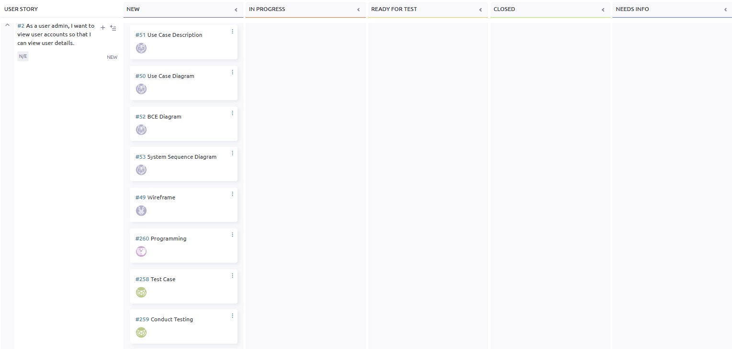

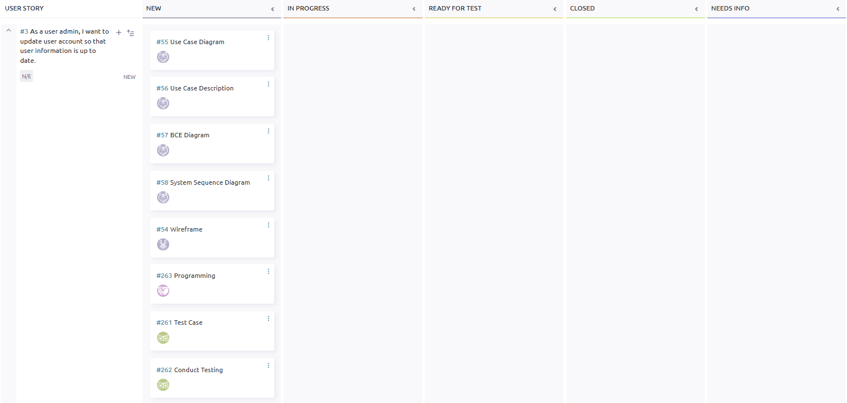

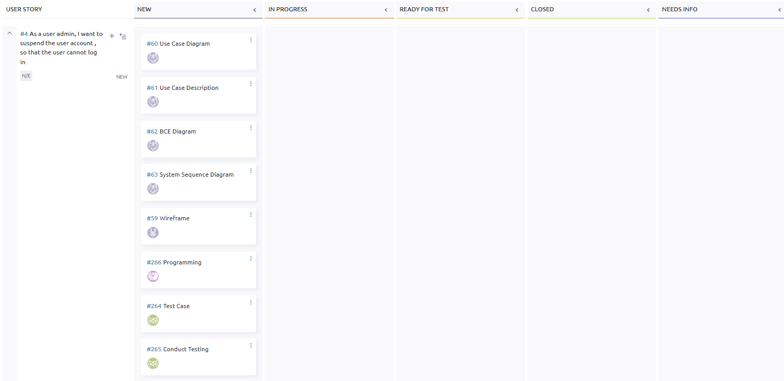

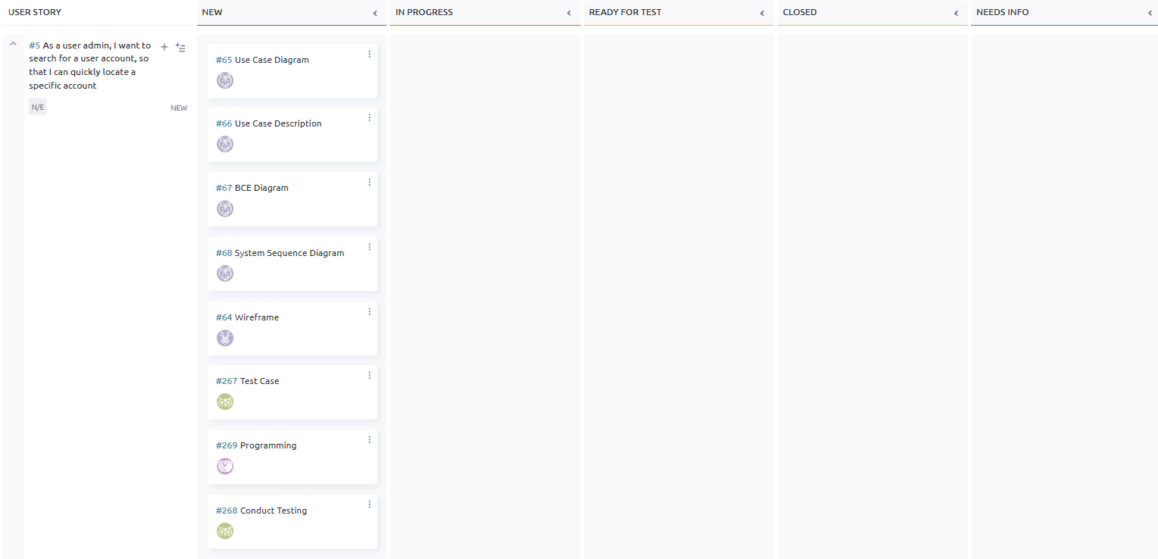

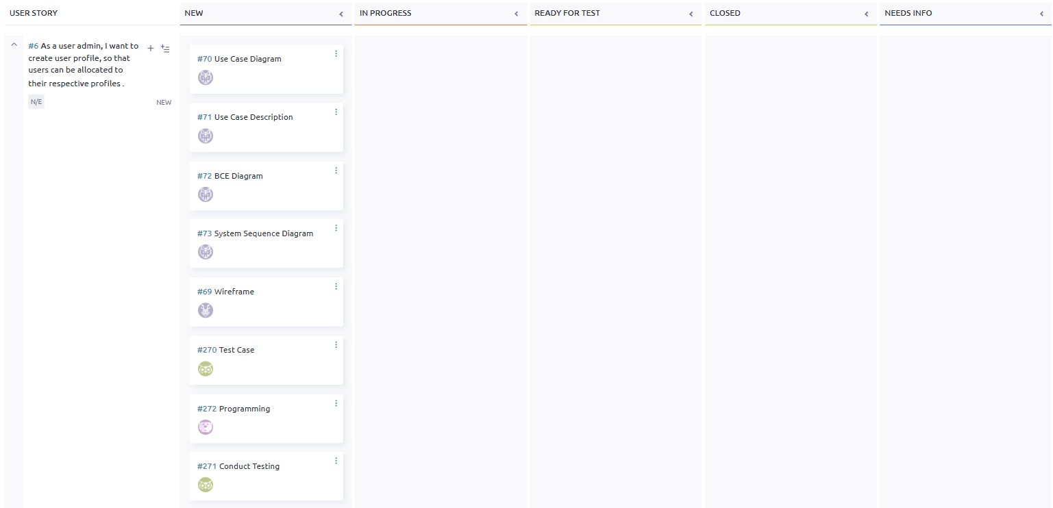

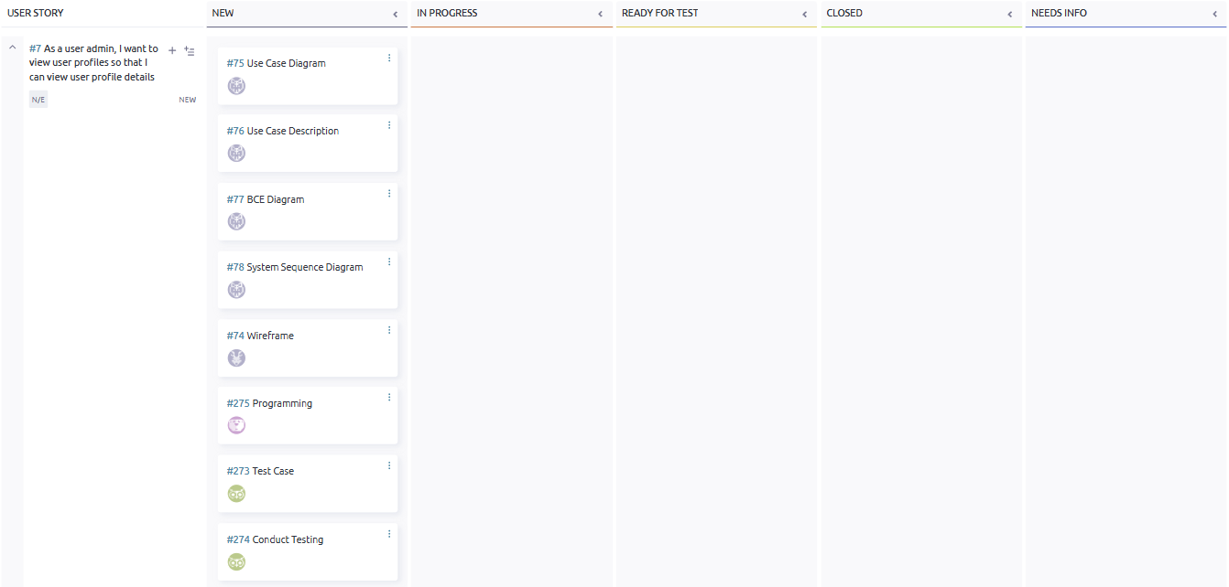

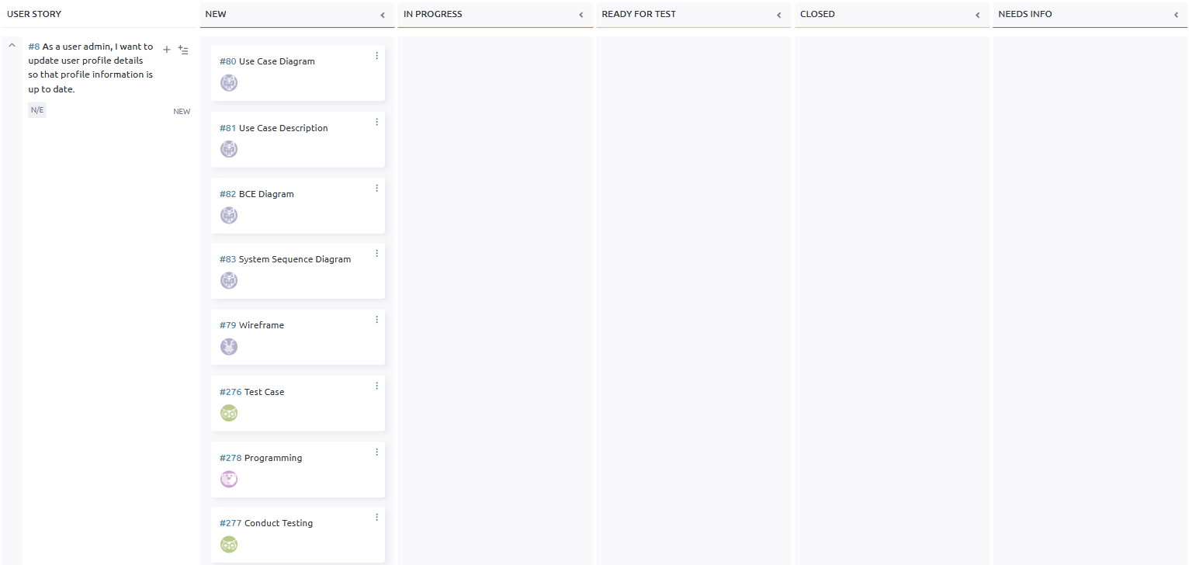

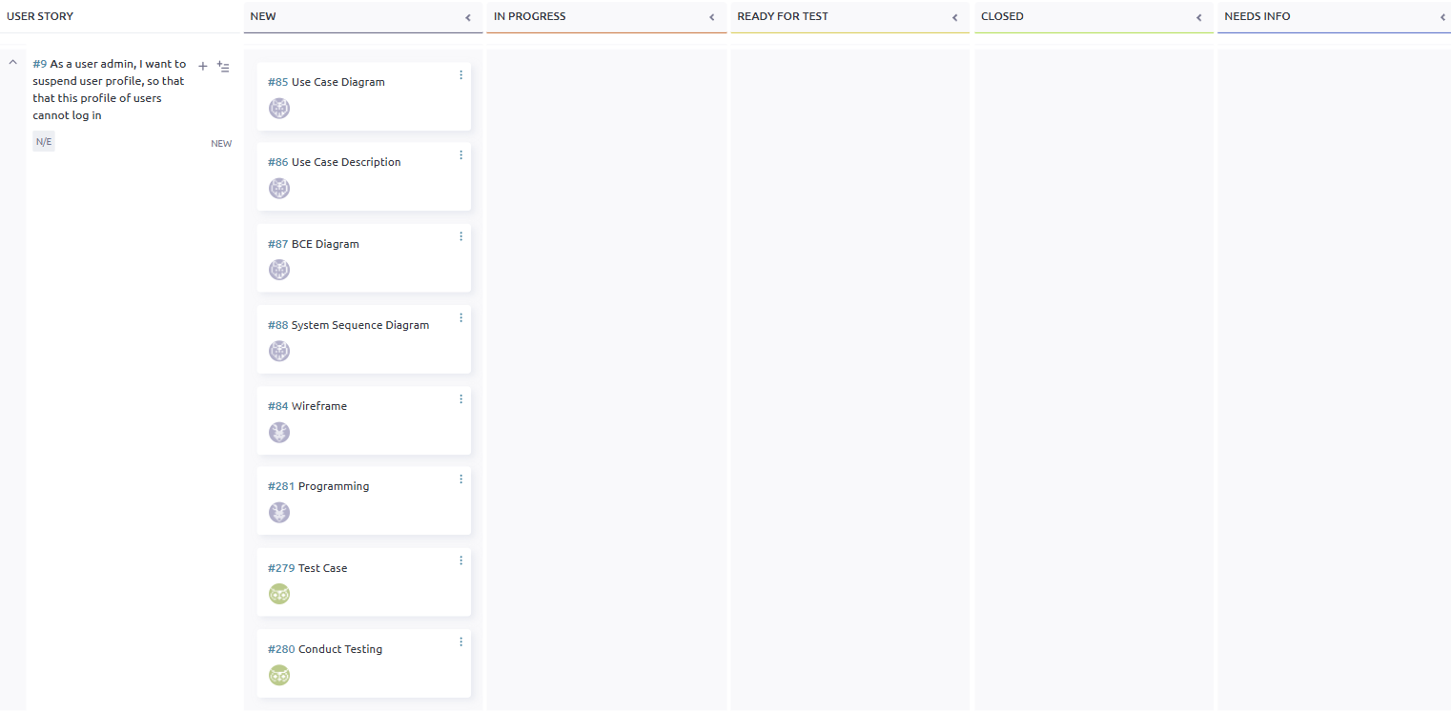

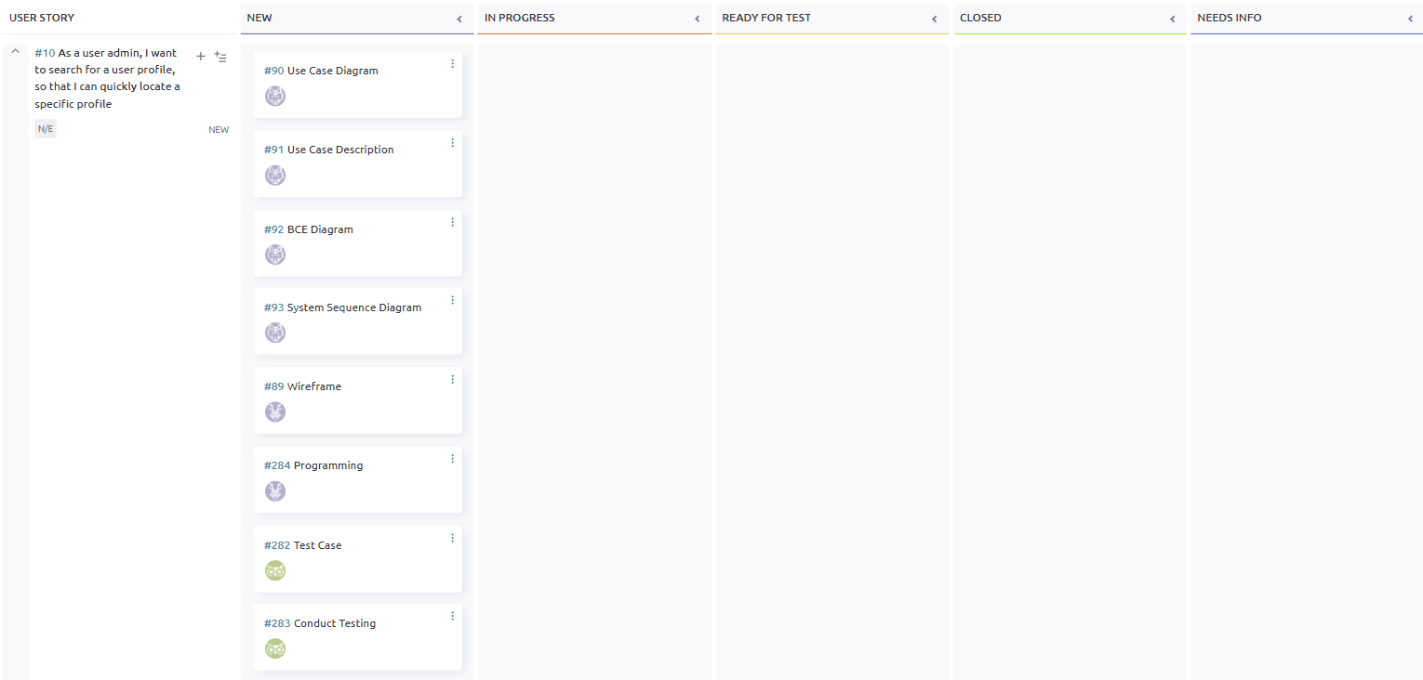

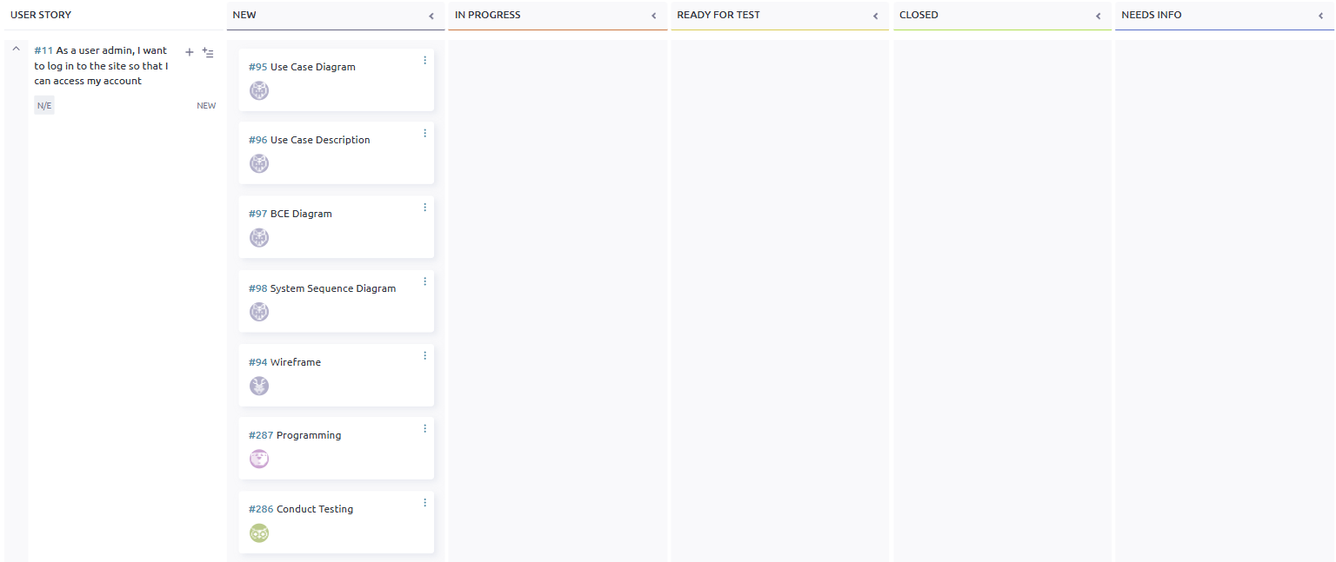

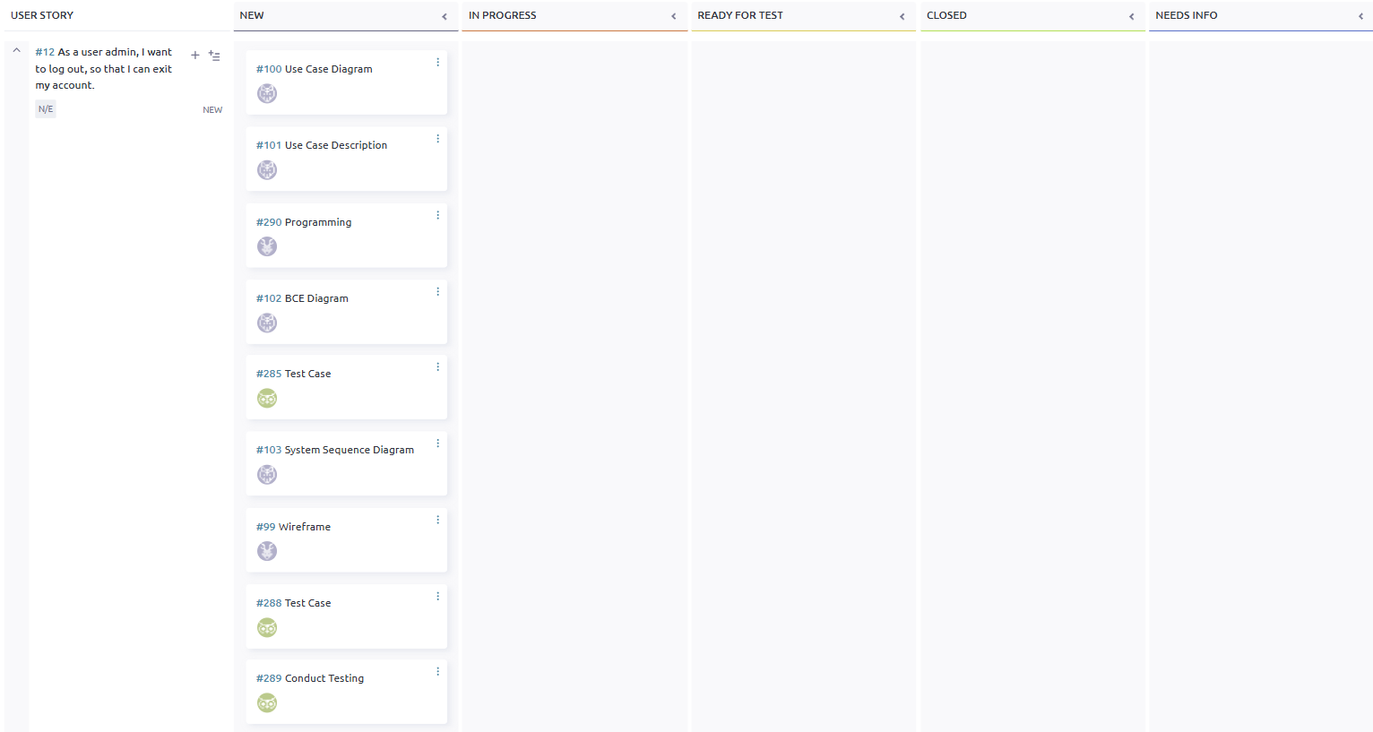

## **Taiga - End**

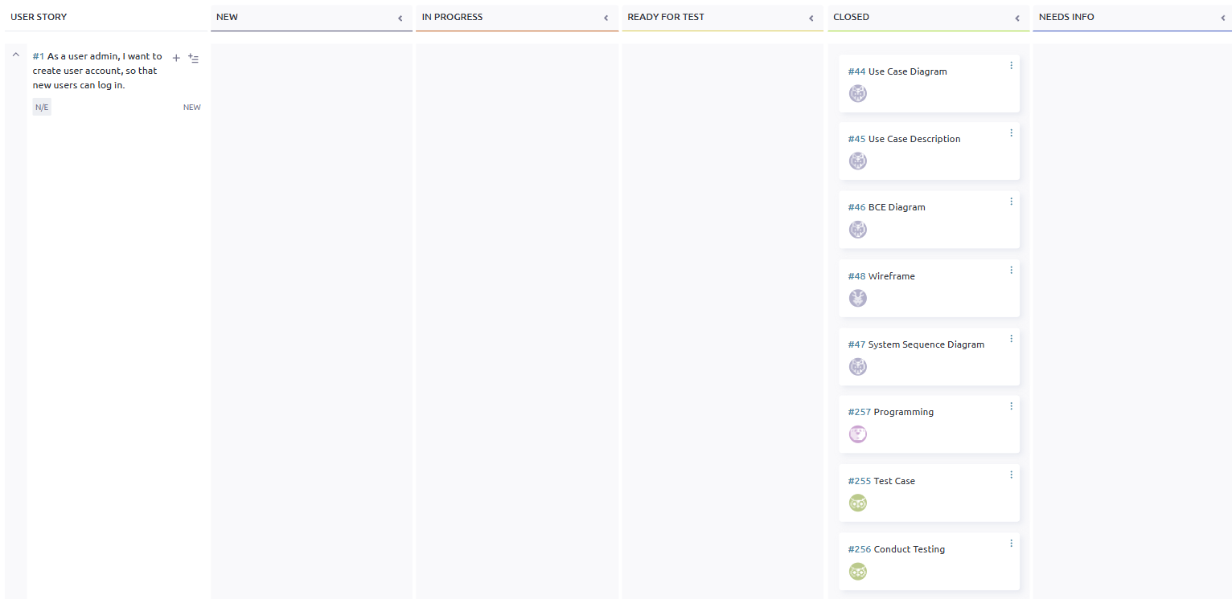

## 

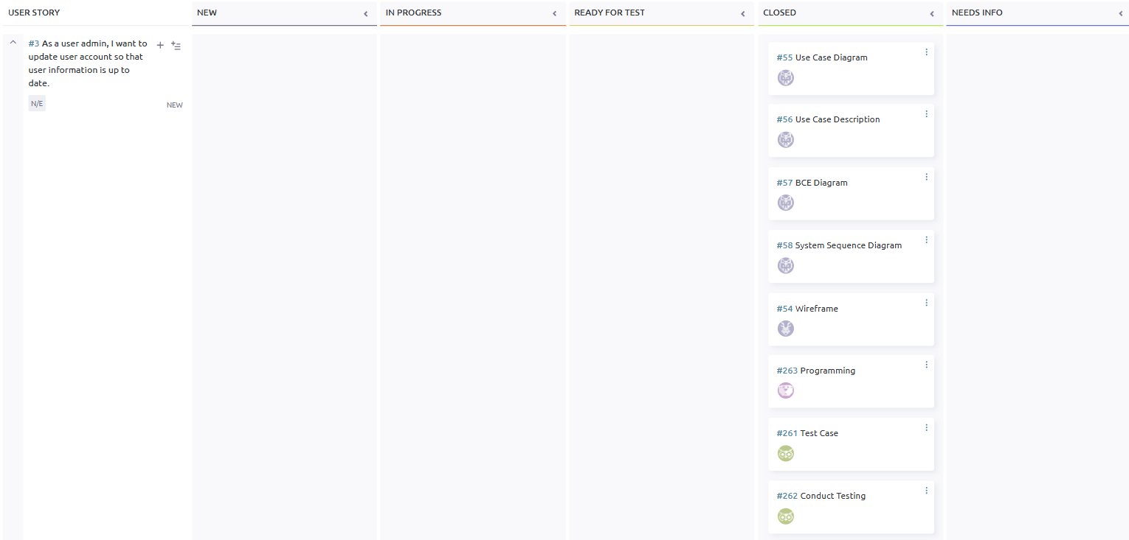

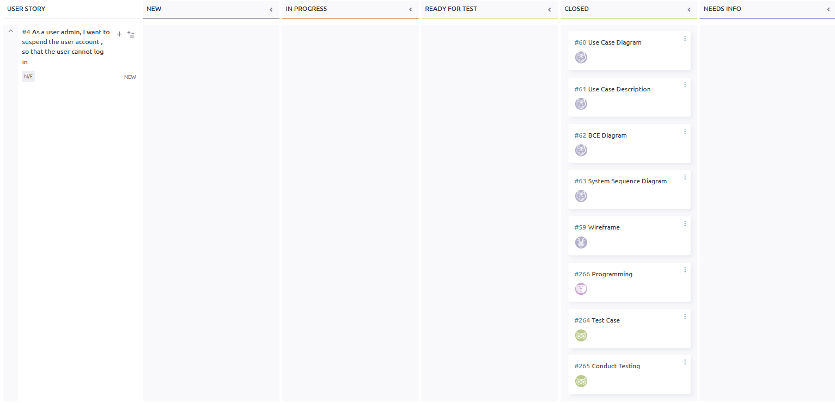

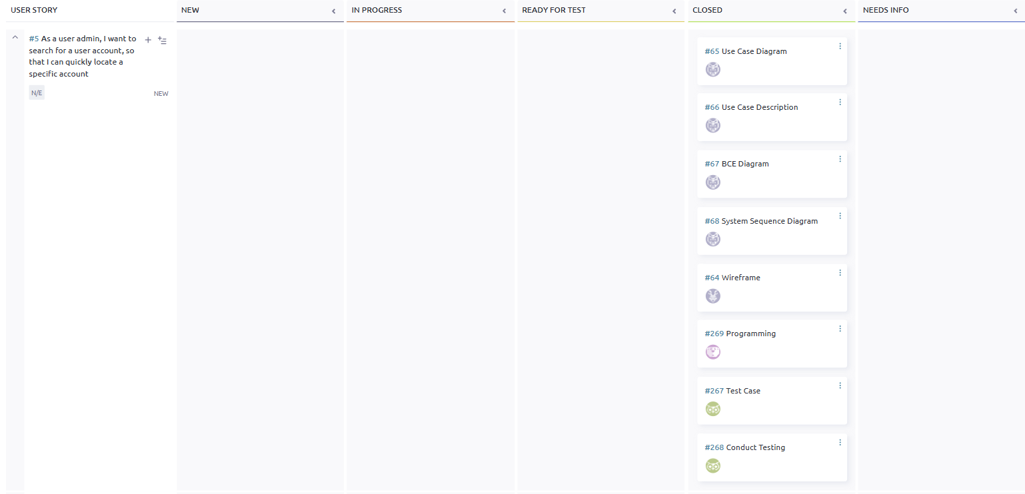

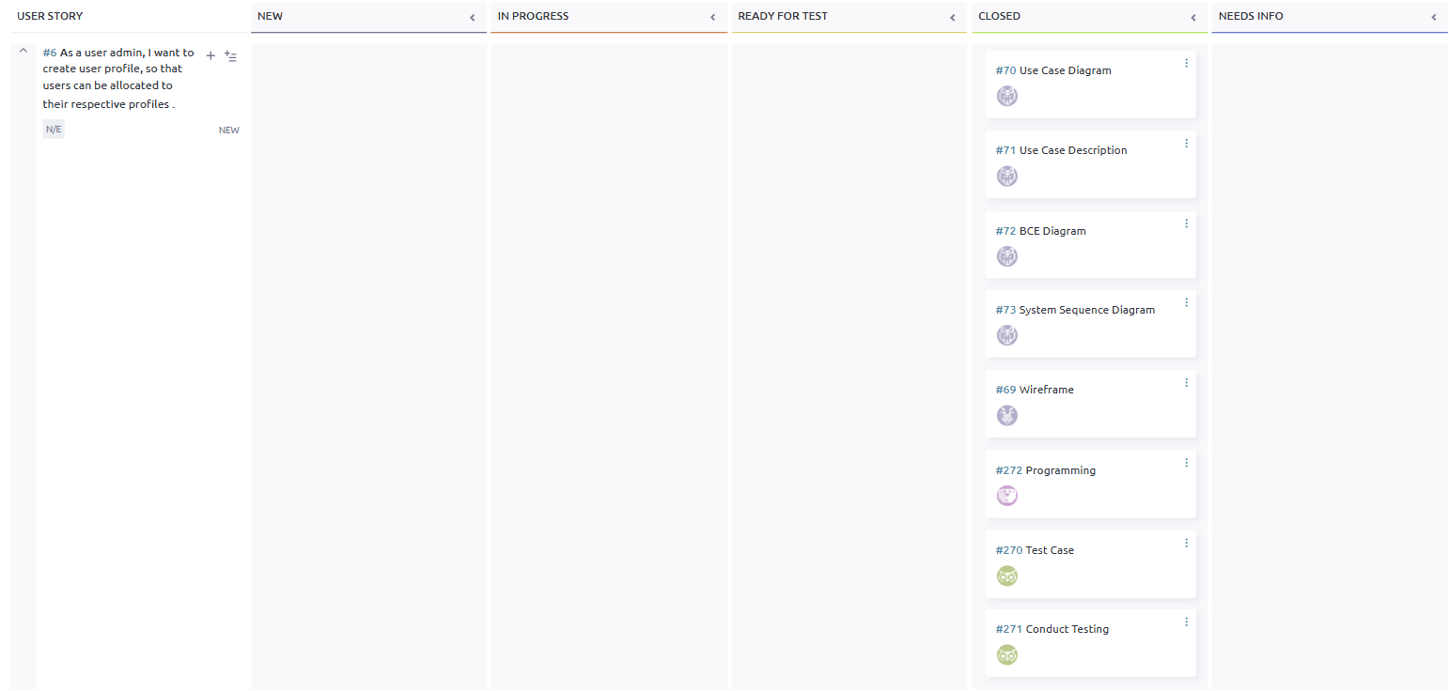

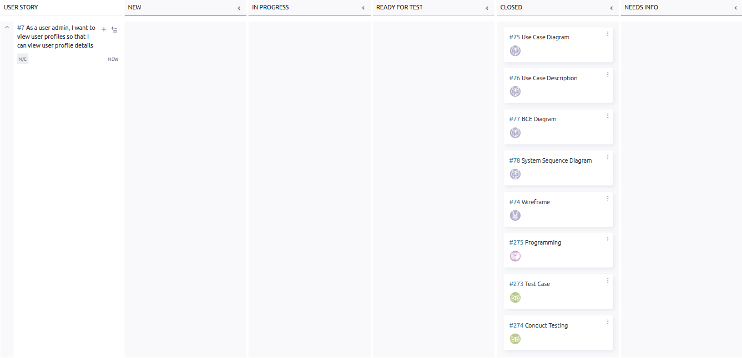

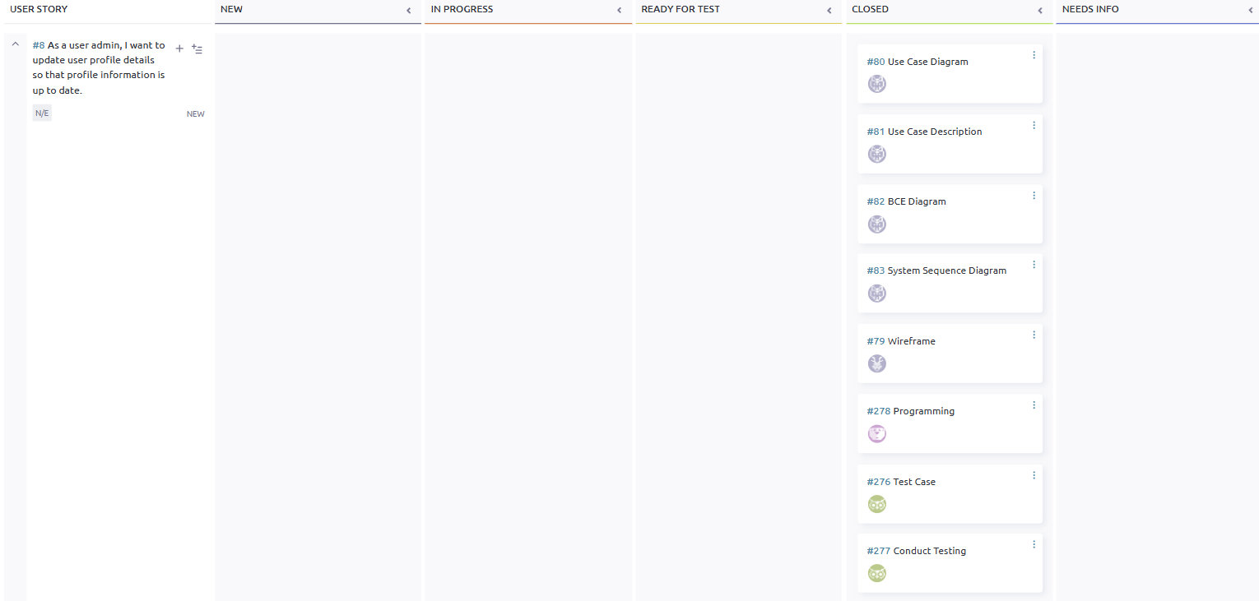

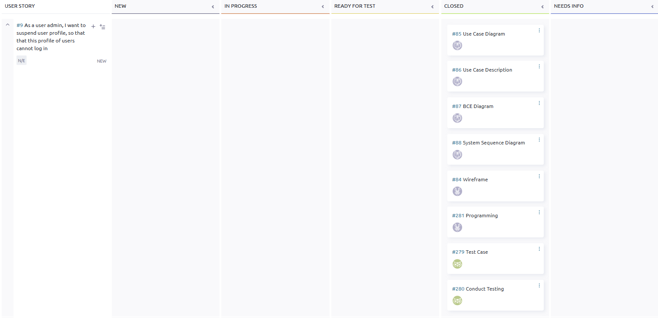

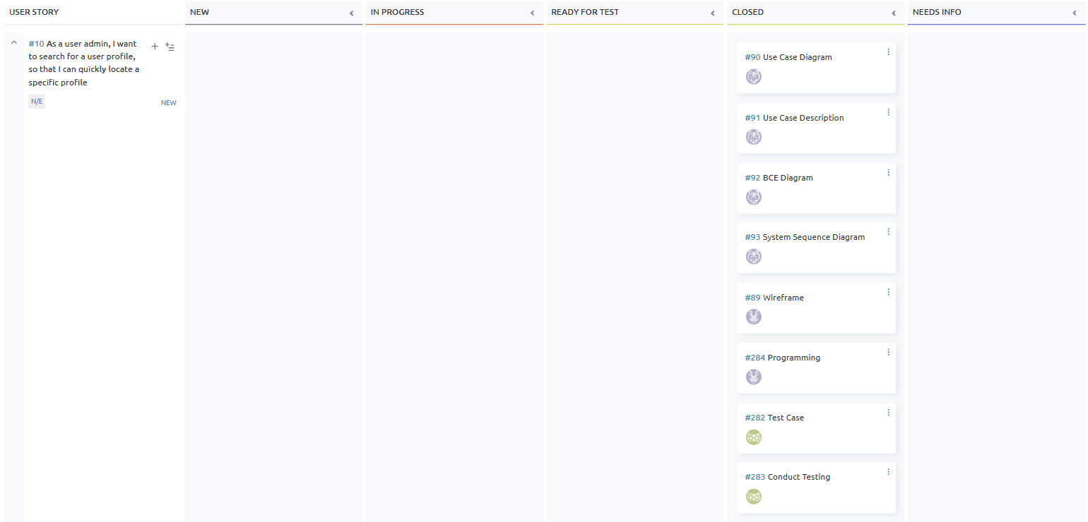

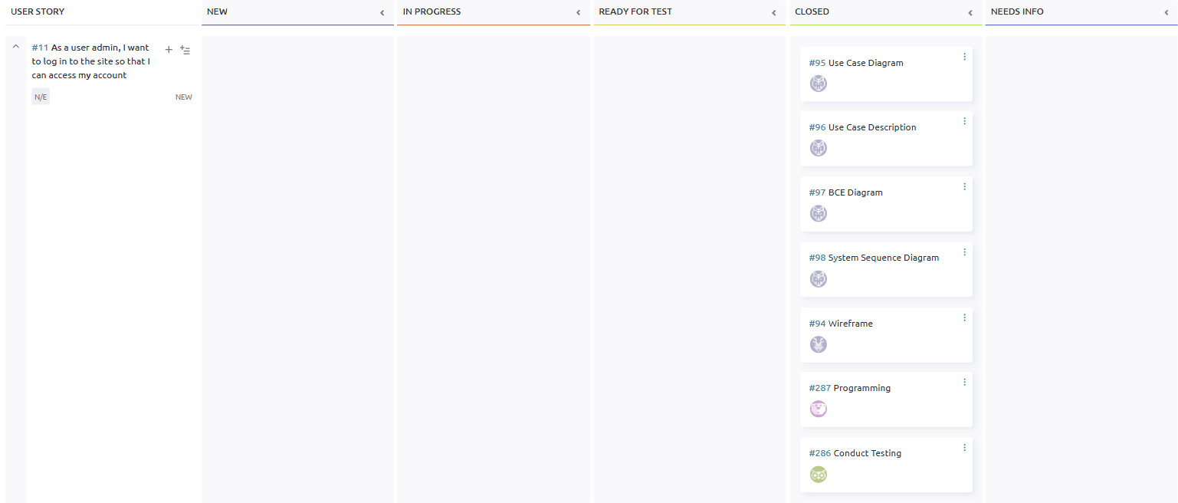

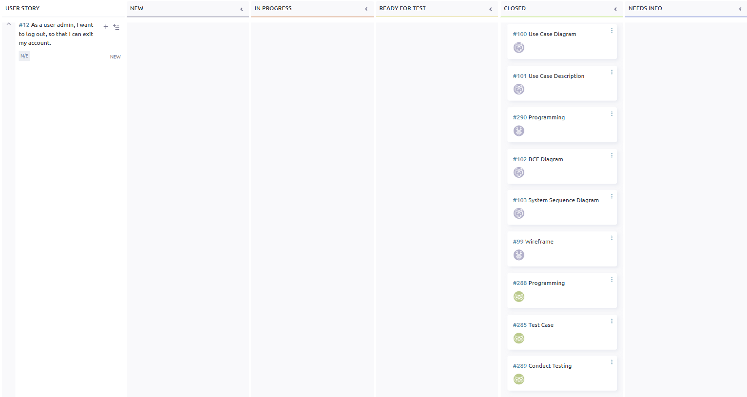

## **Entity Relationship Diagram**

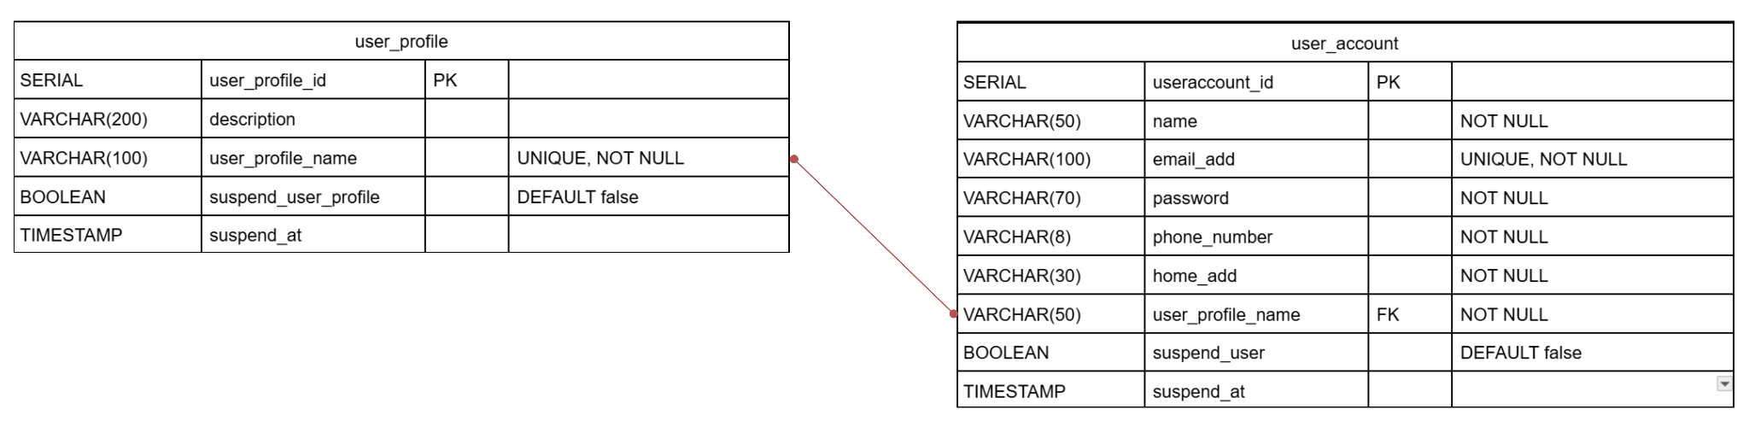

## 

## **Class Diagram**

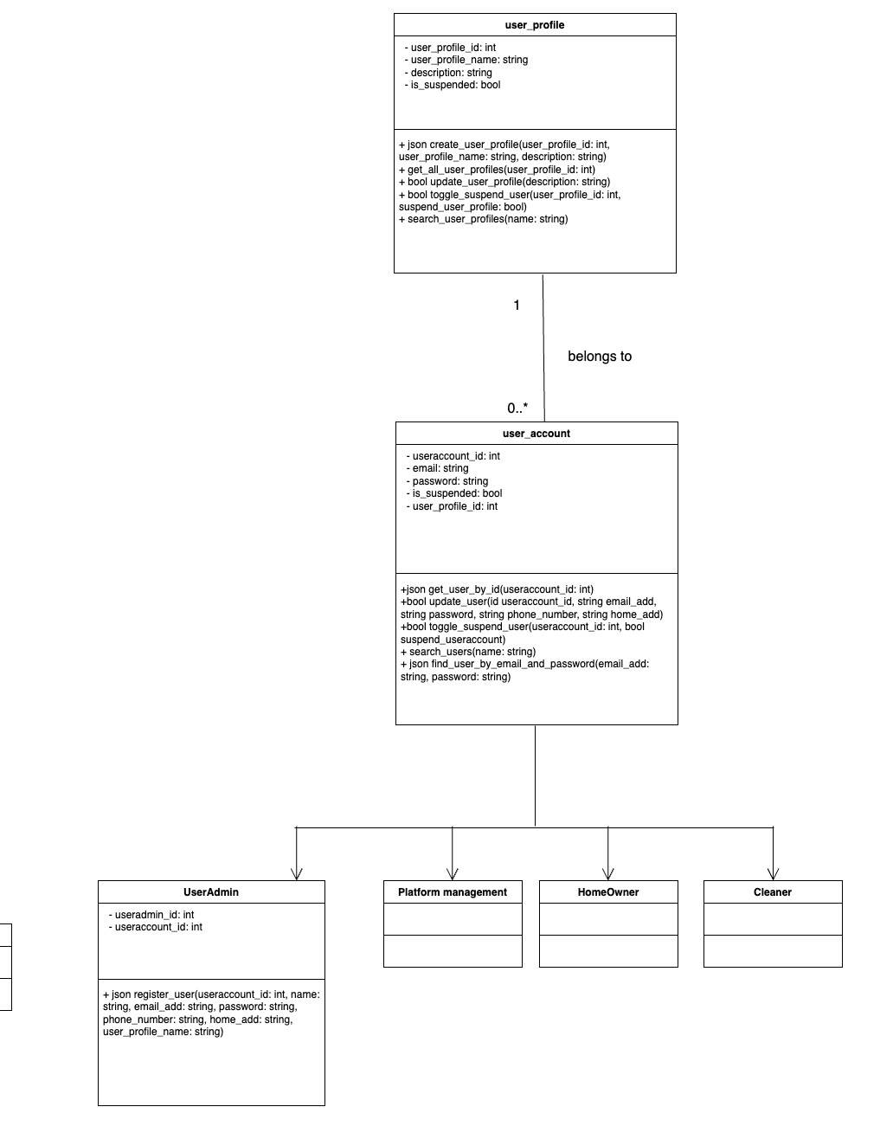

## **#1. User Admin - Create User Account**

User Stories

As a user admin, I want to create a user account, so that new users can log in.

| Use Case Diagram Taiga ID#44 |
| --- |
|  |

| Use Case Description Taiga ID# 45 |
| --- |
| **Name :** User Admin - Create User Account |
| **Stakeholders and goals :** User Admin – wants to create accounts to allow new users to log in. |
| **Description :** This allows a User Admin to create a user account. The admin fills in required user information such as name, email, and password. Once created, users can then login using their credentials to access the system. |
| **Actors :** User Admin |
| **Pre-condition(s) :** User Admin is logged in |
| **Trigger :** User Admin decides to create a new user account |
| **Normal flow :**   1. Admin selects “+ ADD USER” button 2. System displays account creation form 3. User Admin enters user details and submits form 4. System validates input 5. System saves the user account and confirms creation |
| **Sub-flows :** None |
| **Alternative/Exceptional flows :**  4a. Email Exists: system shows an error indicating the email is already in use |

| BCE Diagram Taiga ID# 46 |
| --- |
|  |

| Sequence Diagram Taiga ID#45 |
| --- |
|  |

| Wire Frame Taiga ID# 48 |
| --- |
|  |

Test Case Taiga ID# 255

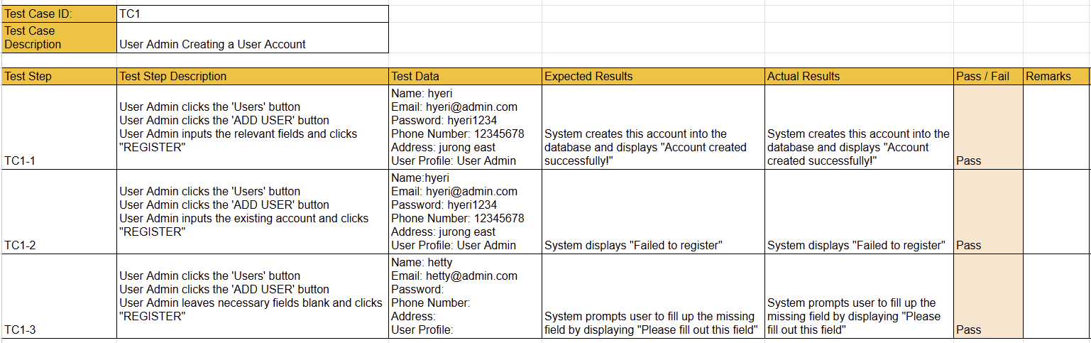

## **#2. User Admin - View User Account**

User story

As a user admin, I want to view a user account so that I can view the user details.

| Use Case Diagram Taiga ID# 50 |
| --- |
|  |

| Use Case Description Taiga ID#51 |
| --- |
| **Name :** User Admin - View User Account |
| **Stakeholders and goals :** User Admin – wants to view user details for management or reference purposes |
| **Description :** This allows an admin to view a user’s details |
| **Actors :** User Admin |
| **Pre-condition(s) :**  The user admin is logged in  There must have be least one User Account that exists in the system |
| **Trigger :** User Admin decides to view user account |
| **Normal flow :**   1. System displays a list of user accounts 2. Admin selects a user from the list and clicks on the name of the user 3. System displays the selected user's details |
| **Sub-flows :** None |
| **Alternative/Exceptional flows :** None |

| BCE Diagram Taiga ID#52 |
| --- |
|  |

| Sequence Diagram Taiga ID#53 |
| --- |
|  |

| Wire Frame Taiga ID# 49 |
| --- |
|  |

Test Case Taiga ID# 258

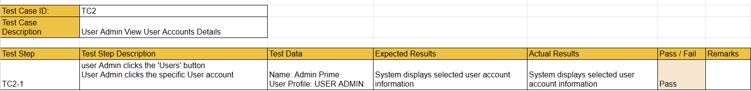

## **#3. User Admin - Update User Account**

User story

As a user admin, I want to update a user account so that user information is up to date.

| Use Case Diagram Taiga ID# 55 |
| --- |
|  |

| Use Case Description Taiga ID#56 |
| --- |
| **Name :** User Admin -Update User Account |
| **Stakeholders and goals :** User Admin – wants to update user information so that records remain accurate and up to date |
| **Description :** This allows an admin to modify details of an existing user account such as name, phone number or address |
| **Actors :** User Admin |
| **Pre-condition(s) :**  Admin is logged in  The user account to be updated must exist. |
| **Trigger :** Admin decides to update a user account |
| **Normal flow :**   1. System displays a list of user accounts 2. Admin clicks “EDIT” button on the user to update 3. System displays a form with the user’s current details 4. Admin updates the necessary fields and submits the form 5. System validates the input 6. System updates the user account and confirms success |
| **Sub-flows :** None |
| **Alternative/Exceptional flows :** None |

| BCE Diagram Taiga ID#57 |
| --- |
|  |

| Sequence Diagram Taiga ID#58 |
| --- |
|  |

| Wire Frame Taiga ID#54 |
| --- |
|  |

Test Case Taiga ID# 261

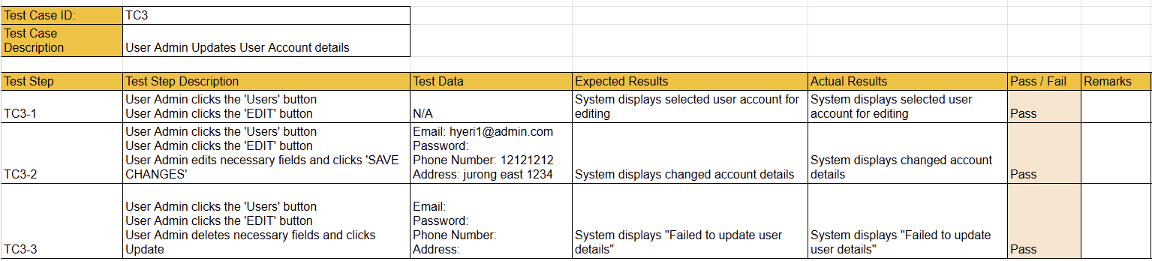

## **#4. User Admin - Suspend User Account**

User story

As a user admin, I want to suspend a user account, so that the user cannot log in

| Use Case Diagram Taiga ID#60 |
| --- |
|  |

| Use Case Description Taiga ID#61 |
| --- |
| **Name :** User AdminSuspend User Account |
| **Stakeholders and goals :** User Admin – wants to suspend user accounts to restrict access to the system |
| **Description :** This allows an admin to suspend a user account, preventing the user from logging in or accessing the platform until unsuspended. |
| **Actors :** User Admin |
| **Pre-condition(s) :**  Admin is logged in  User is not already suspended |
| **Trigger :** Admin decides to suspend a user account |
| **Normal flow :**   1. Admin navigates to the "Manage User Accounts" section 2. System displays a list of user accounts 3. Admin selects a user to suspend and clicks on the Suspend User toggle 4. System updates the user account status to "suspended" 5. System confirms that the account has been suspended |
| **Sub-flows :** None |
| **Alternative/Exceptional flows :** None |

| BCE Diagram Taiga ID#62 |
| --- |
|  |

| Sequence Diagram Taiga ID#63 |
| --- |
|  |

| Wire Frame Taiga ID#59 |
| --- |
|  |

Test Case Taiga ID# 264

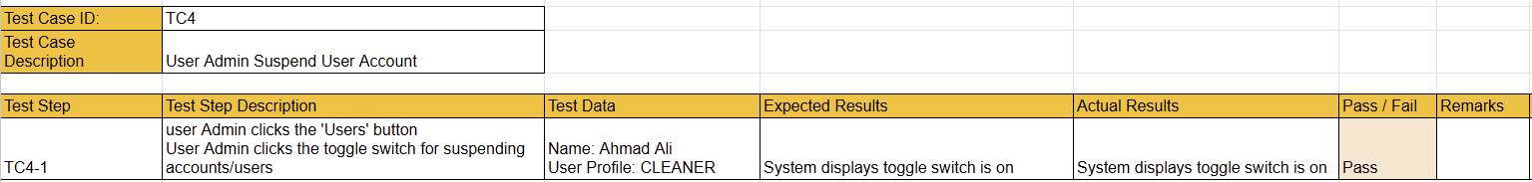

## 

## **#5. User Admin - Search User Account**

User story

As a user admin, I want to search for a user account, so that I can quickly locate a specific account

| Use Case Diagram Taiga ID#65 |
| --- |
|  |

| Use Case Description Taiga ID#66 |
| --- |
| **Name :** User Admin - Search User Account |
| **Stakeholders and goals :** User Admin – wants to quickly find a specific user account |
| **Description :** This allows an admin to search for user accounts using their name to locate specific users quickly. |
| **Actors :** User Admin |
| **Pre-condition(s) :** Admin is logged in |
| **Trigger :** Admin decides to search for a user account |
| **Normal flow :**   1. Admin enters a name into the search bar and clicks “Search” 2. System filters and displays matching user accounts |
| **Sub-flows :** None |
| **Alternative/Exceptional flows :**  2a. No User Found: Page shows that there is no user found |

| BCE Diagram Taiga ID#67 |
| --- |
|  |

| Sequence Diagram Taiga ID#68 |
| --- |
|  |

| Wire Frame Taiga ID#64 |
| --- |
|  |

Test Case Taiga ID# 267

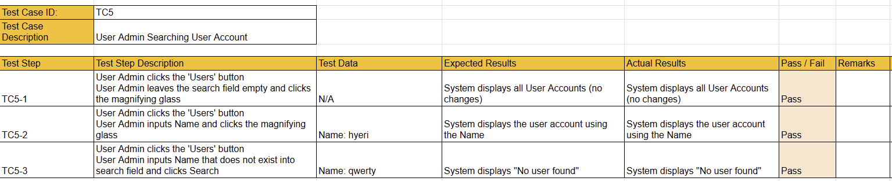

## 

## **#6. User Admin - Create User Profile**

User story

As a user admin, I want to create a user profile, so that users can be allocated to their respective profile .

| Use Case Diagram Taiga ID#70 |
| --- |
|  |

| Use Case Description Taiga ID#71 |
| --- |
| **Name :** User Admin **-** Create User Profile |
| **Stakeholders and goals :** User Admin – wants to create user profile so users can be organised and managed more efficiently |
| **Description :** This allows an admin to create a new user profile by providing details such as the profile name and description. The profile can later be used to assign users collectively. |
| **Actors :** User Admin |
| **Pre-condition(s) :** Admin is logged in |
| **Trigger :** User Admin decides to create a new user profile |
| **Normal flow :**   1. Admin selects “+ ADD PROFILE” 2. System displays profile creation form 3. User Admin enters profile details and submits form 4. System validates input 5. System saves the user profile and confirms creation |
| **Sub-flows :** None |
| **Alternative/Exceptional flows :**  3a. Profile Name Exists: system shows an error indicating the profile name is already taken |

| BCE Diagram Taiga ID#72 |
| --- |
|  |

| Sequence Diagram Taiga ID#73 |
| --- |
|  |

| Wire Frame Taiga ID#69 |
| --- |
|  |

Test Case Taiga ID# 270

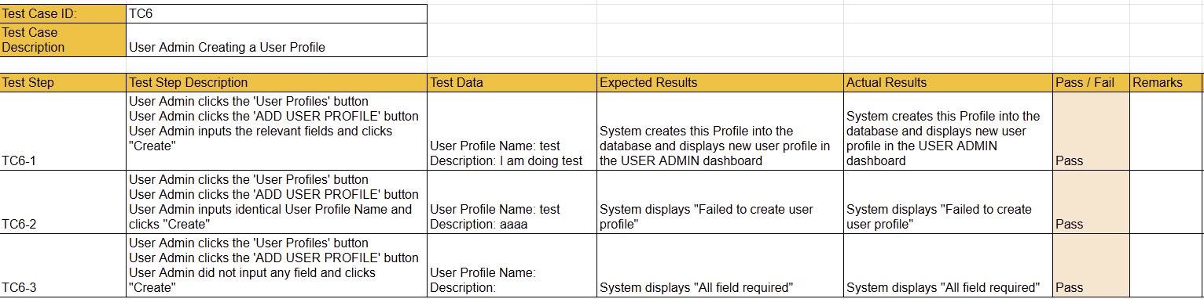

## **#7. User Admin - View** U**ser** P**rofile**

User story

As a user admin, I want to view user profiles so that I can view user profile details.

| Use Case Diagram Taiga ID#75 |
| --- |
|  |

| Use Case Description Taiga ID#76 |
| --- |
| **Name :** User Admin - View User Profiles |
| **Stakeholders and goals :** User Admin - wants to view all user profiles for review or management |
| **Description :** This allows an admin to view a list of existing user profiles and see details such as profile name and description |
| **Actors :** User Admin |
| **Pre-condition(s) :**  User Admin is logged in  There must have be least one User Profile that must exist in the system |
| **Trigger :** Admin decides to view user profiles |
| **Normal flow :**   1. System displays a list of user profiles such as well as details such as name and description |
| **Sub-flows :** None |
| **Alternative/Exceptional flows :** None |

| BCE Diagram Taiga ID#77 |
| --- |
|  |

| Sequence Diagram Taiga ID#78 |
| --- |
|  |

| Wire Frame Taiga ID#74 |
| --- |
|  |

Test Case Taiga ID# 273

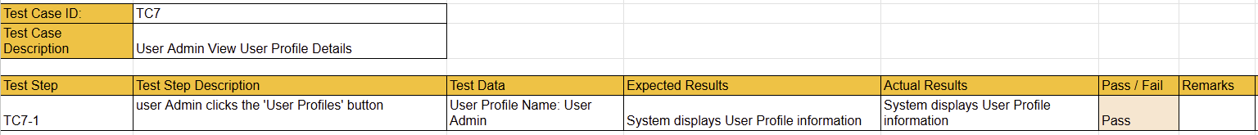

## **#8. User Admin - Update User** P**rofile**

User story

As a user admin, I want to update user profile details so that profile information is up to date.

| Use Case Diagram Taiga ID#80 |
| --- |
|  |

| Use Case Description Taiga ID#81 |
| --- |
| **Name :** User Admin - Update User Profile |
| **Stakeholders and goals :** User Admin - wants to update user profile details so the information remains accurate and current |
| **Description :** This allows an admin to modify the details of an existing user profile, such as the profile name or description. |
| **Actors :** User Admin |
| **Pre-condition(s) :**  User Admin is logged in  The user profile to be updated must exist. |
| **Trigger :** Admin decides to update a user profile |
| **Normal flow :**   1. System displays a list of user profiles 2. Admin clicks “EDIT” button on the user profile to update 3. System displays the current profile details in an editable form 4. Admin updates the necessary fields and submits the form 5. System validates the input 6. System updates the profile and confirms success |
| **Sub-flows :** None |
| **Alternative/Exceptional flows :** None |

| BCE Diagram Taiga ID#82 |
| --- |
|  |

| Sequence Diagram Taiga ID#83 |
| --- |
|  |

| Wire Frame Taiga ID#79 |
| --- |
|  |

Test Case Taiga ID# 276

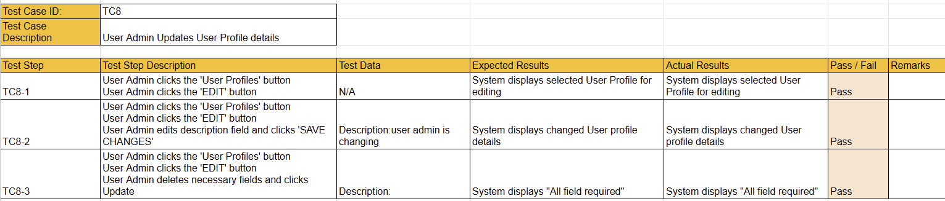

## **#9. User Admin - Suspend User** P**rofile**

User story

As a user admin, I want to suspend user profile, so that that this profile of users cannot log in

| Use Case Diagram Taiga ID#85 |
| --- |
|  |

| Use Case Description Taiga ID#86 |
| --- |
| **Name :** User Admin - Suspend User profile |
| **Stakeholders and goals :** User Admin - wants to suspend user profile so that users within the profile cannot log in |
| **Description :** This allows an admin to suspend a user profile, which prevents all users in that profile from accessing the system until reactivated. |
| **Actors :** User Admin |
| **Pre-condition(s) :**  User Admin is logged in  User Profile is not already suspended |
| **Trigger :** Admin decides to suspend a user profile |
| **Normal flow :**   1. System displays a list of user profiles 2. Admin selects a profile to selects a user profile to suspend and clicks on the Suspend user profile toggle 3. System updates the profile status to "suspended" 4. System confirms the profile has been suspended and users belonging to that profile can no longer log in |
| **Sub-flows :** None |
| **Alternative/Exceptional flows :** None |

| BCE Diagram Taiga ID#87 |
| --- |
|  |

| Sequence Diagram Taiga ID#88 |
| --- |
|  |

| Wire Frame Taiga ID#84 |
| --- |
|  |

Test Case Taiga ID# 279

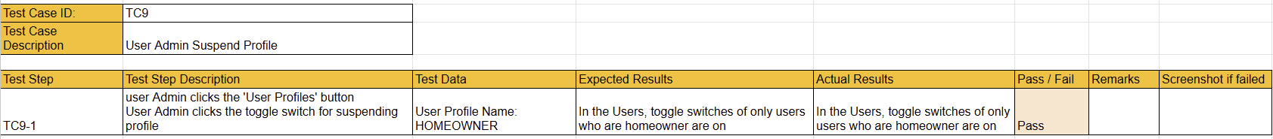

## 

## 

## **#10.User Admin - Search User Profile**

User story

As a user admin, I want to search for a user profile, so that I can quickly locate a specific profile.

| Use Case Diagram Taiga ID#90 |
| --- |
|  |

| Use Case Description Taiga ID#91 |
| --- |
| **Name :** User Admin **-** Search User Profile |
| **Stakeholders and goals :** User Admin - wants to quickly find a user profile for review or management |
| **Description :** This allows an admin to search for a user profile using keywords like profile name to locate a specific profile quickly. |
| **Actors :** User Admin |
| **Pre-condition(s) :**  User Admin is logged in |
| **Trigger :** Admin decides to search for a User Profile |
| **Normal flow :**   1. Admin enters a profile name into the search bar and clicks “Search” 2. System filters and displays matching user profiles |
| **Sub-flows :** None |
| **Alternative/Exceptional flows :**  3a. No Results Found: system shows a message indicating no matches for the entered keyword |

| BCE Diagram Taiga ID#92 |
| --- |
|  |

| Sequence Diagram Taiga ID#93 |
| --- |
|  |

| Wire Frame Taiga ID#89 |
| --- |
|  |

Test Case Taiga ID# 282

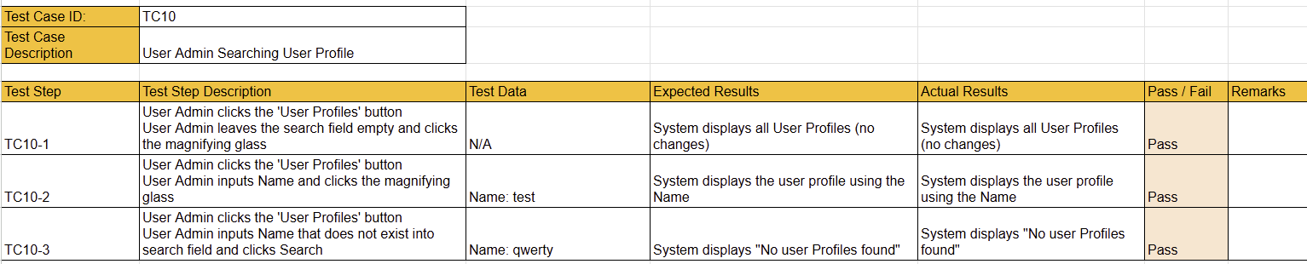

## 

## **#11. User Admin - Login**

User story

As a user admin, I want to log in to the site so that I can access my account

| Use Case Diagram Taiga ID#95 |
| --- |
|  |

| Use Case Description Taiga ID#96 |
| --- |
| **Name :** User Admin - Login |
| **Stakeholders and goals :** User Admin - wants to access their account to perform administrative tasks |
| **Description :** This allows an admin to log in to the site by providing valid credentials to access their account and admin functionalities. |
| **Actors :** User Admin |
| **Pre-condition(s) :**  User Admin has a valid user account  User Admin Account/Profile is not Suspended |
| **Trigger :** User Admin decides to log in to the site |
| **Normal flow :**   1. System displays the login form 2. Admin enters email and password 3. Admin submits the form 4. System validates credentials 5. System grants access and redirects the admin to the Admin dashboard |
| **Sub-flows :** None |
| **Alternative/Exceptional flows :**  4.a. Invalid Credentials: System displays error message |

| BCE Diagram Taiga ID#97 |
| --- |
|  |

| Sequence Diagram Taiga ID#98 |
| --- |
|  |

| Wire Frame Taiga ID#94 |
| --- |
|  |

Test Case Taiga ID# 383

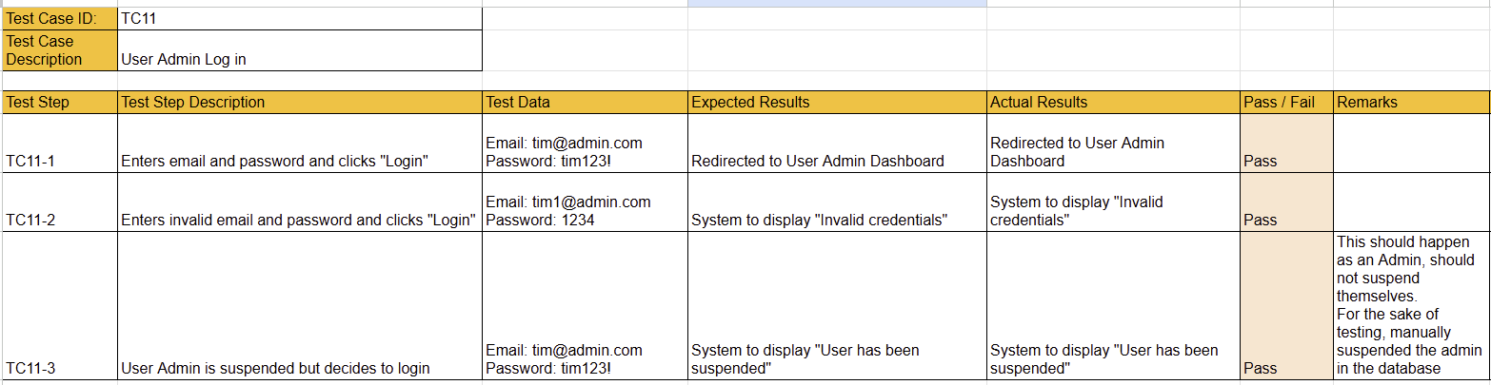

## **#12. User Admin - Logout**

User story

As a user admin, I want to log out, so that I can exit my account.

| Use Case Diagram Taiga ID#100 |
| --- |
|  |

| Use Case Description Taiga ID#101 |
| --- |
| **Name :** User Admin - Logout |
| **Stakeholders and goals :** User Admin - wants to exit their account after use |
| **Description :** This allows an admin to log out of the system, ending the current session |
| **Actors :** User Admin |
| **Pre-condition(s) :** User Admin is logged in |
| **Trigger :** Admin decides to log out |
| **Normal flow :**   1. User Admin clicks on the “Logout” button 2. The system terminates the current session. 3. System redirects the User Admin to the login page |
| **Sub-flows :** None |
| **Alternative/Exceptional flows :** None |

| BCE Diagram Taiga ID#102 |
| --- |
|  |

| Sequence Diagram Taiga ID#103 |
| --- |
|  |

| Wire Frame Taiga ID#99 |
| --- |
|  |

Test Case Taiga ID# 285



## **Test Driven Development**

We used postman, a popular API testing platform, to send raw requests to the website’s API, to test if the API is working as intended.

We tested the login api route, /api/login , and included a set of valid credentials.

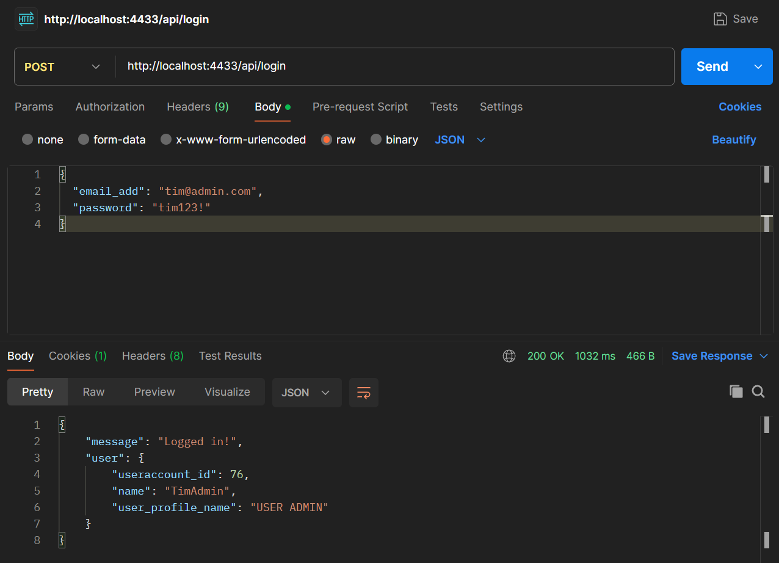

As expected, the app returns that the credentials are valid hence “Logged in” is observed

Conversely, when invalid credentials are provided, the app responds expectedly.

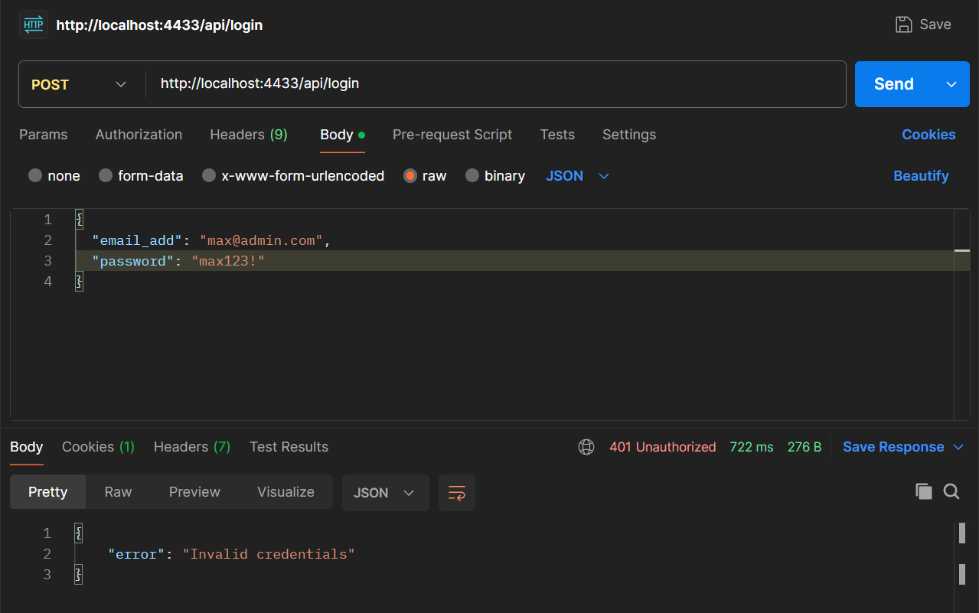

## 

## 

## 

## 

## 

## 

## 

## 

## 

## 

# **Sprint 2**

**Duration: 8th April - 21th April**

## Sprint Planning, Review and Retrospective

| **Meeting Date:**  12th April | |
| --- | --- |
| **Duration:** 9:00am - 11:00am | |
| **Sprint Duration:** 8th April - 21th April | |
| **Attendees:** 7/7 | **Agenda** |
| 1. Go through Wireframe flow.  2. Add function names for each action (to help with Sequence Diagrams).  3. Check and answer queries and doubts.  4. Decide on needed databases and their columns.  5. Check for additional deliverables.  6. Allocate/reallocate manpower resources.  7. Need additional QC personnel for diagrams (check with Terence on 21st).  8. Confirmation for DevDay Timing and Agenda.  9. Standardise single Login & Logout diagrams.  10. Update Class Diagram |
| **Absentees:** N/A |
|
| **What has been done during this meeting.** | - Reviewed and adjusted diagrams based on Wireframe Flow.  - Added function names to actions for easier sequence diagram drawing.  - Confirmed need for iterative updates for SSD and BCE diagrams during coding.  - Discussed additional deliverables and manpower allocation.  - Standardised Login and Logout diagrams. |
| **What we are going to do until the next meeting.** | ● Update all diagrams according to the Wireframe flow.  ● Check diagrams with Terence (email or on 21st April).  ● Homework (All Members): SQL table suggestions for the User Story you are doing — due 14 April (paste into Figma).  ● Homework (Tim): Expose Express server to Docker image — due 14 April.  ● Synchronise Login/Logout:  → Taiga ID 11 (logIn)  → Taiga ID 39 (logOut) |

| **Meeting Date:** 19 th April | |
| --- | --- |
| **Duration:** 9am - 11am | |
| **Sprint Duration:** 8th April - 21th April | |
| **Attendees:** 5/7 | **Agenda** |
| | 1. Progress Check (update, no need to complete).  2. Go through Class Diagram flow.  3. Match database tables with Class Diagram requirements.  4. Standardise method and variable names.  5. Standardise database relations.  6. Confirm password hashing function (SHA256).  7. Allocate remaining tasks and roles.  8. Discuss Master Report Document Formatting.  9. List queries for Terence (for 21st April).  10. Peer check BCE and Sequence Diagrams. | | --- | |
| **Absentees:** Leong jie and Hailey |
|
| **What has been done during this meeting.** | - Progress updates and checking for all members.  - Reviewed Class Diagram and confirmed database table requirements.  - Started standardising method names, variable names, and DB structure.  - Allocated remaining tasks clearly among team members.  - Decided to use SHA256 for password hashing.  - Started preparing Master Report structure. |
| **What we are going to do until the next meeting.** | ● Wayne: Set up SHA256 password hashing; Update & Populate Database; Update Meeting Records; Data Persistence Diagram.  ● Yangxuan: Fill in Report (sections); Research on Data Driven Development and Ethical Considerations.  ● Hailey: Finalise Class Diagram; Fill in Report (sections); Research on Data Driven Development and Ethical Considerations.  ● Hyeri: Manage Taiga Board; Write and Test Test Cases; Fill in Sprint Start/End in Report.  ● Yi Jia: Draw Diagrams; Organise User Story Folder.  ● Leong Jie: Update Gantt Chart; Check Test Cases and suggest additional tests; Screen Record Demo.  ● Timothy: Continue Full Stack Web Development; Draw Remaining Diagrams. |

## **Taiga - Start**

## 

## 

## 

## 

## 

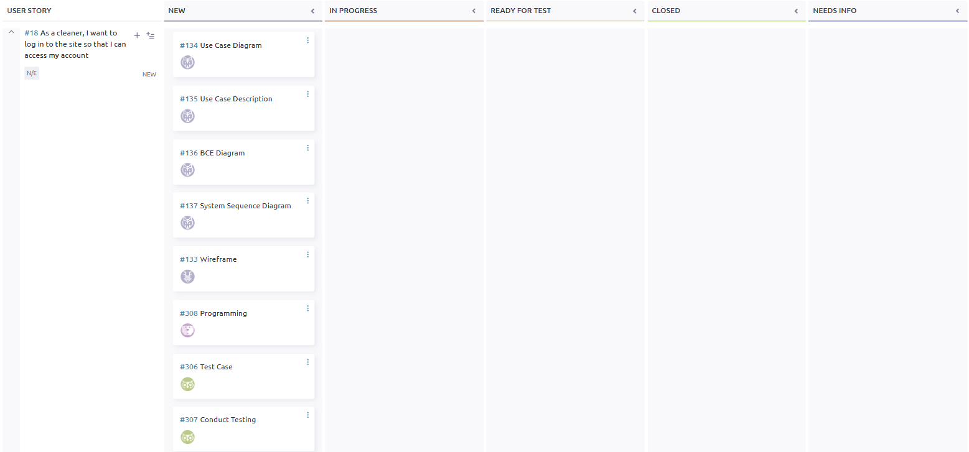

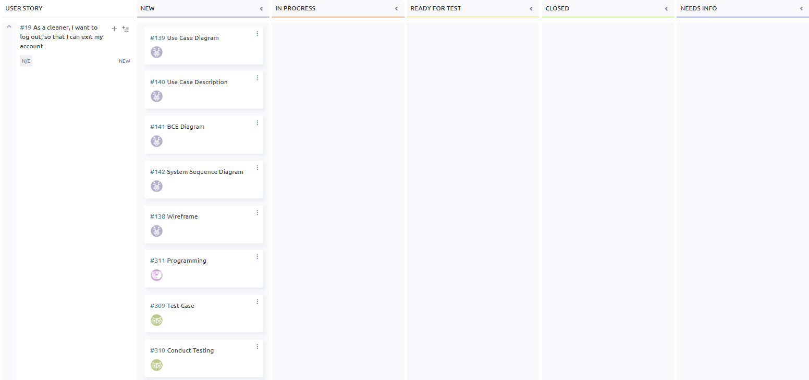

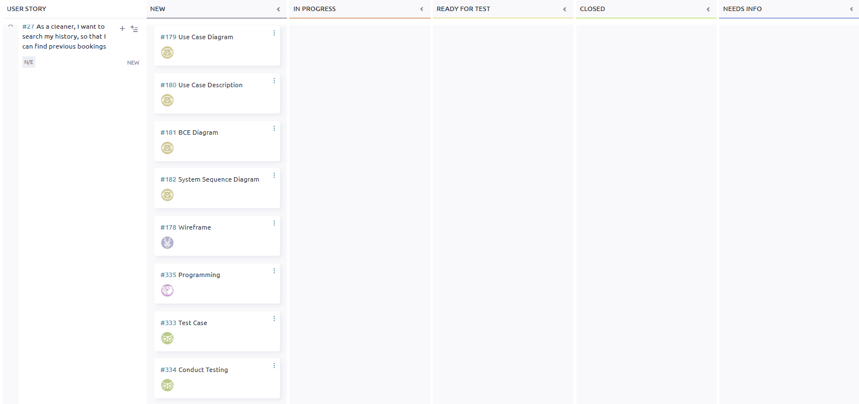

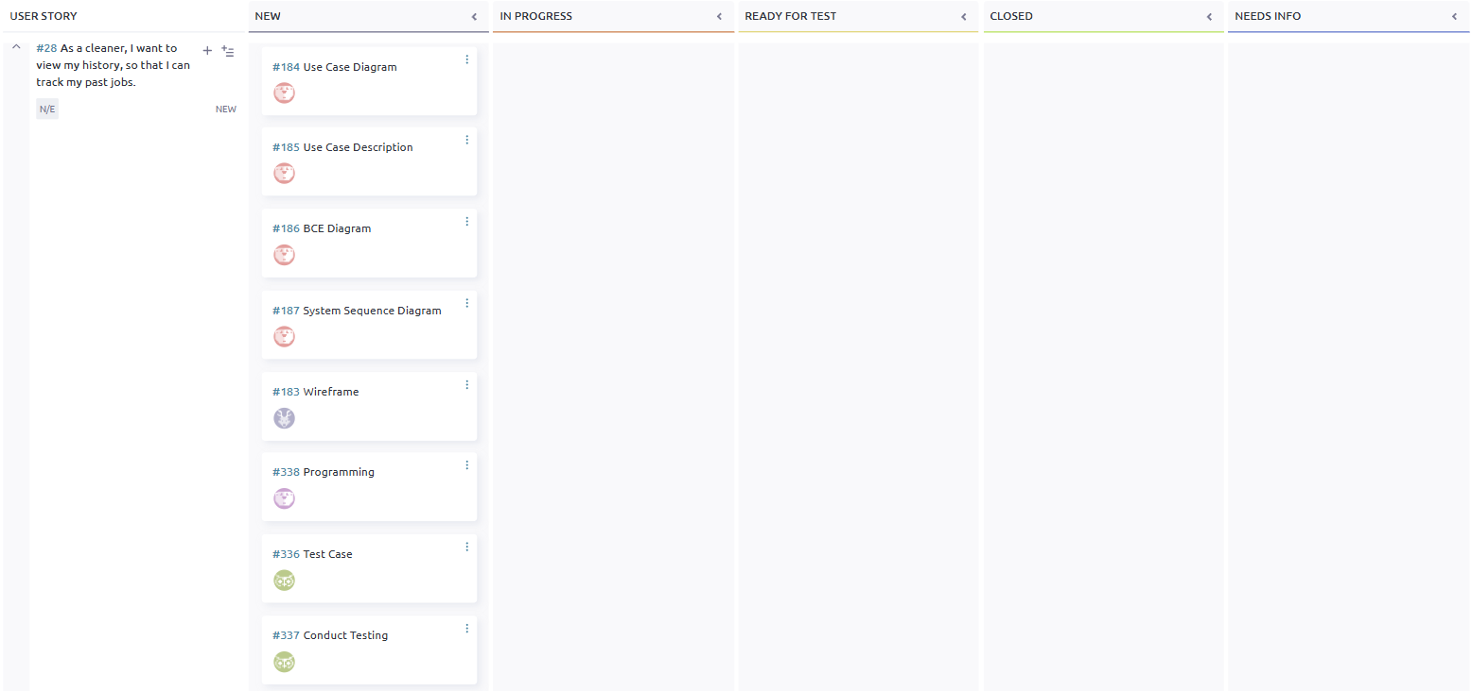

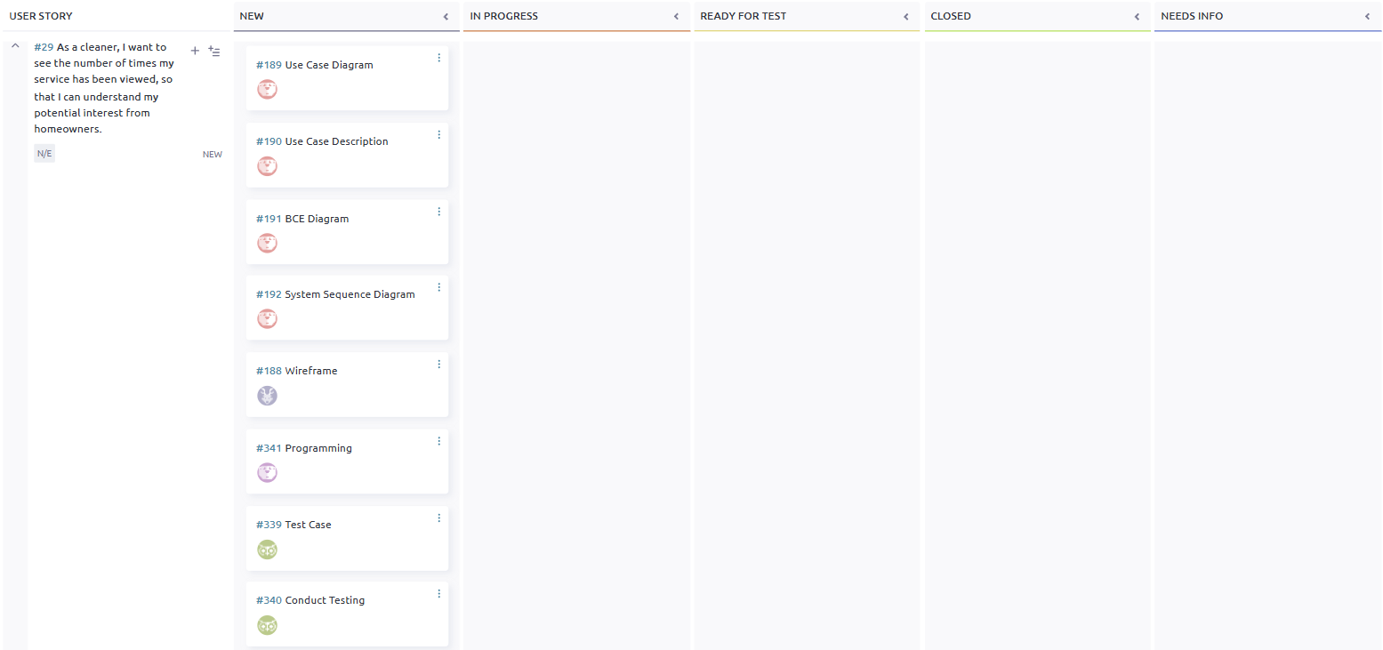

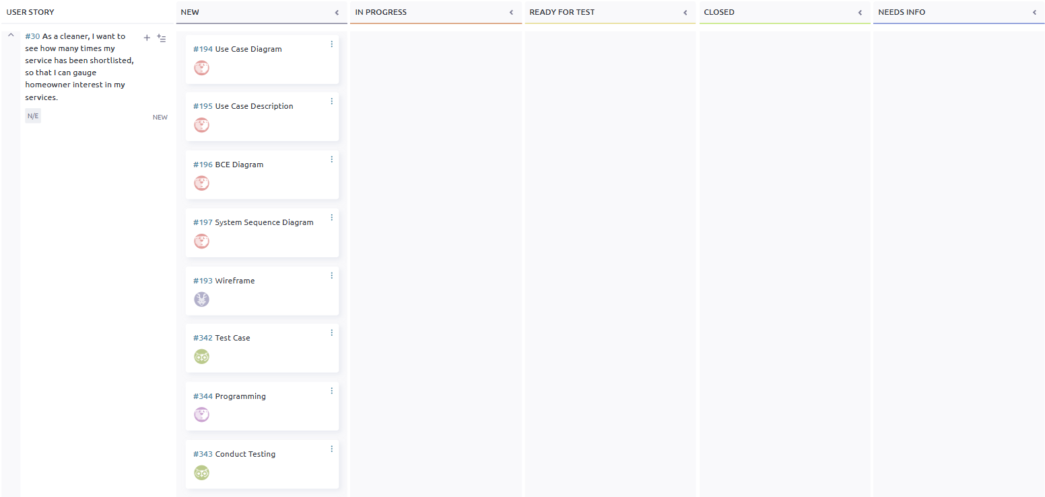

## 

## **Taiga - End**

## 

## 

## 

## 

## 

## 

## 

## 

## 

## 

## 

## **Entity Relationship Diagram**

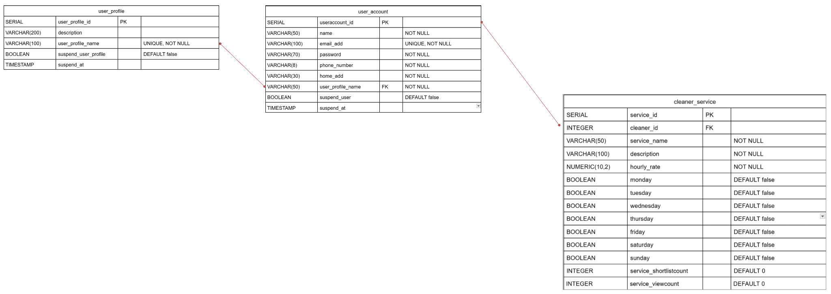

## 

## 

## 

## 

## 

## 

## 

## 

## 

## 

## 

## 

## 

## **Class** D**iagram**

## 

## 

## 

## 

## 

## 

## **#13. Cleaner - Create Service Listing**

User stories

As a cleaner, I want to create a service listing, so that homeowner can book my cleaning services.

| Use Case Diagram Taiga ID#43 |
| --- |
|  |

| Use Case Description Taiga ID#110 |
| --- |
| **Name :** Cleaner - Create Service Listing |
| **Stakeholders and goals :** Cleaner – wants to create a service listing so homeowners can view and book them |
| **Description :** This allows a cleaner to create a new service listing on the platform by entering relevant details. The listing becomes available for homeowners to book. |
| **Actors :** Cleaner |
| **Pre-condition(s) :** Cleaner is logged in |
| **Trigger :** Cleaner decides to create a new Service Listing |
| **Normal flow :**   1. Cleaner selects “+ADD LISTING” button 2. System displays listing creation form 3. Cleaner enters details and submits form 4. System validates input 5. System saves the listing and confirms creation |
| **Sub-flows :** None |
| **Alternative/Exceptional flows :** None |

| BCE Diagram Taiga ID#111 |
| --- |
|  |

| Sequence Diagram Taiga ID#112 |
| --- |
|  |

| Wire Frame Taiga ID#109 |
| --- |
|  |

Test Case Taiga ID# 291

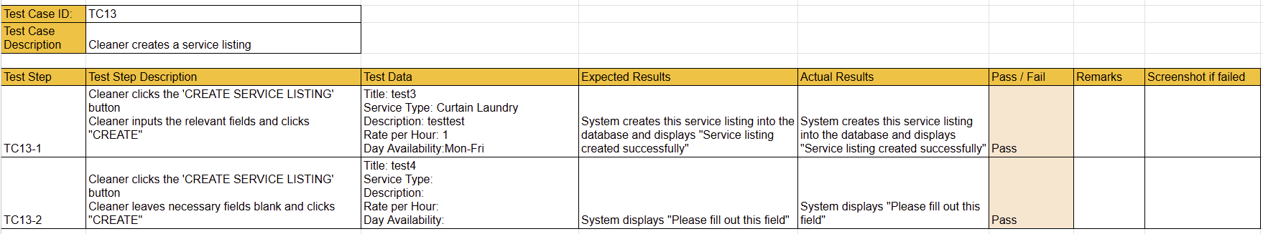

## **#14. Cleaner - View Service Listing**

User story

As a cleaner, I want to view my service listing, so that I can see my service listing details.

| Use Case Diagram Taiga ID#114 |
| --- |
|  |

| Use Case Description Taiga ID#115 |
| --- |
| **Name :** Cleaner View Service Listing |
| **Stakeholders and goals :** Cleaner – wants to see the details of a service listing that they’ve created. |
| **Description :** This allows a cleaner to view a service listing that they have created |
| **Actors :** Cleaner |
| **Pre-condition(s) :**  Cleaner must be logged in  Cleaner must have at least one service listing that must exist in the system |
| **Trigger :** Cleaner decides to view their service listing. |
| **Normal flow :**   1. System displays a list of current service listings. 2. Cleaner selects a service listing from the list and clicks on the name of the listing 3. System displays the service listing with relevant details. |
| **Sub-flows :** None |
| **Alternative/Exceptional flows :** None |

| BCE Diagram Taiga ID#116 |
| --- |
|  |

| Sequence Diagram Taiga ID#117 |
| --- |
|  |

| Wire Frame Taiga ID#113 |
| --- |
|  |

Test Case Taiga ID# 294

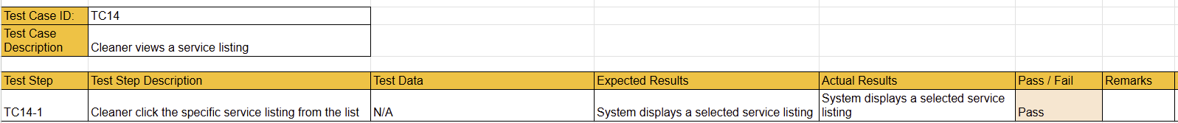

## 

## **#15. Cleaner - Update Service Listing**

User story

As a cleaner, I want to update my service listing, so that service information is up to date

| Use Case Diagram Taiga ID#119 |
| --- |
|  |

| Use Case Description Taiga ID#120 |
| --- |
| **Name :** Cleaner - Update Service Listing |
| **Stakeholders and goals :** Cleaner – wants to keep their service listings accurate and current |
| **Description :** This allows a logged-in cleaner to modify the details of an existing service listing they have created. They can update fields such as title, description, price, and availability. |
| **Actors :** Cleaner |
| **Pre-condition(s) :**  Cleaner must be logged in.  The service listing to be updated must exist. |
| **Trigger :** Cleaner decides to update a Service Listing |
| **Normal flow :**   1. Cleaner clicks “EDIT” button on the service listing to update 2. System displays a form with the service listing’s current details 3. Cleaner updates the necessary fields and submits the form 4. System validates the input. 5. System updates the service listing and confirms success |
| **Sub-flows :** None |
| **Alternative/Exceptional flows :** None |

| BCE Diagram Taiga ID#121 |
| --- |
|  |

| Sequence Diagram Taiga ID#122 |
| --- |
|  |

| Wire Frame Taiga ID#118 |
| --- |
|  |

Test Case Taiga ID# 297

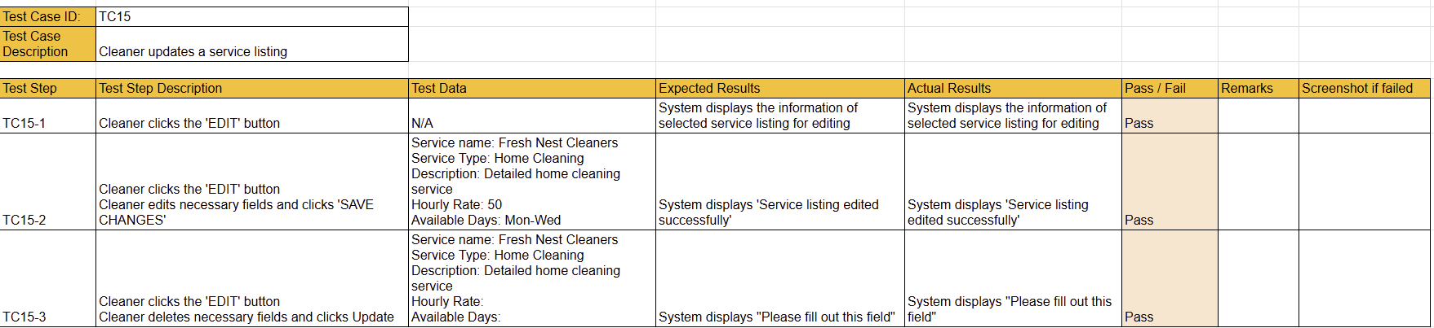

## **#16. Cleaner - Remove Service Listing**

User story

As a cleaner, I want to remove a service listing, so that I can terminate services that are no longer available.

| Use Case Diagram Taiga ID#124 |
| --- |
|  |

| Use Case Description Taiga ID#125 |
| --- |
| **Name :** Cleaner - Remove Service Listing |
| **Stakeholders and goals :** Cleaner – wants to delete unavailable service from their profile to keep their offerings current. |
| **Description :** This allows a cleaner to delete one of their existing service listings so it is no longer shown to clients. |
| **Actors :** Cleaner |
| **Pre-condition(s) :**  Cleaner must be logged in.  The service listing to be deleted must exist. |
| **Trigger :** Cleaner decides to delete a service listing |
| **Normal flow :**   1. Cleaner selects a listing to delete and clicks on the “Delete” button 2. System deletes the service listing. 3. System shows a confirmation message. |
| **Sub-flows :** None |
| **Alternative/Exceptional flows :** None |

| BCE Diagram Taiga ID#126 |
| --- |
|  |

| Sequence Diagram Taiga ID#127 |
| --- |
|  |

| Wire Frame Taiga ID#123 |
| --- |
|  |

Test Case Taiga ID# 300



## **#17. Cleaner - Search** F**or Specific Service Listing**

User story

As a cleaner, I want to search for a specific service listing, so that I can quickly locate my services.

| Use Case Diagram Taiga ID#129 |
| --- |
|  |

| Use Case Description Taiga ID#130 |
| --- |
| **Name :** Cleaner - Search for Specific Service Listing |
| **Stakeholders and goals :** Cleaner – wants to easily find a particular listing among many, saving time. |
| **Description :** This allows a logged in cleaner to search through their own service listings by title. The system filters and displays matching results upon search submission. |
| **Actors :** Cleaner |
| **Pre-condition(s) :**  Cleaner must be logged in.  The cleaner must have at least one existing service listing. |
| **Trigger :** Cleaner decides to search for a service listing |
| **Normal flow :**   1. Cleaner enters a service name in the search bar and clicks “Search”. 2. System filters and displays matching service listings |
| **Sub-flows :** None |
| **Alternative/Exceptional flows :**  4a. No Results Found: system shows that there is no services found |

| BCE Diagram Taiga ID#131 |
| --- |
|  |

| Sequence Diagram Taiga ID#132 |
| --- |
|  |

| Wire Frame Taiga ID#128 |
| --- |
|  |

Test Case Taiga ID# 303

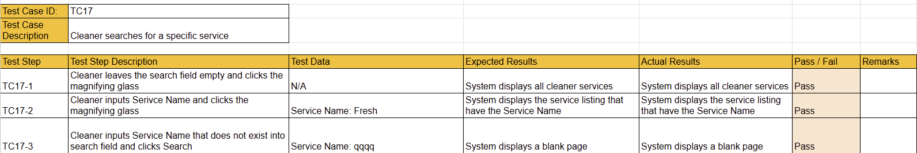

## **#18. Cleaner - Login**

User story

As a cleaner, I want to log in to the site so that I can access my account

| Use Case Diagram Taiga ID#134 |
| --- |
|  |

| Use Case Description Taiga ID#135 |
| --- |
| **Name :** Cleaner - Login |
| **Stakeholders and goals :** Cleaner – wants to access their account to manage services and bookings |
| **Description :** This allows a cleaner to log in to the site by entering valid credentials to access their personal dashboard and functionalities. |
| **Actors :** Cleaner |
| **Pre-condition(s) :**  The cleaner must already have a registered account.  Cleaner Account/Profile is not Suspended |
| **Trigger :** Cleaner decides to log in to the site |
| **Normal flow :**   1. System displays the login form 2. Cleaner enters email and password. 3. Cleaner submits the login form. 4. System validates credentials. 5. System grants access and redirects cleaner to their dashboard. |
| **Sub-flows :** None |
| **Alternative/Exceptional flows :**  4a. Invalid Credentials: System displays error message |

| BCE Diagram Taiga ID#136 |
| --- |
|  |

| Sequence Diagram Taiga ID#137 |
| --- |
|  |

| Wire Frame Taiga ID#133 |
| --- |
|  |

Test Case Taiga ID# 306

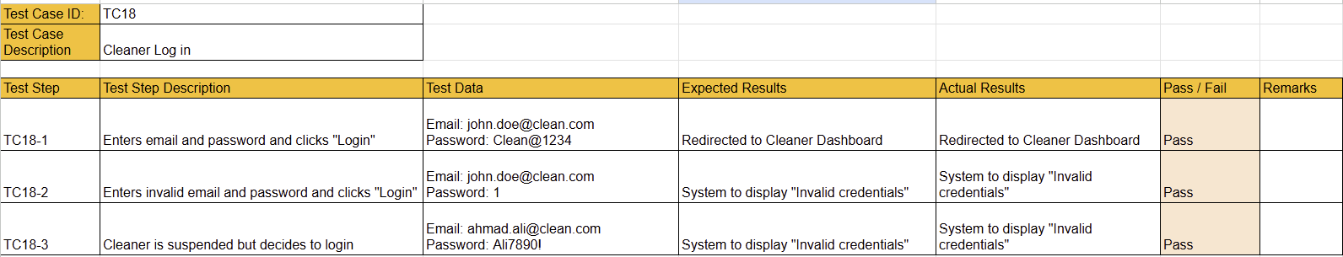

## 

## 

## 

## 

## 

## 

## 

## 

## 

## 

## 

## **#19. Cleaner - Logout**

User story

As a cleaner, I want to log out, so that I can exit my account

| Use Case Diagram Taiga ID#139 |
| --- |
|  |

| Use Case Description Taiga ID#140 |
| --- |
| **Name :** Cleaner - Logout |
| **Stakeholders and goals :** Cleaner - wants to exit their account after use |
| **Description :** This allows the Cleaner to log out of the system, ending the current session. |
| **Actors :** Cleaner |
| **Pre-condition(s) :** Cleaner is logged in |
| **Trigger :** Cleaner decides to log out |
| **Normal flow :**   1. Cleaner clicks on the “Logout” button 2. The system terminates the current session. 3. System redirects the Cleaner to the login page |
| **Sub-flows :** None |
| **Alternative/Exceptional flows :** None |

| BCE Diagram Taiga ID#141 |
| --- |
|  |

| Sequence Diagram Taiga ID#142 |
| --- |
|  |

| Wire Frame Taiga ID#138 |
| --- |
|  |

Test Case Taiga ID# 309



## **#27. Cleaner - Search Match History**

User story

As a cleaner, I want to search my match history, so that I can find previous bookings

| Use Case Diagram Taiga ID#179 |
| --- |
|  |

| Use Case Description Taiga ID#180 |
| --- |
| **Name :** Cleaner Search Match History |
| **Stakeholders and goals :** Cleaner - wants to search previous bookings for reference or follow-up |
| **Description :** This allows a cleaner to search their past bookings using keywords or dates to quickly access relevant history. |
| **Actors :** Cleaner |
| **Pre-condition(s) :**  Cleaner must be logged in Cleaner must have previous bookings in their history |
| **Trigger :** Cleaner decides to search a previous booking |
| **Normal flow :**   1. System displays a list of previously used services 2. Cleaner enters a listing into the search bar or chooses a date and clicks “Search” 3. System filters and displays matching history |
| **Sub-flows :** None |
| **Alternative/Exceptional flows :**  3a. No Results Found: System displays “No matching records found” |

| BCE Diagram Taiga ID#181 |
| --- |
|  |

| Sequence Diagram Taiga ID#182 |
| --- |
|  |

| Wire Frame Taiga ID#178 |
| --- |
|  |

Test Case Taiga ID# 333

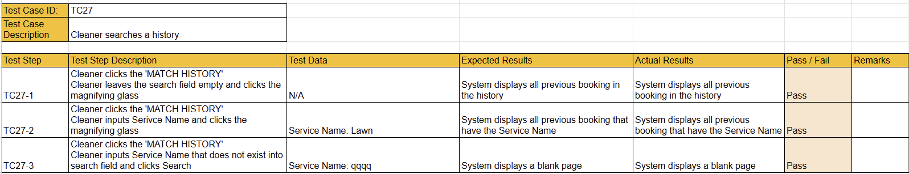

## **#28. Cleaner - View Match History**

User story

As a cleaner, I want to view my match history, so that I can track my details of past job.

| Use Case Diagram Taiga ID#184 |
| --- |
|  |

| Use Case Description Taiga ID#185 |
| --- |
| **Name :** Cleaner - View Match History |
| **Stakeholders and goals :** Cleaner - wants to track and review previously completed jobs |
| **Description :**This allows a cleaner to access a list of their past jobs, including client details, service dates, for record-keeping and tracking purposes. |
| **Actors :** Cleaners |
| **Pre-condition(s) :**   1. Cleaner must be logged in 2. Cleaner must have previous bookings in their history |
| **Trigger :** Cleaner decides to view their job history details |
| **Normal flow :**   1. System retrieves and displays a list of completed and past bookings 2. Cleaner clicks on a specific job history to view more details |
| **Sub-flows :** None |
| **Alternative/Exceptional flows :**  2a. No History Found: system displays a message indicating no past bookings are available |

| BCE Diagram Taiga ID#186 |
| --- |
|  |

| Sequence Diagram Taiga ID#187 |
| --- |
|  |

| Wire Frame Taiga ID#183 |
| --- |
|  |

Test Case Taiga ID# 336

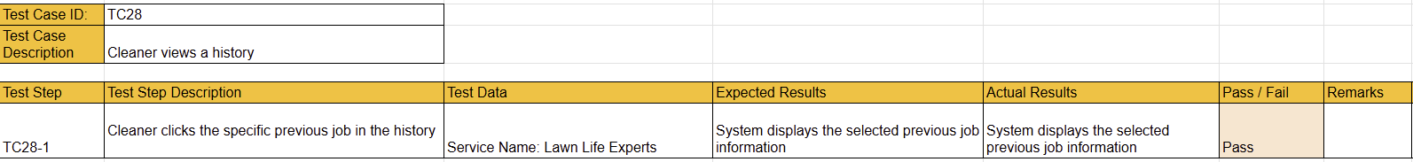

## **#29. Cleaner - View Service Listing View Count**

User story

As a cleaner, I want to see the number of times my service listing has been viewed, so that I can understand my potential interest from homeowners.

| Use Case Diagram Taiga ID#189 |
| --- |
|  |

| Use Case Description Taiga ID#190 |
| --- |
| **Name :** Cleaner - View Service Listing View Count |
| **Stakeholders and goals :** Cleaner - wants to understand homeowner interest by tracking listing views |
| **Description :** This allows a cleaner to see how many times each of their service listings has been viewed by homeowners, helping them evaluate the visibility and reach of their services. |
| **Actors :** Cleaner |
| **Pre-condition(s) :**  Cleaner is logged in  Cleaner has at least one Service Listing |
| **Trigger :** Cleaner decides to check the number of views for their service listings |
| **Normal flow :**   1. System displays a list of current service listings. 2. Cleaner selects a service listing from the list and clicks on the name of the listing 3. System displays the service listing with a view count. |
| **Sub-flows :** None |
| **Alternative/Exceptional flows :** None |

| BCE Diagram Taiga ID#191 |
| --- |
|  |

| Sequence Diagram Taiga ID#192 |
| --- |
|  |

| Wire Frame Taiga ID#188 |
| --- |
|  |

Test Case Taiga ID# 339

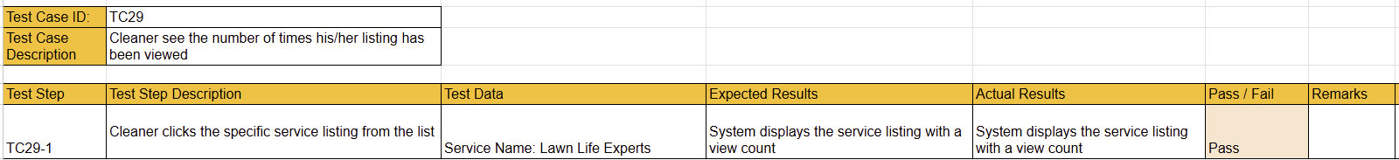

## **#30. Cleaner - View Service Listing Shortlist Count**

User story

As a cleaner, I want to see how many times my service listing has been shortlisted, so that I can gauge homeowner interest in my services.

| Use Case Diagram Taiga ID#194 |
| --- |
|  |

| Use Case Description Taiga ID#195 |
| --- |
| **Name :** Cleaner - View Service Listing Shortlist Count |
| **Stakeholders and goals :** Cleaner – wants to assess the popularity and interest level of their service listings |
| **Description :**This allows a cleaner to view the number of times each of their service listings has been added to a homeowner’s shortlist, helping them understand demand for their services. |
| **Actors :** Cleaner |
| **Pre-condition(s) :**  Cleaner is logged in  Cleaner has at least one Service Listing |
| **Trigger :** Cleaner decides to check shortlist statistic for their listing |
| **Normal flow :**   1. System displays a list of current service listings. 2. Cleaner selects a service listing from the list and clicks on the name of the listing 3. System displays the service listing with a shortlist count. |
| **Sub-flows :** None |
| **Alternative/Exceptional flows :** None |

| BCE Diagram Taiga ID#196 |
| --- |
|  |

| Sequence Diagram Taiga ID#197 |
| --- |
|  |

## 

| Wire Frame Taiga ID#193 |
| --- |
|  |

Test Case Taiga ID# 342

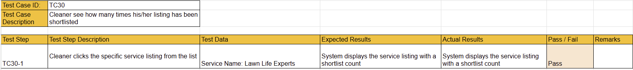

# 

# 

# **Sprint 3**

**Duration: 21th April - 28th April**

## Sprint Planning, Review and Retrospective

| **Meeting Date:** 23th April | |
| --- | --- |
| **Duration:**  2pm - 4pm | |
| **Sprint Duration:** 21th April - 28th April | |
| **Attendees:** 7/7 | **Agenda** |
| 1. Progress Updates 2. Outstanding Issues Discussion 3. Task Allocations for Next Sprint |
| **Absentees:**N/A |
|
| **What has been done during this meeting.** | - Shared individual progress updates.  - Identified outstanding issues.  - Discussed requirements for test driven development (TDD). |
| **What we are going to do until the next meeting.** | - Tim to implement test driven development for admin and user features (AdminUpdateProfile, AdminCreateNewAccount, AdminViewProfiles, AdminSearchUserProfile, AdminCreateProfile, UserUpdateOwnAccount, AdminSuspendProfile).  - Tim to work on the CICD section of the final report after app development.  - Yi Jia to continue working on user story diagrams.  - Hyeri to continue working on test cases.  - Leong Jie to continue refining class diagrams.  - Yangxuan continues to do the report.  - Tim to complete Homeowner actor tasks before next class (28 April).  - Everyone to check with Mr Terence in the next meeting (28 April).  - Reminder: Only write "Alternate" flow if necessary for user stories/test cases. |

## **Taiga - Start**

## 

## 

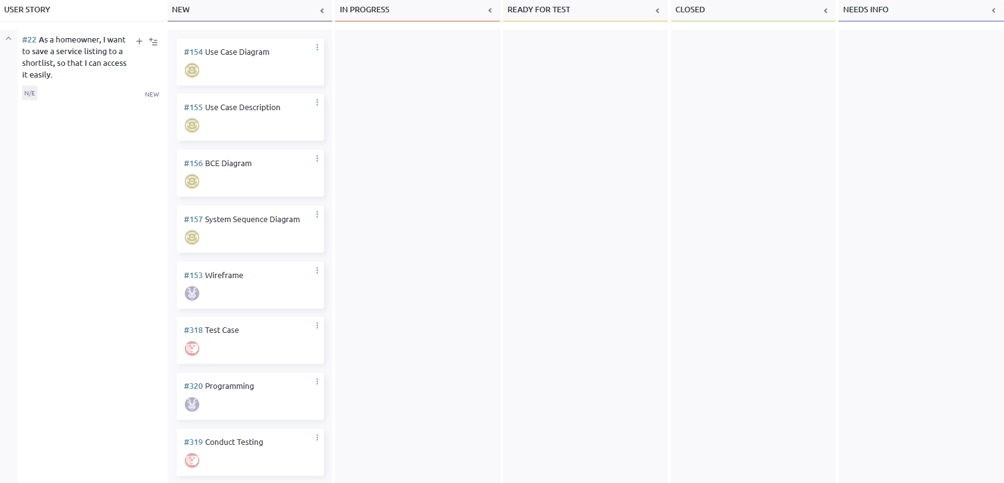

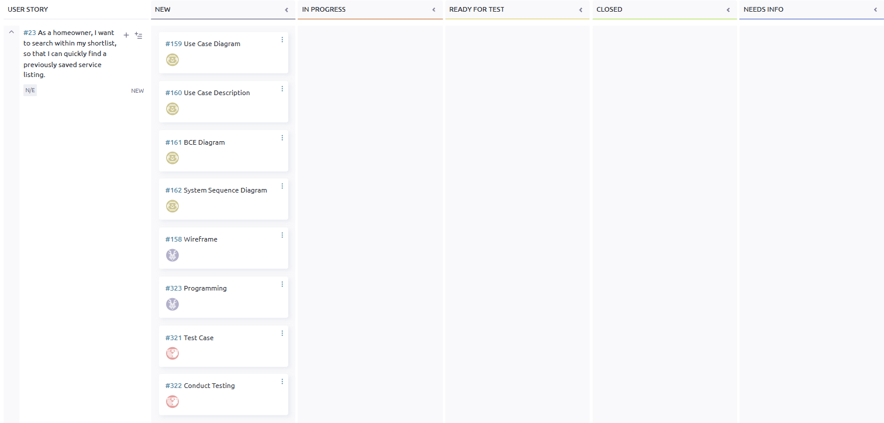

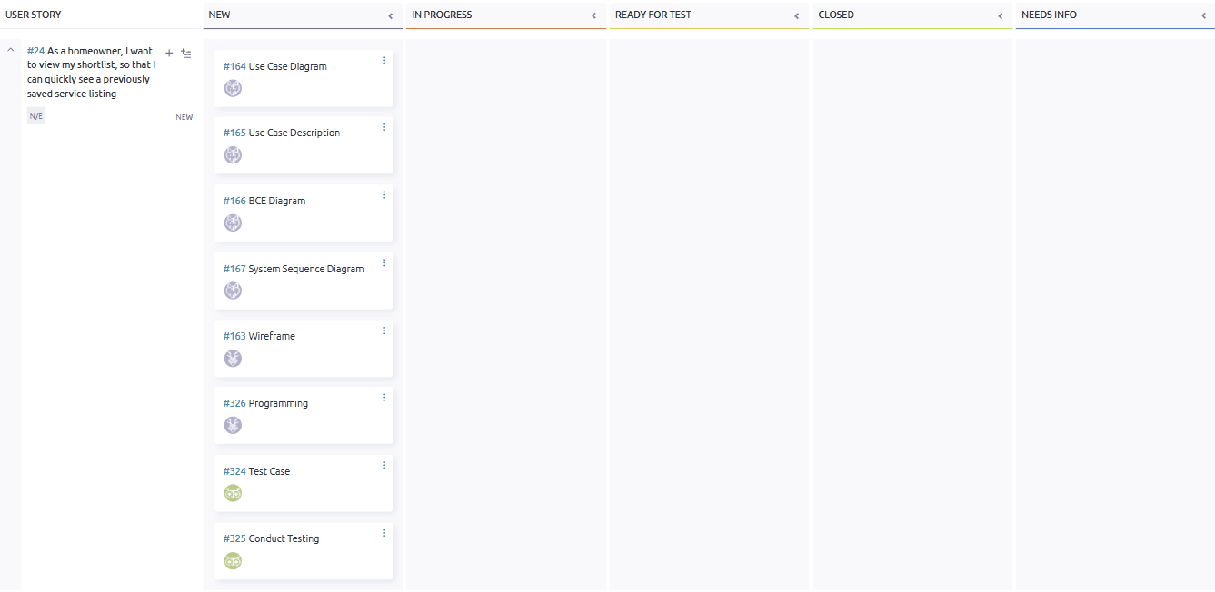

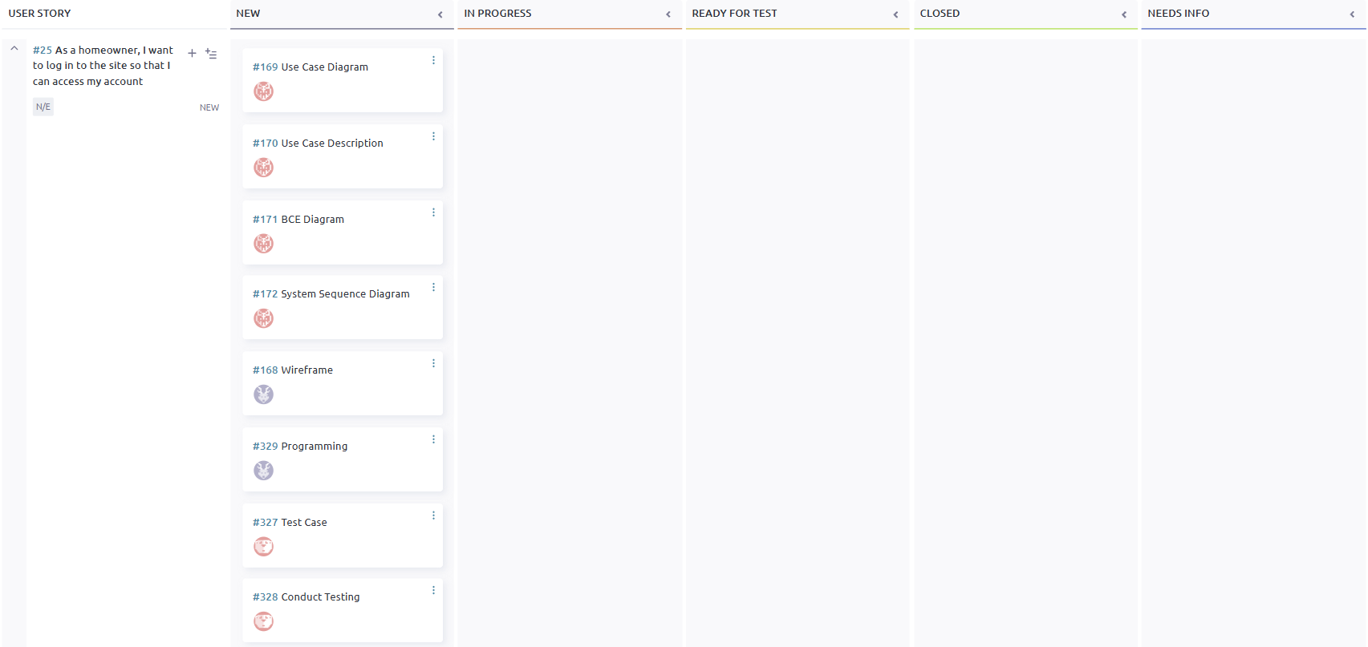

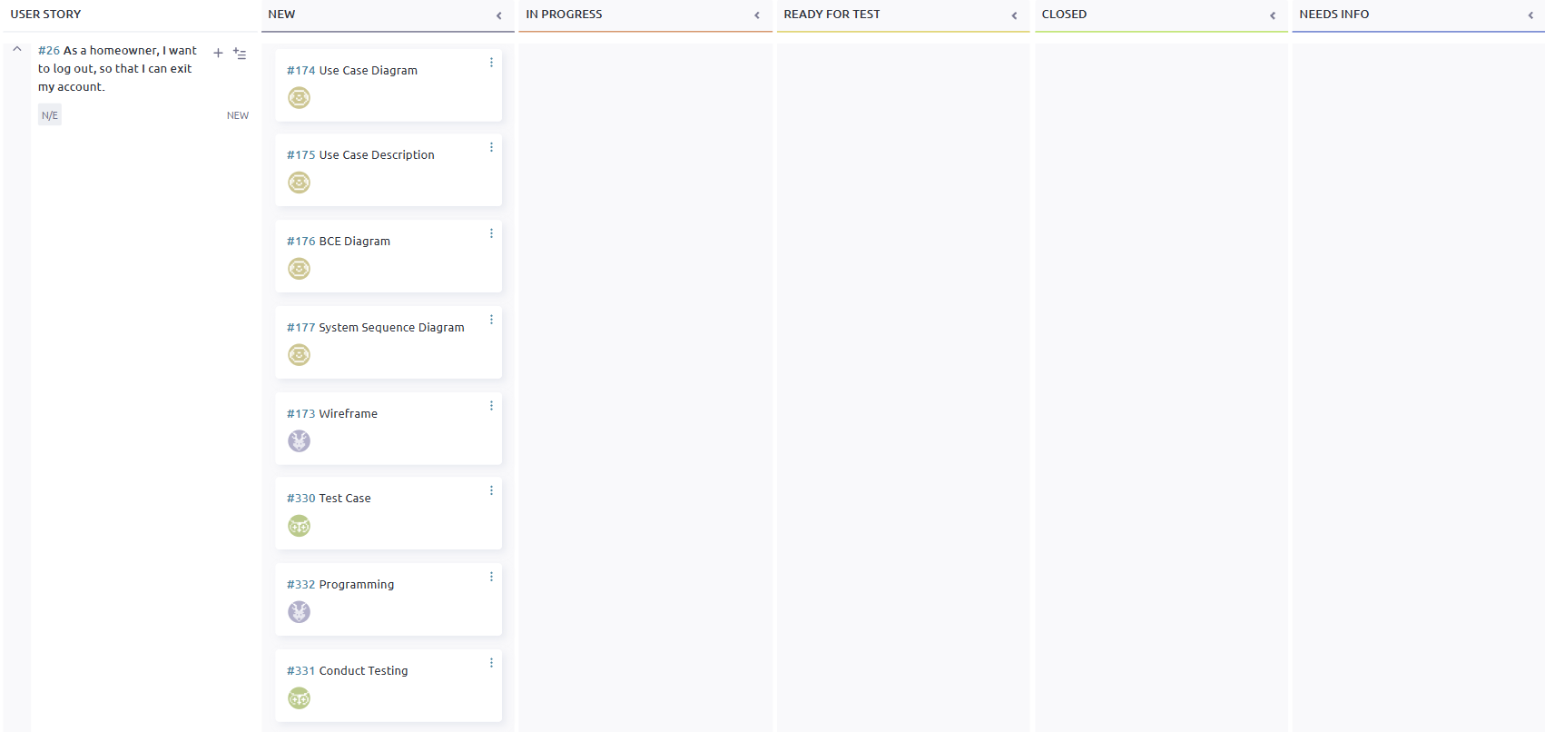

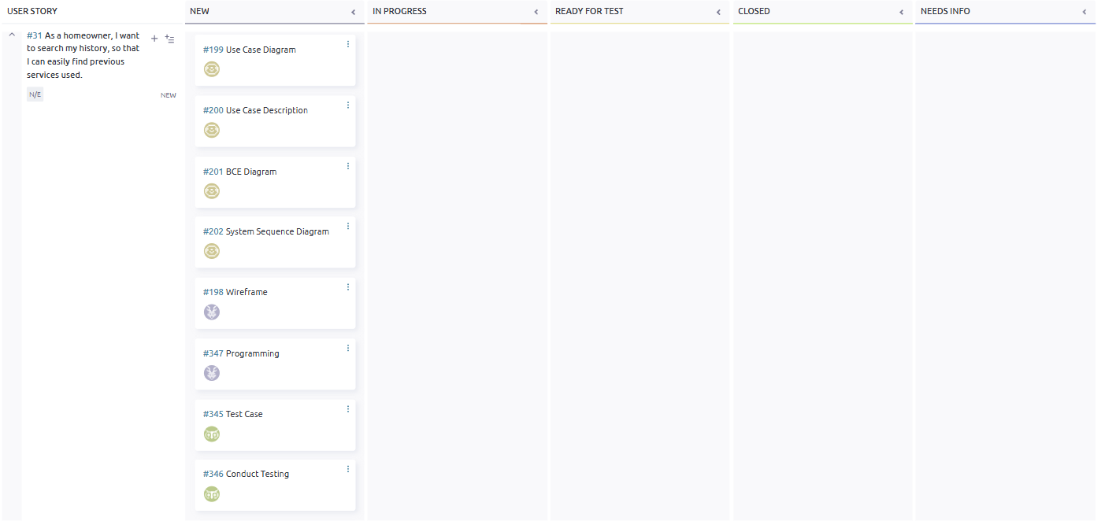

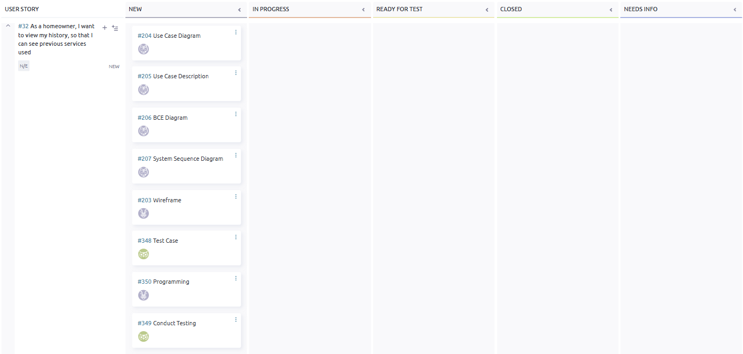

## 

## **Taiga - End**

## 

## 

## 

## 

## 

## 

## 

## 

## 

## Entity Relationship Diagram

## 

## 

## 

## 

## 

## 

## 

## 

## 

## 

## 

## 

## **Class** D**iagram**

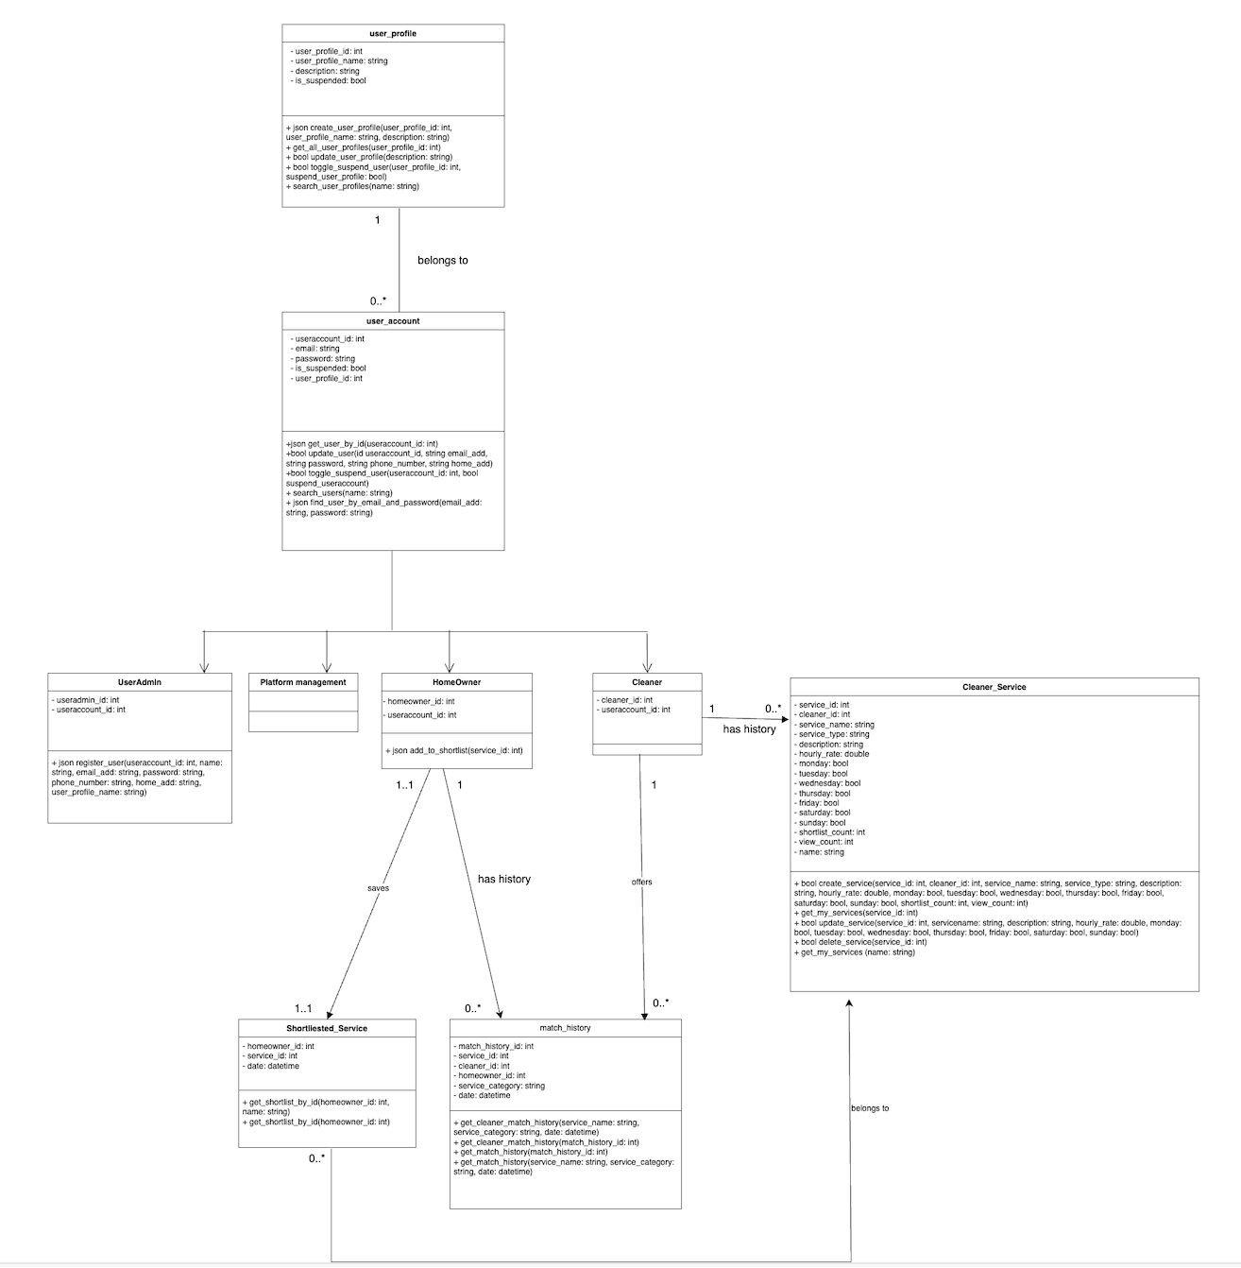

## **#20. Homeowner - Search Service Listings**

User story

As a homeowner, I want to search for service listings, so that I can find available cleaning services that match my needs.

| Use Case Diagram Taiga ID#144 |
| --- |
|  |

| Use Case Description Taiga ID#145 |
| --- |
| **Name :** Homeowner Search Service Listings |
| **Stakeholders and goals :** Homeowner - wants to find available cleaning services that match their needs |
| **Description :** This allows a Homeowner to search available cleaning service listings using their name to locate specific Service Listings |
| **Actors :** Homeowner |
| **Pre-condition(s) :** Homeowner is logged into the system. |
| **Trigger :** Homeowner decides to search for a specific Service Listing. |
| **Normal flow :**   1. Homeowner enters a name into the search bar and clicks “Search” 2. System filters and displays matching Service Listings |
| **Sub-flows :** None |
| **Alternative/Exceptional flows :** No Service Found: Page shows that there is no listings found |

| BCE Diagram Taiga ID#146 |
| --- |
|  |

| Sequence Diagram Taiga ID#147 |
| --- |
|  |

| Wire Frame Taiga ID#143 |
| --- |
|  |

Test Case Taiga ID# 312

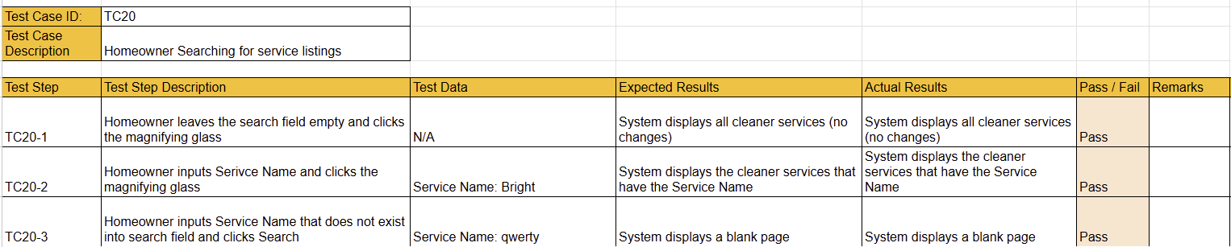

## **#21. Homeowner - View service** L**isting**

User story

As a homeowner, I want to view a service listing, so that I can check the details before booking.

| Use Case Diagram Taiga ID#149 |
| --- |
|  |

| Use Case Description Taiga ID#150 |
| --- |
| **Name :** Homeowner View Service Listing |
| **Stakeholders and goals :** Homeowner - want to view a Service Listing’s details before making a booking |
| **Description :** This allows a homeowner to view the full details of a cleaner’s Service Listing to make an informed decision. |
| **Actors :** Homeowner |
| **Pre-condition(s) :** Homeowner is logged into the system. |
| **Trigger :** Homeowner decides to view a particular Service Listing |
| **Normal flow :**   1. System displays a list of available services 2. Homeowner selects the "View" button on a Specific Listing 3. System displays full details of the selected service |
| **Sub-flows :** None |
| **Alternative/Exceptional flows :** None |

| BCE Diagram Taiga ID#151 |
| --- |
|  |

| Sequence Diagram Taiga ID#152 |
| --- |
|  |

| Wire Frame Taiga ID#148 |
| --- |
|  |

Test Case Taiga ID# 315

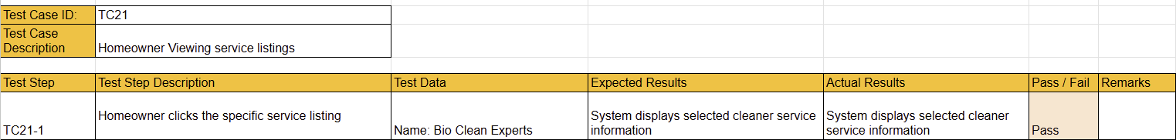

## **#22. Homeowner - Save** S**ervice** L**isting to Shortlist**

User story

As a homeowner, I want to save a service listing to a shortlist, so that I can access it easily.

| Use Case Diagram Taiga ID#154 |
| --- |
|  |

| Use Case Description Taiga ID#155 |
| --- |
| **Name:** Homeowner Save Service Listing to Shortlist |
| **Stakeholders and goals :** Homeowner - wants to add a Service Listing to his/her shortlist for easy access later on. |
| **Description :** This use case allows a homeowner to add a Service Listing to their shortlist, enabling them to revisit preferred listings easily without having to search again. |
| **Actors :** Homeowner |
| **Pre-condition(s) :**  Homeowner is logged into the system.  Service Listing has not already been shortlisted |
| **Trigger :** Homeowner decides to save a Service Listing to their shortlist |
| **Normal flow :**   1. Homeowner clicks on the "Heart" icon on a specific Service Listing. 2. System saves that service listing to the Homeowner's shortlist. 3. The Heart icon is updated to be red. |
| **Sub-flows :** None |
| **Alternative/Exceptional flows :** None |

| BCE Diagram Taiga ID#156 |
| --- |
|  |

| Sequence Diagram Taiga ID#157 |
| --- |
|  |

| Wire Frame Taiga ID#153 |
| --- |
|  |

Test Case Taiga ID# 318

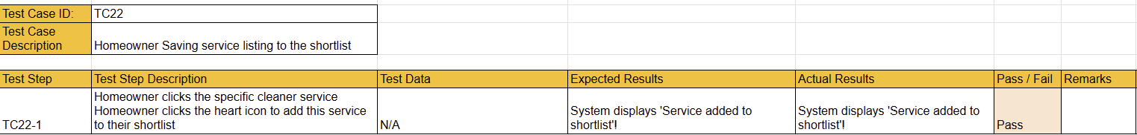

## 

## **#23. Homeowner - Search Shortlist**

User story

As a homeowner, I want to search within my shortlist, so that I can quickly find a previously saved service listing.

| Use Case Diagram Taiga ID#159 |
| --- |
|  |

| Use Case Description Taiga ID#160 |
| --- |
| **Name :** Homeowner Search Shortlist |
| **Stakeholders and goals :** Homeowner - wants to search for a specific Service Listing within the Shortlist. |
| **Description :** This allows a Homeowner to search for Service Listings within the shortlist to locate specific Service Listings which were previously saved quickly. |
| **Actors :** Homeowner |
| **Pre-condition(s) :** Homeowner has to be logged in |
| **Trigger :** Homeowner decides to search for a Service Listing in their shortlist |
| **Normal flow :**   1. Homeowner keys in the name of the Service Listing he/she wants to find and clicks “search” 2. System filters and displays matching saved listings |
| **Sub-flows :** None |
| **Alternative/Exceptional flows :**  2a. No Results Found: system displays a message that no saved listings match the search criteria |

| BCE Diagram Taiga ID#161 |
| --- |
|  |

| Sequence Diagram Taiga ID#162 |
| --- |
|  |

| Wire Frame Taiga ID#158 |
| --- |
|  |

Test Case Taiga ID# 321

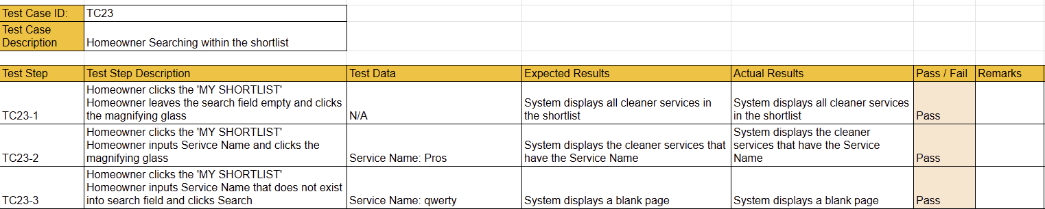

## **#24. Homeowner - View Shortlist**

User story

As a homeowner, I want to view my shortlist, so that I can quickly see previously saved service listings.

| Use Case Diagram Taiga ID#164 |
| --- |
|  |

| Use Case Description Taiga ID#165 |
| --- |
| **Name :** Home Owner View Shortlist |
| **Stakeholders and goals :** Homeowner - wants to easily view a list of the previously saved Service Listings |
| **Description :** This allows a Homeowner to view all Service Listings they have previously saved to their Shortlist for future consideration or booking. |
| **Actors :** Homeowner |
| **Pre-condition(s) :** Homeowner is logged in |
| **Trigger :** Homeowner decides to view their Shortlist |
| **Normal flow :**   1. System retrieves all saved Service Listings for the homeowner 2. System displays the list of saved services with relevant details |
| **Sub-flows :** None |
| **Alternative/Exceptional flows :**  1a. No Service Saved: system displays a message indicating that the shortlist is currently empty |

| BCE Diagram Taiga ID#166 |
| --- |
|  |

| Sequence Diagram Taiga ID#167 |
| --- |
|  |

| Wire Frame Taiga ID#163 |
| --- |
|  |

Test Case Taiga ID# 324

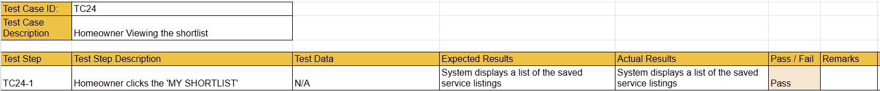

## **#25. Homeowner -** L**ogin**

User story

As a homeowner, I want to log in to the site so that I can access my account

| Use Case Diagram Taiga ID#169 |
| --- |
|  |

| Use Case Description Taiga ID#170 |
| --- |
| **Name :** Homeowner - Login |
| **Stakeholders and goals :** Homeowner - wants to access their account to manage bookings and saved services |
| **Description :** This allows a Homeowner to log in to the platform by entering valid credentials to access their personal dashboard and features. |
| **Actors :** Homeowner |
| **Pre-condition(s) :**  Homeowner has a valid user account  Homeowner Account/Profile is not Suspended |
| **Trigger :** Homeowner decides to log in to the site |
| **Normal flow :**   1. System displays the login form 2. Homeowner enters email and password. 3. Homeowner submits the login form. 4. System validates credentials. 5. System grants access and redirects Homeowners to their dashboard. |
| **Sub-flows :** None. |
| **Alternative/Exceptional flows :**  4a. Invalid Credentials: System display error message |

| BCE Diagram Taiga ID#171 |
| --- |
|  |

| Sequence Diagram Taiga ID#172 |
| --- |
|  |

| Wire Frame Taiga ID#168 |
| --- |
|  |

Test Case Taiga ID# 327

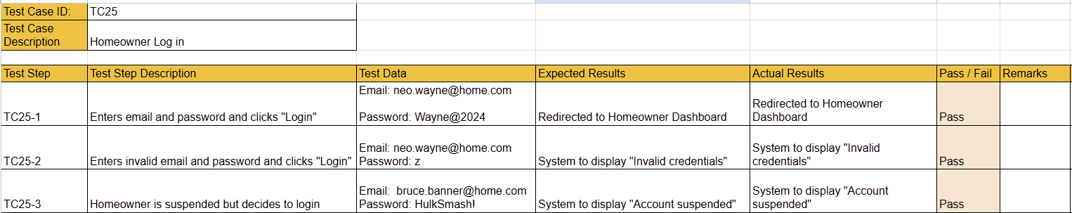

## 

## 

## 

## 

## 

## 

## 

## 

## 

## 

## **#26. Homeowner -** L**ogout**

User story

As a homeowner, I want to log out, so that I can exit my account.

| Use Case Diagram Taiga ID#174 |
| --- |
|  |

| Use Case Description Taiga ID#175 |
| --- |
| **Name :** Homeowner - Logout |
| **Stakeholders and goals :** Homeowner - wants to exit their account after use |
| **Description :**This allows a Homeowner to Logout of the system, ending the current session |
| **Actors :** Homeowner |
| **Pre-condition(s) :** Homeowner is logged in |
| **Trigger :** Homeowner decides to log out |
| **Normal flow :**   1. Homeowner clicks on the “Logout” button 2. The system terminates the current session. 3. System redirects the Homeowner to the login page |
| **Sub-flows :** None |
| **Alternative/Exceptional flows :** None |

| BCE Diagram Taiga ID#176 |
| --- |
|  |

| Sequence Diagram Taiga ID#177 |
| --- |
|  |

| Wire Frame Taiga ID#173 |
| --- |
|  |

Test Case Taiga ID# 330



## **#31. Homeowner - Search Match History**

User story

As a homeowner, I want to search my match history, so that I can easily find previous services used.

| Use Case Diagram Taiga ID#199 |
| --- |
|  |

| Use Case Description Taiga ID#200 |
| --- |
| **Name :** Homeowner Search Match History |
| **Stakeholders and goals :** Homeowner - wants to search previous bookings for reference or follow-up |
| **Description :** This allows a homeowner to search their past bookings using keywords or dates to quickly access relevant history. |
| **Actors :** Homeowner |
| **Pre-condition(s) :**  Homeowner must be logged in Homeowner must have previous bookings in their history |
| **Trigger :** Homeowner decides to search a previous booking |
| **Normal flow :**   1. System displays a list of previously used services 2. Homeowner enters a listing into the search bar or chooses a date and clicks “Search” 3. System filters and displays matching history |
| **Sub-flows :** None |
| **Alternative/Exceptional flows :**  3a. No Results Found: System displays “No matching records found” |

| BCE Diagram Taiga ID#201 |
| --- |
|  |

| Sequence Diagram Taiga ID#202 |
| --- |
|  |

| Wire Frame Taiga ID#198 |
| --- |
|  |

Test Case Taiga ID# 345

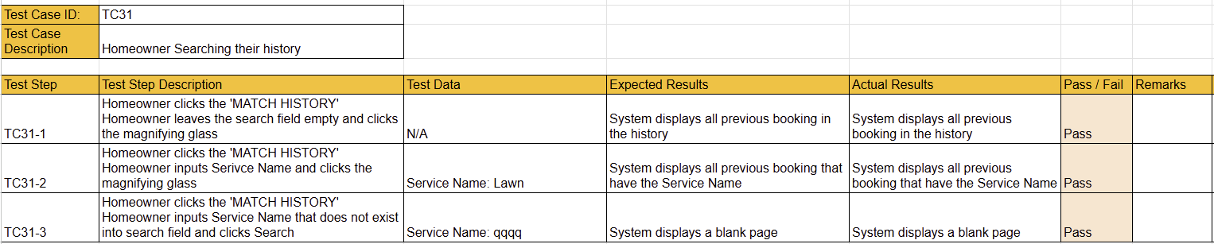

## **#32. Homeowner -** View **Match History**

User story

As a homeowner, I want to view my match history, so that I can see details of a previous service used

| Use Case Diagram Taiga ID#204 |
| --- |
|  |

| Use Case Description Taiga ID#205 |
| --- |
| **Name :** Homeowner View Match History |
| **Stakeholders and goals :** Homeowner - wants to track and review a previously used service |
| **Description :**This allows a homeowner to access the details of a past service used for record-keeping and tracking purposes. |
| **Actors :** Homeowner |
| **Pre-condition(s) :**  Homeowner is logged in  Homeowner has previous bookings in their history |
| **Trigger :** Homeowner decides to view their match history |
| **Normal flow :**   1. System retrieves and displays a list of completed and past bookings 2. Homeowner clicks on a specific job to view more details |
| **Sub-flows :** None |
| **Alternative/Exceptional flows :**  2a. No History Found: system displays a message indicating no past bookings are available |

| BCE Diagram Taiga ID#206 |
| --- |
|  |

| Sequence Diagram Taiga ID#207 |
| --- |
|  |

| Wire Frame Taiga ID#203 |
| --- |
|  |

Test Case Taiga ID# 348

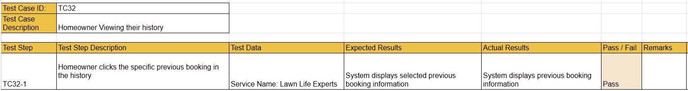

## 

## 

# 

# 

# **Sprint 4**

**Duration: 28th April - 12th May**

## Sprint Planning, Review and Retrospective

| **Meeting Date:** 5th May | |
| --- | --- |
| **Duration:** 2:30pm - 3:30pm | |
| **Sprint Duration:** 28th April - 12th May | |
| **Attendees:** 5/7 | **Agenda** |
| Progress check and set deadlines  Recording and editing of demo |
| **Absentees:** Leong Jie  Hailey |
|
| **What has been done during this meeting.** | * What's left for final doc   + Tim to add some screenshots of TDD. no need for all user stories. Maybe just login [due 6th May night]   + Yang Xuan to work on Data Driven Development (before 8th May)   + Hyeri to add in test cases to Document (before 8th May)   + Leong Jie to add GANTT Chart   + Hailey to add Class Diagram to Document   + Hailey to edit Ethical Considerations in Document |
| **What we are going to do until the next meeting.** | * Quality Check of Document   + Font sizes for body and headings   + Checking of diagrams   + Checking of grammar   + Checking consistency against what was actually done. |

# 

## **Taiga - Start**

## 

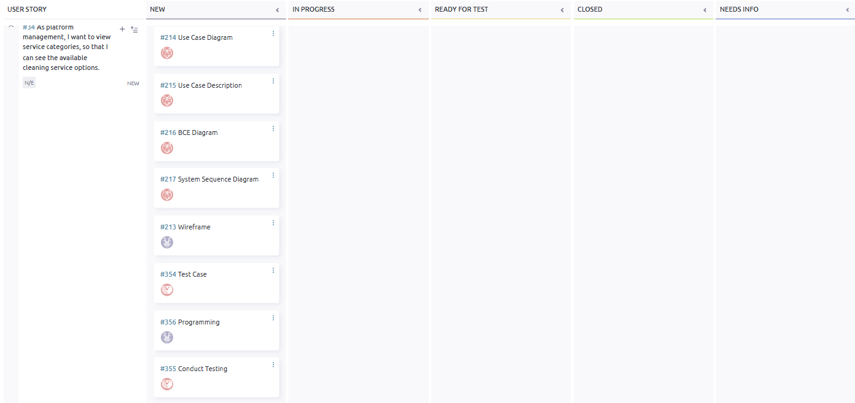

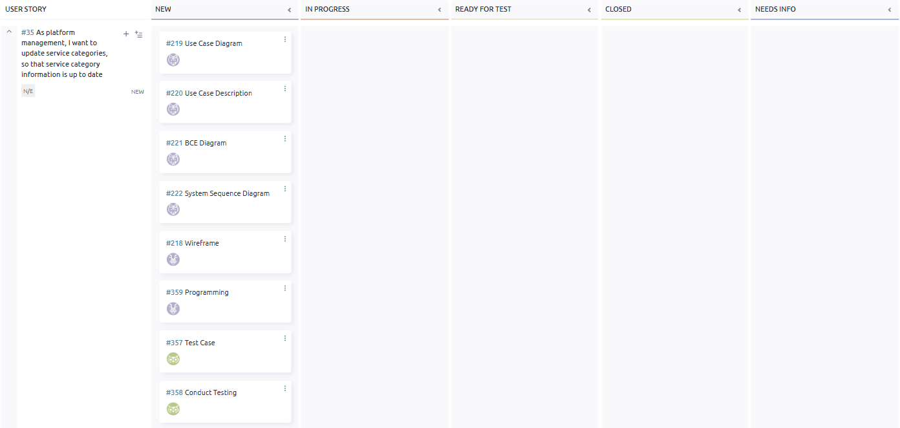

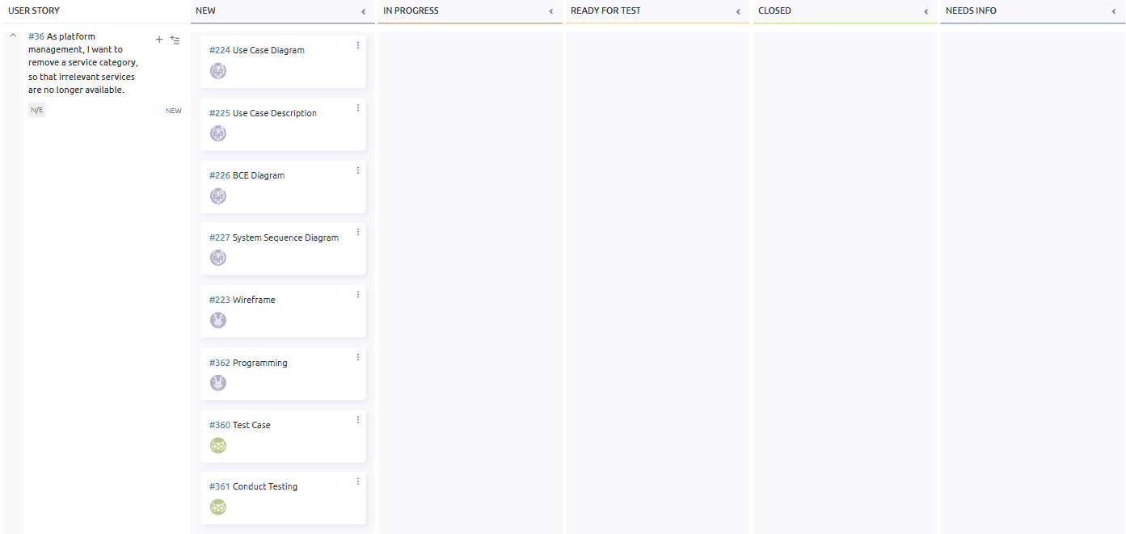

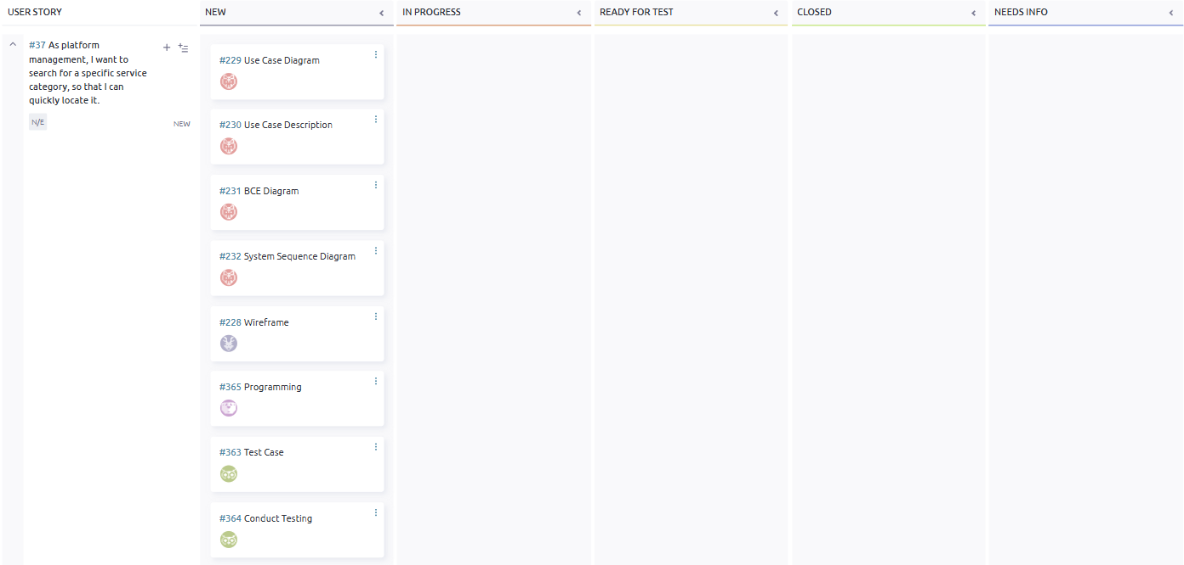

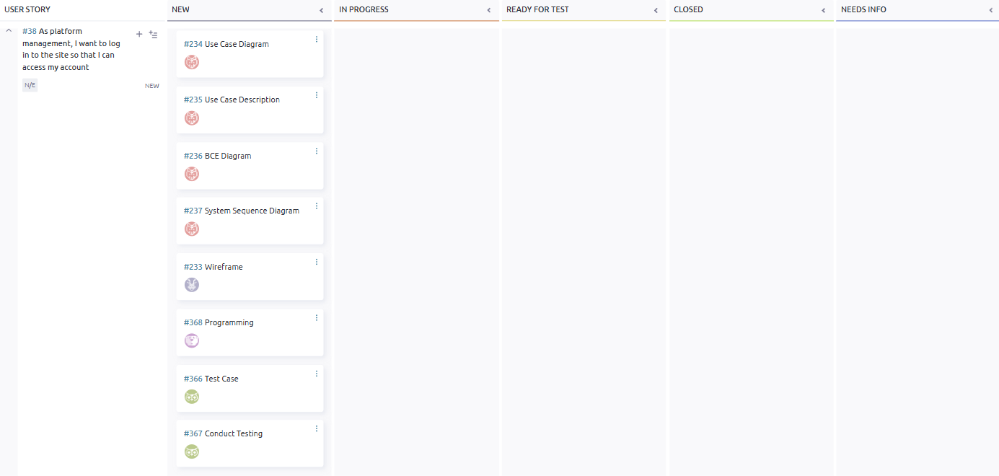

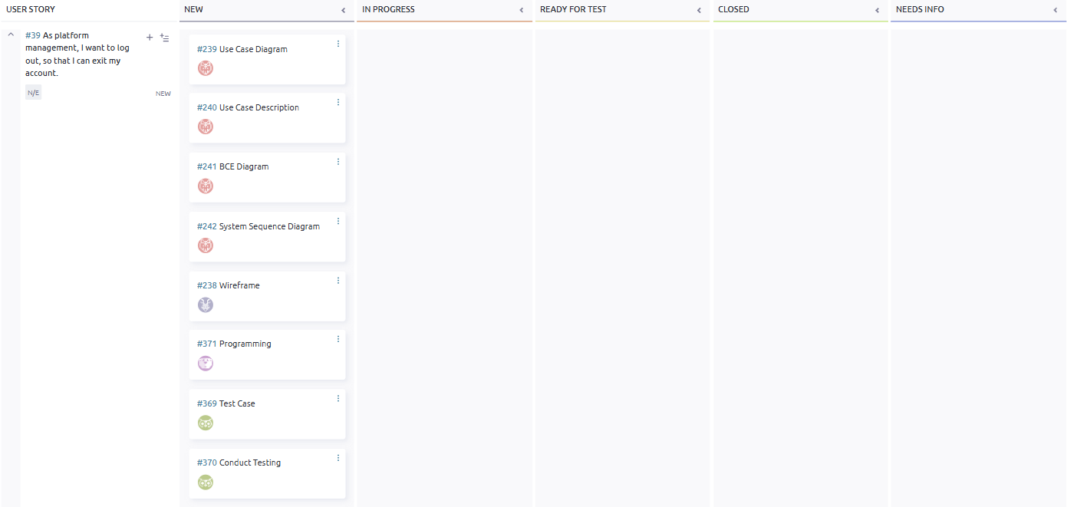

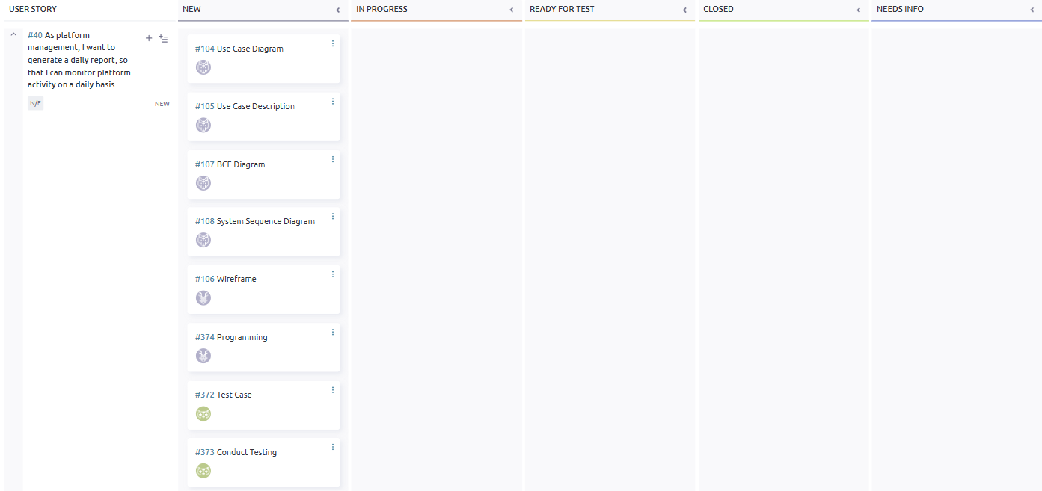

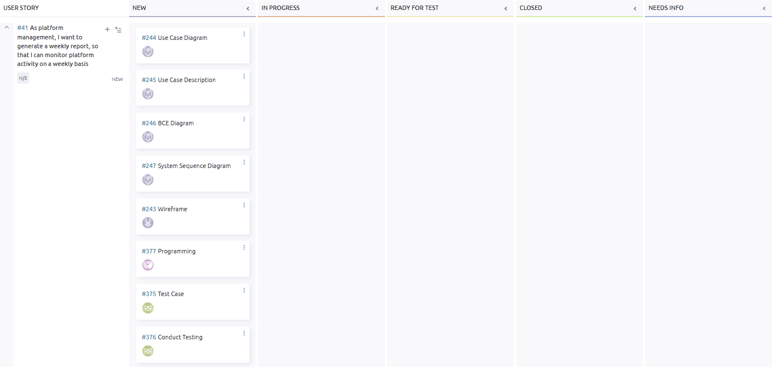

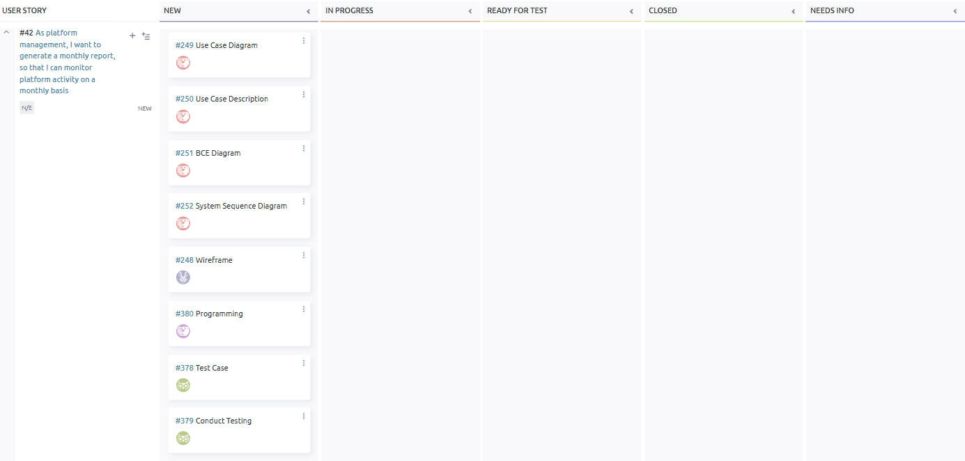

## 

## **Taiga - End**

## 

## 

## 

## 

## 

## 

## 

## 

## 

## 

## 

## **Class** D**iagram**

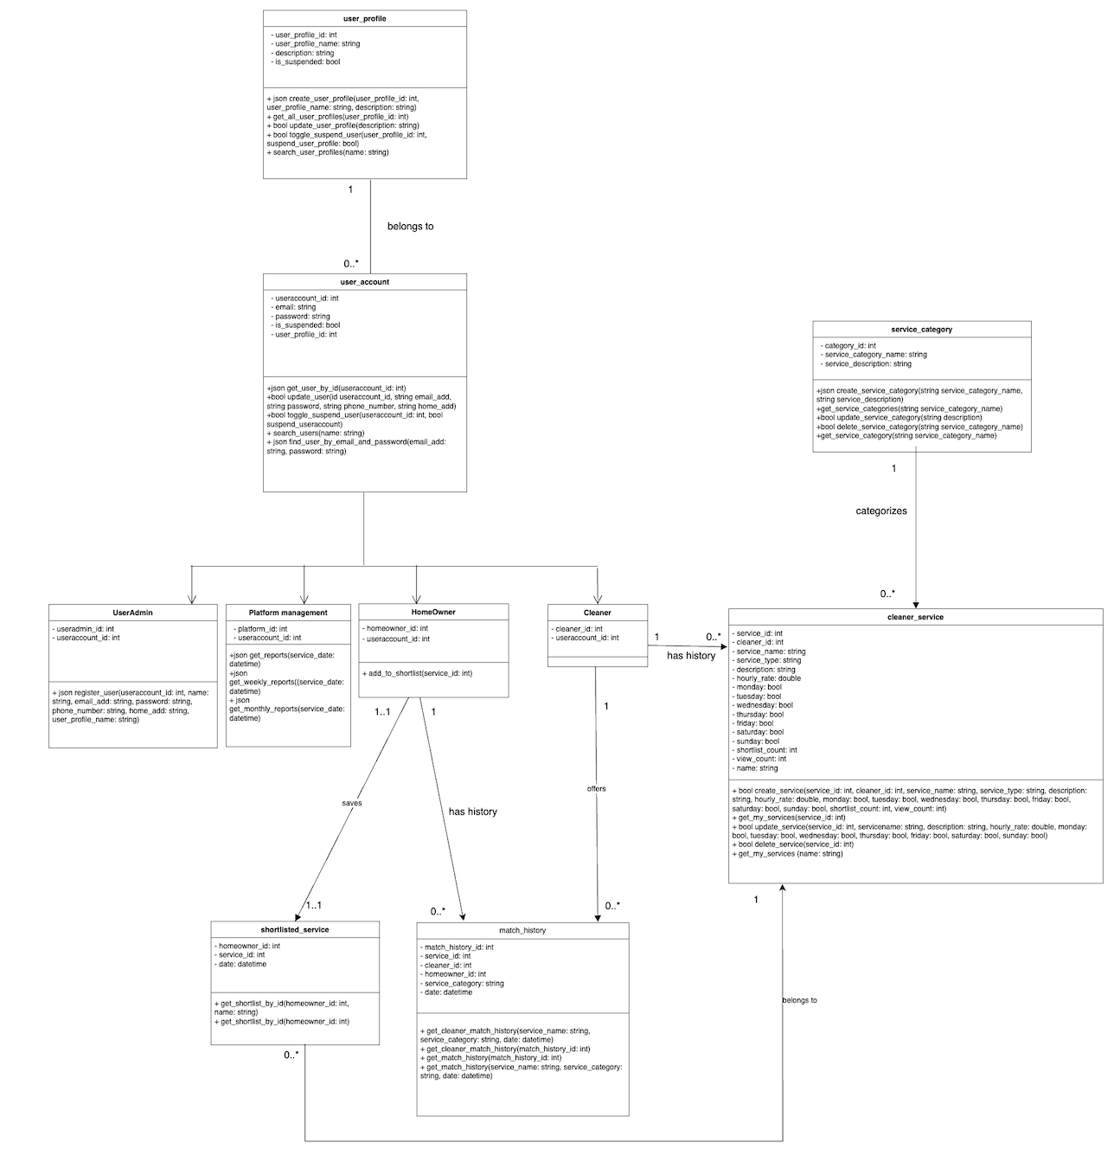

## **Entity Relationship Diagram**

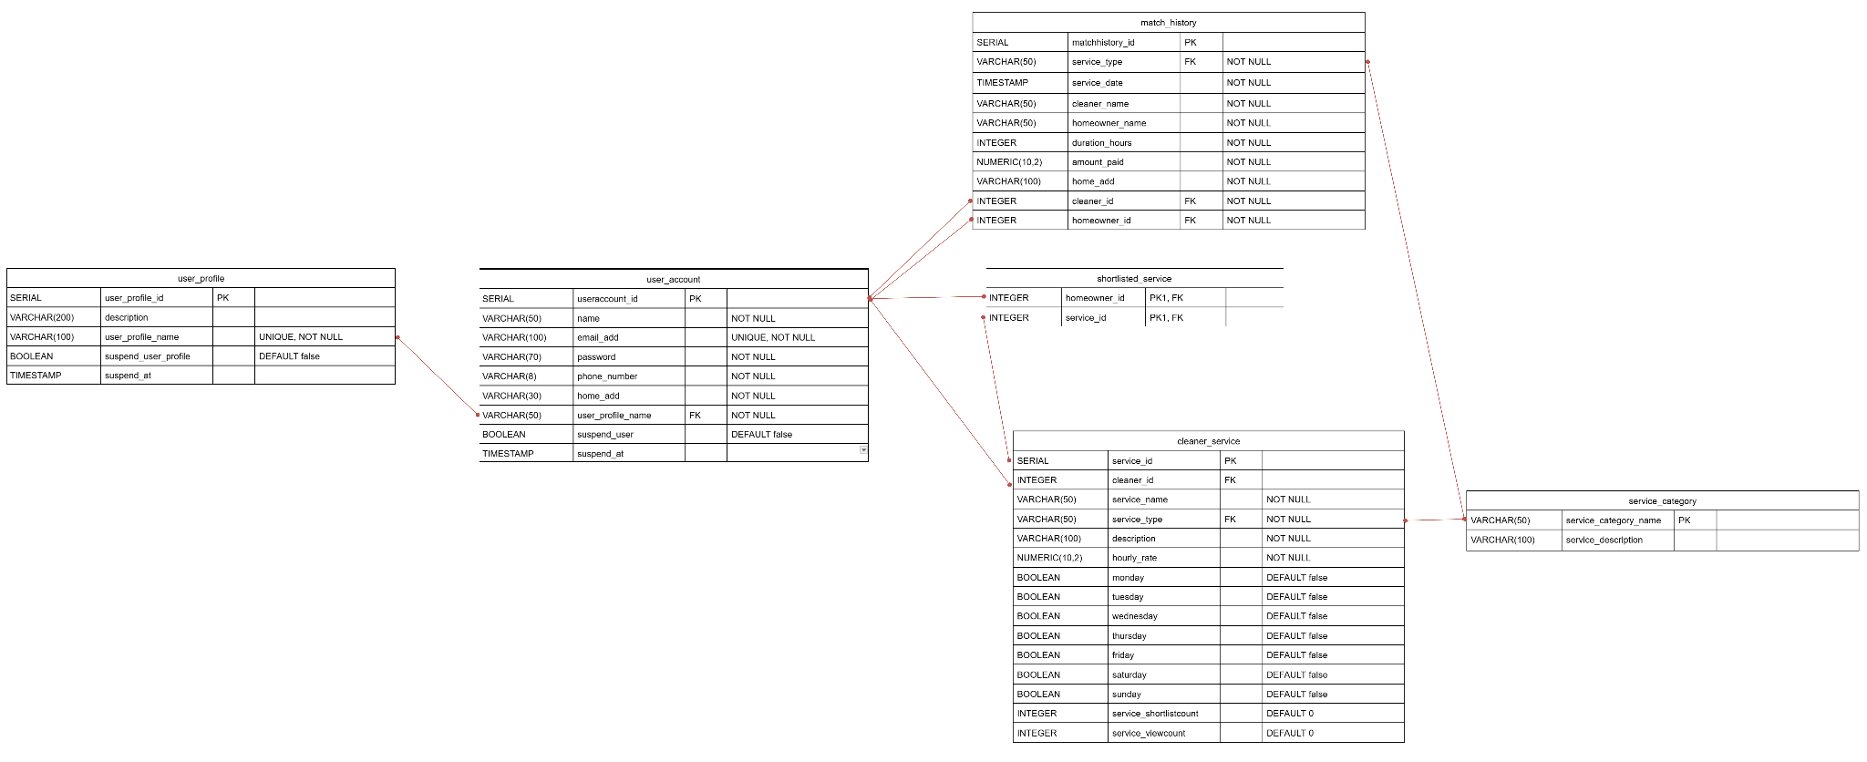

## **#33. Platform Management - Create Service Category**

User story

As platform management, I want to create a new service category, so that cleaners can assign their listing to this new category

| Use Case Diagram Taiga ID#209 |
| --- |
|  |

| Use Case Description Taiga ID#210 |
| --- |
| **Name :** Platform Management Create Service Category |
| **Stakeholders and goals :** Platform Management – wants to organise services into appropriate categories |
| **Description :**  This allows platform management to create new service categories that cleaners can later assign to their listings, helping to maintain a well-structured platform. |
| **Actors :** Platform Management |
| **Pre-condition(s) :** Platform management is logged in |
| **Trigger :** Platform management decides to add a new Service Category |
| **Normal flow :**   1. Platform Management clicks “+ NEW SERVICE CATEGORY” button 2. System displays Service Category creation form 3. Platform Management enters Service Category details and submits form 4. System validates input 5. System saves the Service Category and confirms creation |
| **Sub-flows :** None |
| **Alternative/Exceptional flows :**  3a. Service Category Already Exists: system shows an error indicating the category is already in use |

| BCE Diagram Taiga ID#211 |
| --- |
|  |

| Sequence Diagram Taiga ID#212 |
| --- |
|  |

| Wire Frame Taiga ID#208 |
| --- |
|  |

Test Case Taiga ID# 351

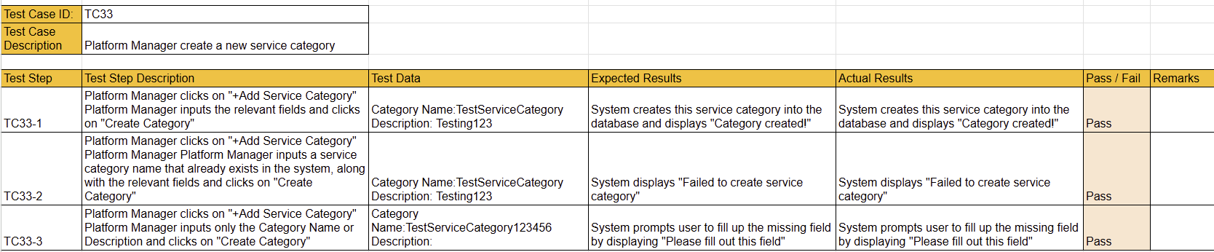

## **#34. Platform Management - View Service Categories**

User story

As platform management, I want to view service categories, so that I can see the available cleaning service options.

| Use Case Diagram Taiga ID#214 |
| --- |
|  |

| Use Case Description Taiga ID#215 |
| --- |
| **Name :** Platform Management View Service Categories |
| **Stakeholders and goals :** Platform Management – wants to monitor and review available Service Categories for management and oversight |
| **Description :** Platform Management – wants to monitor and review available Service Categories for management and oversight |
| **Actors :** Platform Management |
| **Pre-condition(s) :**  Platform management is logged in  There must have be least one Service Categories that must exist in the system |
| **Trigger :** Platform management decides to view all available Service Categories |
| **Normal flow :**   1. System displays a list of user profiles such as well as details such as name and description |
| **Sub-flows :** None |
| **Alternative/Exceptional flows :** None |

| BCE Diagram Taiga ID#216 |
| --- |
|  |

| Sequence Diagram Taiga ID#217 |
| --- |
|  |

| Wire Frame Taiga ID#213 |
| --- |
|  |

Test Case Taiga ID# 354



## **#35. Platform Management - Update Service Categories**

User story

As platform management, I want to update service categories, so that service category information is up to date

| Use Case Diagram Taiga ID#219 |
| --- |
|  |

| Use Case Description Taiga ID#220 |
| --- |
| **Name :** Platform Management Update Service Categories |
| **Stakeholders and goals :** Platform Management – wants to ensure that Service Categories remain relevant and accurate |
| **Description :** Platform Management – wants to ensure that Service Categories remain relevant and accurate |
| **Actors :** Platform Management |
| **Pre-condition(s) :**  Platform management is logged into the system.  The service category to be updated exists. |
| **Trigger :** Platform management decides to update an existing Service Category |
| **Normal flow :**   1. System displays a list of existing Service Categories 2. Platform management clicks “EDIT” button on the Service Category to update 3. System displays a form with the Service Category’s current details 4. Platform management updates the necessary fields and submits the form 5. System validates the input 6. System updates the Service Category and confirms success |
| **Sub-flows :** None |
| **Alternative/Exceptional flows :** None |

| BCE Diagram Taiga ID#221 |
| --- |
|  |

| Sequence Diagram Taiga ID#222 |
| --- |
|  |

| Wire Frame Taiga ID#218 |
| --- |
|  |

Test Case Taiga ID# 357

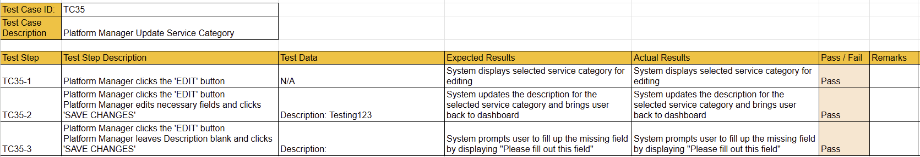

## 

## **#36. Platform Management - Remove Service Category**

User story

As platform management, I want to remove a service category, so that irrelevant services are no longer available.

| Use Case Diagram Taiga ID#224 |
| --- |
|  |

| Use Case Description Taiga ID#225 |
| --- |
| **Name :** Platform Management Remove Service Category |
| **Stakeholders and goals :** Platform Management – wants to remove outdated or irrelevant Service Categories from the platform |
| **Description :** This allows Platform Management to delete a Service Category from the system, ensuring that only relevant and current service options are available to Cleaners and Homeowners. |
| **Actors :** Platform Management |
| **Pre-condition(s) :**  Platform management is logged in  The category to be deleted exists  There are no existing Service Listings assigned to the category |
| **Trigger :** Platform Management decides to delete an irrelevant or outdated service category |
| **Normal flow :**   1. Platform management views list of Service Categories. 2. Selects clicks “DELETE” button on a category to be deleted 3. System deletes the category and shows a success message. |
| **Sub-flows :** None |
| **Alternative/Exceptional flows :**  3a. Category Linked to Listings: system displays an error message indicating that the category cannot be removed |

| BCE Diagram Taiga ID#226 |
| --- |
|  |

| Sequence Diagram Taiga ID#227 |
| --- |
|  |

| Wire Frame Taiga ID#223 |
| --- |
|  |

Test Case Taiga ID# 360

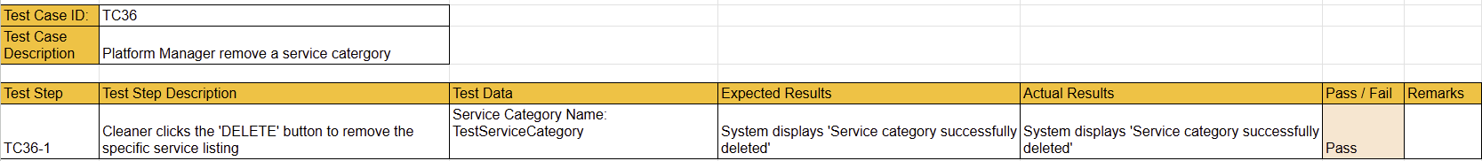

## **#37. Platform Management - Search Service Category**

User story

As platform management, I want to search for a specific service category, so that I can quickly locate it.

| Use Case Diagram Taiga ID#229 |
| --- |
|  |

| Use Case Description Taiga ID#230 |
| --- |
| **Name :** Platform Management Search Service Category |
| **Stakeholders and goals :** Platform Management – wants to quickly find a specific Service Category |
| **Description :** This allows Platform Management to search for a particular Service Category by name to locate specific Service Categories quickly |
| **Actors :** Platform Management |
| **Pre-condition(s) :**Platform Management is logged in |
| **Trigger :**Platform Management decides to search for a Service Category |
| **Normal flow :**   1. Platform Management enters a service category name into the search bar and clicks “Search” 2. System filters and displays matching Service Categories |
| **Sub-flows :** None |
| **Alternative/Exceptional flows :**  2a. No Service Category Found: Page shows that there is no service category found |

| BCE Diagram Taiga ID#231 |
| --- |
|  |

| Sequence Diagram Taiga ID#232 |
| --- |
|  |

| Wire Frame Taiga ID#228 |
| --- |
|  |

Test Case Taiga ID# 363

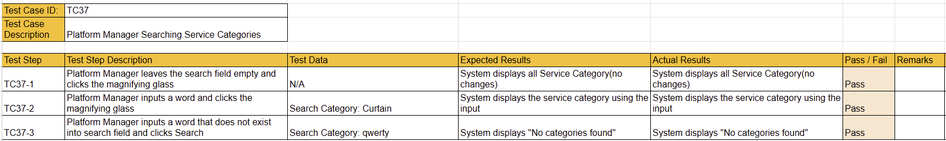

## **#38. Platform Management - Login**

User story

As platform management, I want to log in to the site so that I can access my account

| Use Case Diagram Taiga ID#234 |
| --- |
|  |

| Use Case Description Taiga ID#235 |
| --- |
| **Name :** Platform Management Login |
| **Stakeholders and goals :** Platform Management – wants to access their account and platform features |
| **Description :**  This allows Platform Management to log in using their credentials to manage functions on the platform. |
| **Actors :** Platform Management |
| **Pre-condition(s) :** Platform Management has a valid account |
| **Trigger :** Platform Management decides to log in to the site |
| **Normal flow :**   1. System displays the login form 2. Platform management enters email and password 3. Platform management submits the form 4. System validates credentials 5. System grants access and redirects the admin to the Platform management dashboard |
| **Sub-flows :** None |
| **Alternative/Exceptional flows :**  3a. Invalid credentials: System display error message |

| BCE Diagram Taiga ID#236 |
| --- |
|  |

| Sequence Diagram Taiga ID#237 |
| --- |
|  |

| Wire Frame Taiga ID#233 |
| --- |
|  |

Test Case Taiga ID# 366

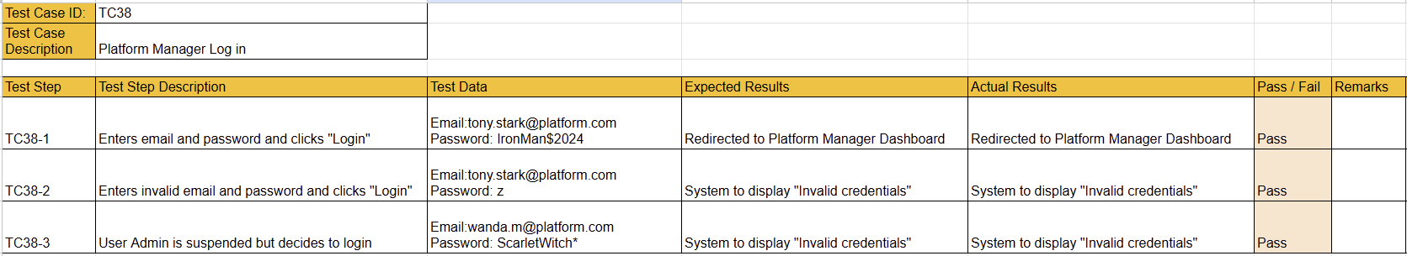

## **#39. Platform Management -** L**ogout**

User story

As platform management, I want to log out, so that I can exit my account.

| Use Case Diagram Taiga ID#239 |
| --- |
|  |

| Use Case Description Taiga ID#240 |
| --- |
| **Name :** Platform Management - Logout |
| **Stakeholders and goals :** Platform Management - wants to exit their account after use |
| **Description :**This allows a Platform Management to logout of the system, ending the current session |
| **Actors :** Platform Management |
| **Pre-condition(s) :** Platform Management is logged in |
| **Trigger :** Platform Management decides to log out |
| **Normal flow :**   1. Platform Management clicks on the “Logout” button 2. The system terminates the current session. 3. System redirects the Platform Management to the login page |
| **Sub-flows :** None |
| **Alternative/Exceptional flows :** None |

| BCE Diagram Taiga ID#241 |
| --- |
|  |

| Sequence Diagram Taiga ID#242 |
| --- |
|  |

| Wire Frame Taiga ID#238 |
| --- |
|  |

Test Case Taiga ID# 369



## **#40. Platform Management - Generate Daily Report**

User story

As platform management, I want to generate a daily report, so that I can monitor platform activity on a daily basis

| Use Case Diagram Taiga ID#104 |
| --- |
|  |

| Use Case Description Taiga ID#105 |
| --- |
| **Name :** : Platform Management Generate Daily Report |
| **Stakeholders and goals :** Platform Management – wants to monitor and evaluate platform activity each day |
| **Description :** This allows Platform Management to generate a report summarising daily platform activity |
| **Actors :** Platform Management |
| **Pre-condition(s) :**  Platform Management is logged in  There must be records in the database to have data for report generation |
| **Trigger :** Platform management decides to generate a daily activity report |
| **Normal flow :**   1. Platform Management clicks on “Generate reports” button 2. Platform Management selects “Daily” 3. Platform Management selects a date to generate report and clicks “GENERATE” 4. System retrieves the relevant data 5. System generates the report and displays it |
| **Sub-flows :** None |
| **Alternative/Exceptional flows :**  4a. No Data Found: system displays a message indicating no data exists for the selected date |

| BCE Diagram Taiga ID#107 |
| --- |
|  |

| Sequence Diagram Taiga ID#108 |
| --- |
|  |

| Wire Frame Taiga ID#106 |
| --- |
|  |

Test Case Taiga ID# 372

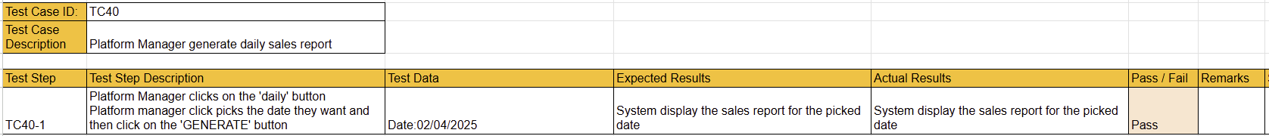

## **#41. Platform Management - Generate Weekly Report**

User story

As platform management, I want to generate a weekly report, so that I can monitor platform activity on a weekly basis

| Use Case Diagram Taiga ID#244 |
| --- |
|  |

| Use Case Description Taiga ID#245 |
| --- |
| **Name :**  Platform Management Generate Weekly Report |
| **Stakeholders and goals :** Platform Management – wants to monitor and evaluate platform activity each week |
| **Description :** This allows Platform Management to generate a report summarising weekly platform activity |
| **Actors :** Platform Management |
| **Pre-condition(s) :**  Platform Management is logged in  There must be records in the database to have data for report generation |
| **Trigger :** Platform Management decides to generate a weekly activity report |
| **Normal flow :**   1. Platform Management clicks on “Generate reports” button 2. Platform Management selects “Weekly ” 3. Platform Management selects a date to generate report and clicks “GENERATE” 4. System retrieves the relevant data 5. System generates the report and displays it |
| **Sub-flows :** None |
| **Alternative/Exceptional flows :**  4a. No Data Found: system displays a message indicating no data exists for the selected week |

| BCE Diagram Taiga ID#246 |
| --- |
|  |

| Sequence Diagram Taiga ID#247 |
| --- |
|  |

| Wire Frame Taiga ID#243 |
| --- |
|  |

Test Case Taiga ID# 375

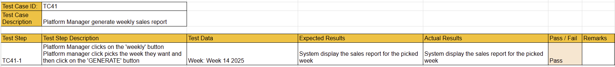

## 

## **#42. Platform Management - Generate Monthly Report**

User story

As platform management, I want to generate a monthly report, so that I can monitor platform activity on a monthly basis

| Use Case Diagram Taiga ID#249 |
| --- |
|  |

| Use Case Description Taiga ID#250 |
| --- |
| **Name :** : Platform Management Generate Monthly Report |
| **Stakeholders and goals :** Platform Management – wants to monitor and evaluate platform activity each month |
| **Description :** This allows Platform Management to generate a report summarising monthly platform activity |
| **Actors :** Platform Management |
| **Pre-condition(s) :**  Platform Management is logged in  There must be records in the database to have data for report generation |
| **Trigger :** Platform Management decides to generate a monthly activity report |
| **Normal flow :**   1. Platform Management clicks on “Generate reports” button 2. Platform Management selects “Monthly ” 3. Platform Management selects a date to generate report and clicks “GENERATE” 4. System retrieves the relevant data 5. System generates the report and displays it |
| **Sub-flows :** None |
| **Alternative/Exceptional flows :**  4a. No Data Found: system displays a message indicating no data exists for the selected month |

| BCE Diagram Taiga ID#251 |
| --- |
|  |

| Sequence Diagram Taiga ID#252 |
| --- |
|  |

| Wire Frame Taiga ID#248 |
| --- |
|  |

Test Case Taiga ID# 378

## 

## 

## **Class Diagram - Finali**s**ed**

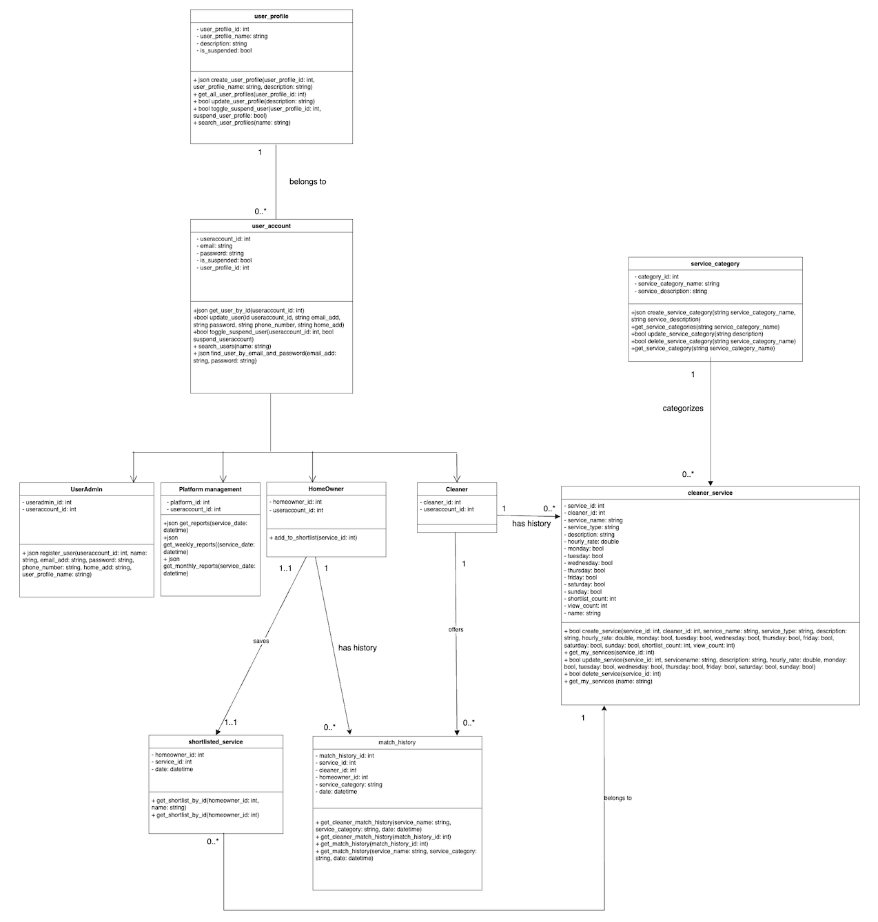

## **Gantt** C**hart**



# 

# 

# 

# 

# 

# **CI/CD**

Gitlab.com was used for CI/CD. Development team used Gitlab git repo to exercise version control. Any approved push made to the main branch would trigger the pipeline to start. This fulfills CI. At the end of the pipeline, the app would be automatically deployed to dockerhub. This fulfills the CD.

## .yml file

## 

Secrets are stored within the project repo as masked environment variables.

## Pipeline

# 

There are 2 stages in the pipeline. Build and deploy.

### Build

A node docker container is run to build the frontend elements of the application. Artifacts are saved to the pipeline’s local files.

### Deploy

A docker image is built using a dockerfile

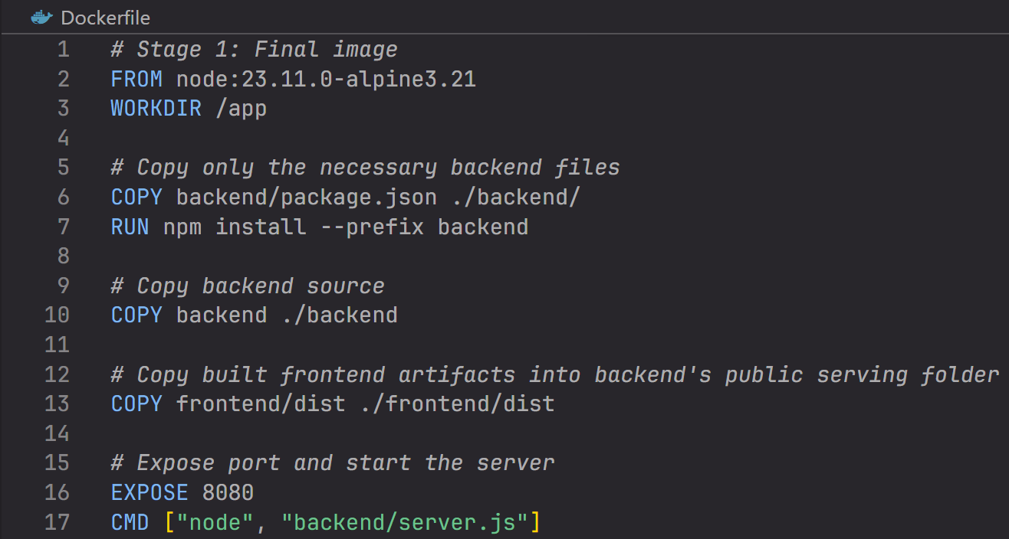

The base docker image used is node:23.11.0-alpine3.21. Essentially a lightweight version of the latest node version. The built artifacts are taken from the pipeline environment and copied into the image. The image is then configured to run the app with server.js as the entrypoint. The app runs on port 8080 internally. A separate docker-compose file is required to run this docker image.

After the image has been built successfully, it is uploaded to dockerhub. Anyone may pull the docker image and run it, to view the website. The secret connection string for our database is included with our docker-compose file. A user would need our docker-compose file to view the website’s full functionality.

Since the website is containerised in a stateless, immutable, cloud-native style, it can be easily hosted and deployed to mainstream cloud providers such as AWS, Digital Ocean, and GCP. This would allow the website to be viewed live on the internet.

# 

# 

# **Database Tables**

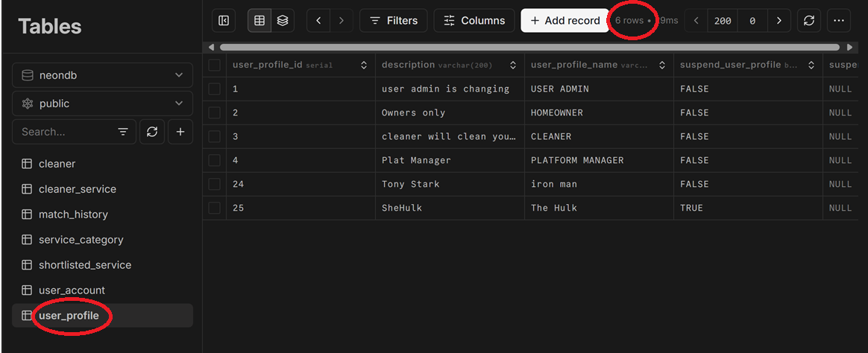

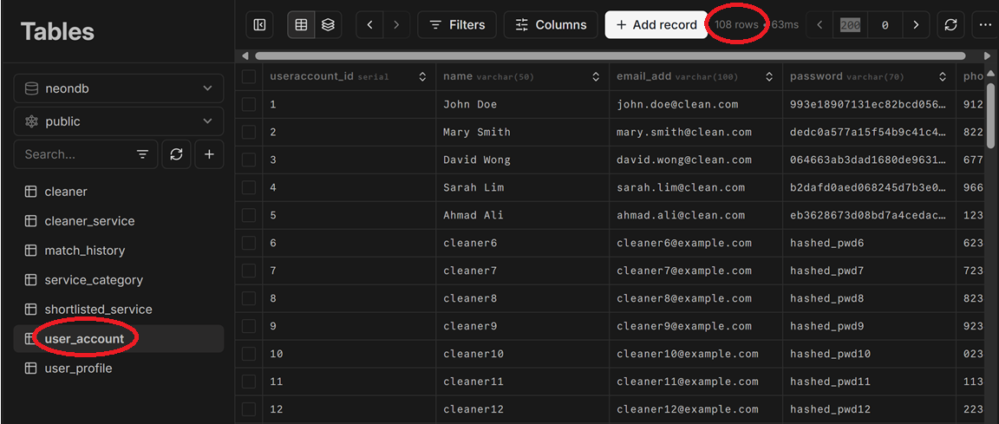

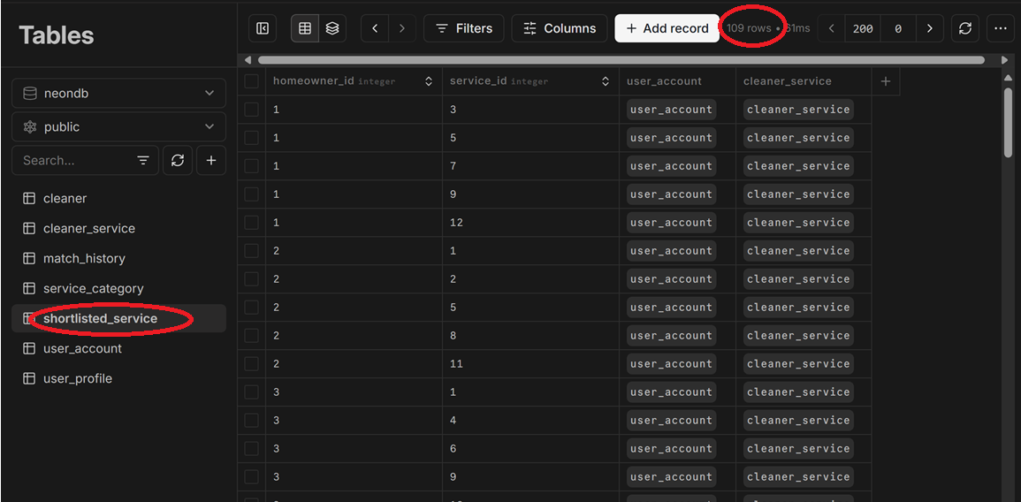

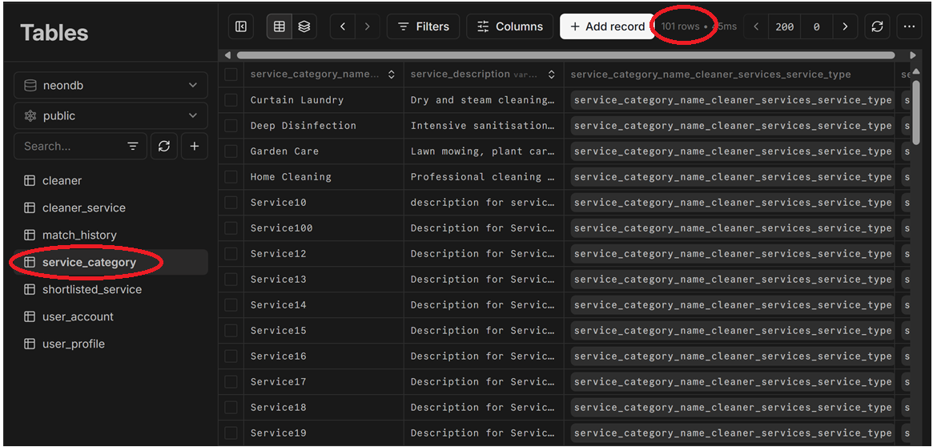

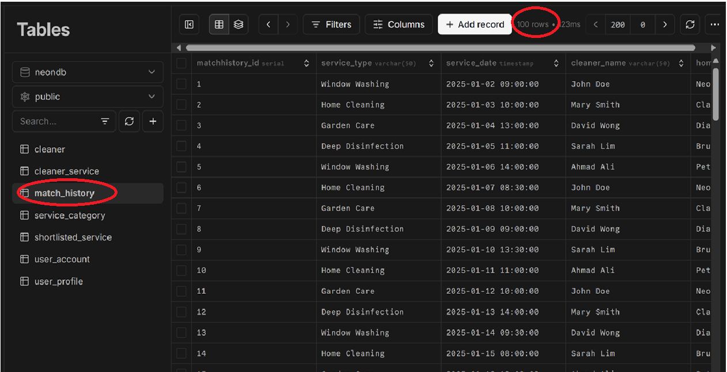

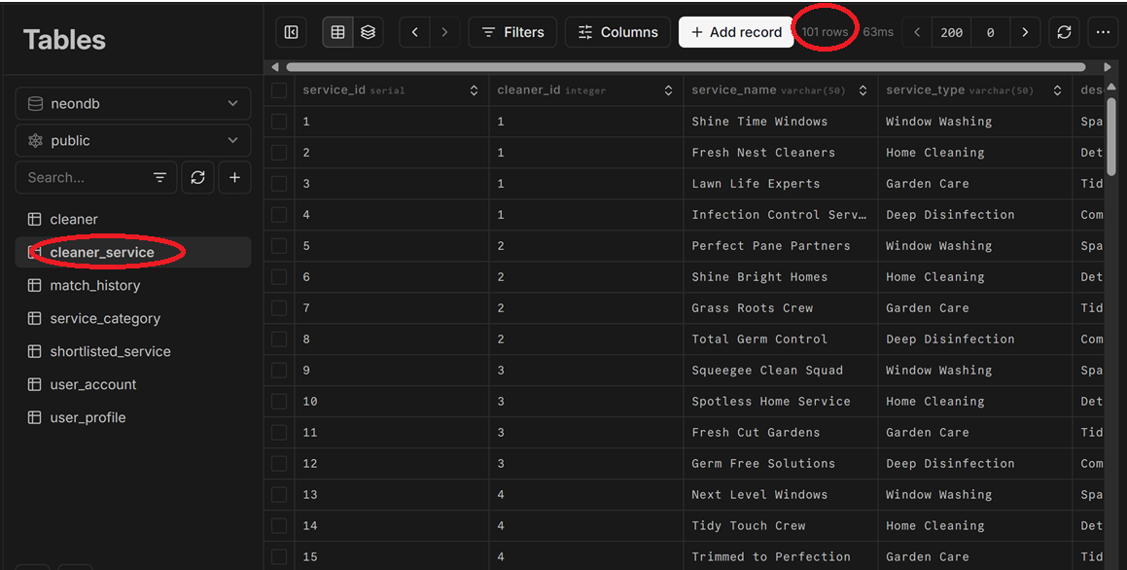

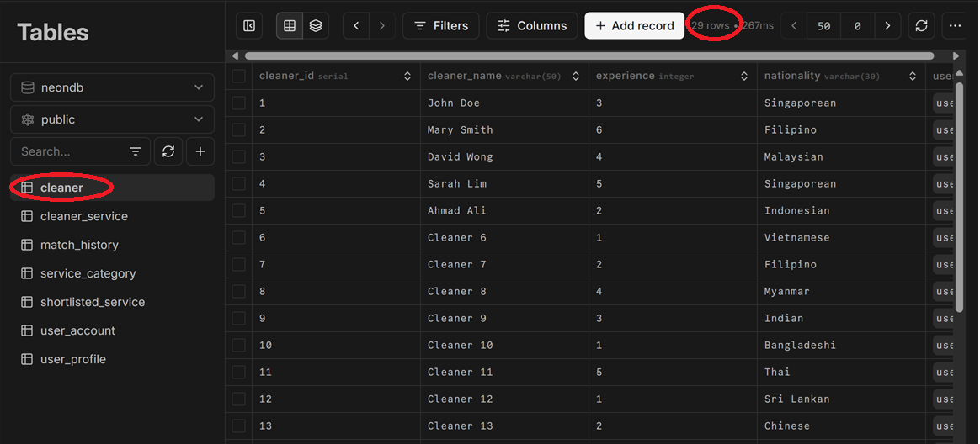

# **Data-Driven Development**

This document outlines the application of Data-Driven Development (DDD) to enhance an existing feature in a cleaning services web platform. The selected feature is currently used by cleaners to monitor how many times their listings have been shortlisted by homeowners. By integrating Artificial Intelligence (AI), this feature will be transformed into a predictive system that estimates the likelihood of a listing being shortlisted, thereby enabling cleaners to proactively improve their offerings.

Data-driven software development for our home cleaning service platform is planned to consist of nine stages:

1. Model Requirements

The model should predict the shortlisting likelihood of a cleaner's listing.  
 Inputs include: listing metadata, user interaction logs, previous shortlisting data, and behavioral patterns.

Output: A score representing the predicted probability of the listing being shortlisted in the near future.

Success Metrics:

* Precision@K
* AUC-ROC
* Improvement in real shortlisting after model deployment

2. Data Collection

Relevant data will be sourced from:

* Listing metadata: category, price, rating, availability
* User interaction logs: views, clicks, time on listing, scroll depth
* Shortlisting history: when and how often each listing was shortlisted
* Contextual data: time of day, day of week, platform trends

3. Data Cleaning

The following cleaning operations will be performed:

* Remove records with missing or invalid data (e.g., price = 0)
* Standardised formats for location, timestamps, and category tags
* Remove spam/bot entries and detect outliers
* Normalise text-based fields

4. Data Labeling

A binary label will be created for supervised learning:

* **1** if the listing was shortlisted within a predefined timeframe after being viewed
* **0** otherwise

An optional multi-class label may include:

* 0 = Never shortlisted
* 1 = Shortlisted once
* 2+ = Shortlisted multiple times

5. Feature Engineering

Key features may include:

* Listing features: price, description length, image count, category
* Behavioral features: average scroll depth, time spent, bounce rate
* Contextual features: upload day/time, seasonal trends
* Derived features: view-to-shortlist ratio, edit recency

Features will be transformed using techniques such as:

* One-hot encoding
* Normalisation
* Embedding representations (for text and categories)

6. Model Training

Several models will be tested:

* Logistic Regression for baseline
* Random Forest or XGBoost for improved accuracy
* Neural Networks if dataset size permits

The dataset will be split into training, validation, and test sets.  
Cross-validation and hyperparameter tuning will be used for optimisation.

7. Model Evaluation

Models will be evaluated using:

* AUC-ROC: Overall classification effectiveness
* Precision@K: Accuracy of the top predicted listings
* Business metrics: Increase in shortlisting activity after AI guidance

Visualisation dashboards may also be used for interpretability.

8. Model Deployment

Deployment will include:

* Exposing the model via a RESTful API
* Integrating with the cleaner dashboard
* Displaying a visual badge like “80% likely to be shortlisted”
* Providing recommendations (e.g., "Add more photos to improve score")

Deployment can be containerised using Docker or hosted via a cloud AI service.

9. Model Monitoring

To ensure ongoing reliability:

* Monitor real-time performance metrics
* Track changes in user engagement and shortlisting frequency
* Set up drift detection alerts for input or prediction changes
* Retrain the model periodically using updated datasets

Tools like Grafana or Prometheus may be used for metric visualisation.

# 

# 

# 

# 

# 

# 

# 

# 

# **Ethical Considerations**

**Process-Related**

Accountability

We recognised both individual and shared responsibilities in our development process. Team members were expected to take ownership of their assigned modules while also contributing to platform-wide reliability and ethical standards. To ensure clear communication and fairness:

Fairness

* Tasks were assigned based on team members' skill sets and learning goals, ensuring balanced contribution.
* Decision-making was done collectively during sprint planning to avoid bias and promote transparency.
* Assistance was offered to team members who needed help after completing personal tasks.
* All decisions were documented in our sprint retrospectives and commit history to uphold intellectual honesty and avoid conflicts of interest.

Management

* We adopted Agile methodology, conducting weekly sprint reviews and planning sessions to assess task progress, delegate new tasks, and ensure timely delivery.
* Developers had full flexibility and autonomy to implement their modules as long as they followed the agreed architectural structure (BCE) and met the quality standards.
* Peer reviews were enforced for each critical function to reduce risk and ensure accountability.

Inclusiveness

* The team actively encouraged participation from all members regardless of background or experience. Language barriers were addressed using annotated diagrams, multilingual comments, and optional voice discussions.
* Diverse feedback was sought during each sprint to integrate different perspectives into our decision-making process.
* Stakeholder feedback (e.g., client advisor, teaching staff) was incorporated to refine ethical handling of user data and interface accessibility.

**Product-Related**

Reliability and Safety

* The platform underwent multiple rounds of functional and usability testing to ensure stable performance.

Fairness

* We ensure all users — regardless of role — have a fair and consistent experience using the system.